- Pledge of Allegiance: Dan Bernard June 18, 2019 @ 10:00AM

- Chaplin’s Prayer: Dan Bernard

- Roll Call:
  - Commander – J. Wagner - Present
  - Senior Vice Commander - D. Bernard – Present
  - Junior Vice Commander - B. Kurland – Absent
  - Adjutant - B. Dismukes - Present
  - Finance Officer - R. Johnston – Excused Absence
  - Sargent-At-Arms - J Connor – Present
  - Chapter Executive Committeeman – S. Fantino - Absent
  - Chapter Alternate Executive Committeeman – M. Gillenwater - Absent
  - Trustee Year 2 - R. Duffney - Absent
  - Trustee Year 1 – Pete Palkowski - Present
  - Service Officer - J. Friese - Present
  - Welfare Officer – Ed Charles - Present
  - Historian - N/A
  - Chaplain - D. Bernard - Present
  - Americanism Officer - Absent
  - VA Representative - Pete Palkowski – Present

- Introduction of Guests and New Members:
  - None
- Reading of the Minutes of the Last Meeting:
Adjutant read the minutes of May, 2019. Motion to accept, Seconded, and approved by all.
- Report of the Finance Officer: Balance = $4,968.58 bank balance
  - Bank deposits
    - Walmart $421.63
    - Roger Murry $126.00
    - Mel Gillenwater 100.00
- Reading and Actions on Bill’s Payable:
  - None
- Reports of Committees:
  - Pete Palkowski gave a short update on current events at the VA in regards to Community Care.
  - Adjutant updated the committee on the ongoing actions at National.

- Unfinished Business:
  - Next collection a Walmart is scheduled for Thursday July 4th

- Old Business
  - None
- New Business:
  - The museum has asked that on Purple Heart Day this year we travel to the Casino Cottonwood near Fort Lauderdale. We agreed to work with the Museum to get PH Members from our chapter as well as the chapters form Punta Gorda and West Palm Beach to attend this event. Bill Dismukes as well as Dan Bernard will work with museum representative Judy to set this up. The date is 7 August.
- Good of the Order:
  - Meeting Adjourned: A Motion by Ed Charles and 2nd by Jerry Freese at 11:10 was approved by all present.

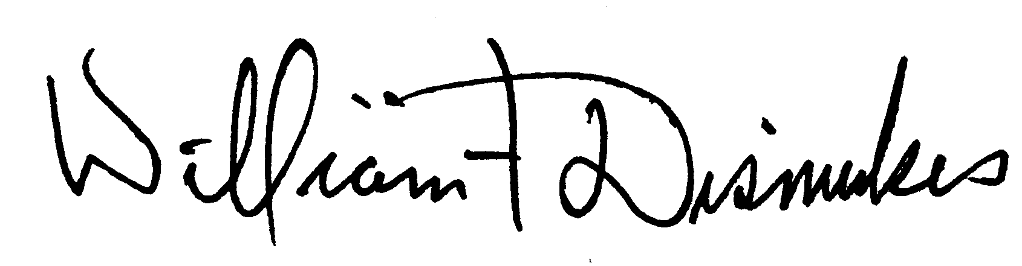
Bill Dismukes
Adjutant
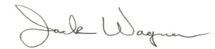
Approved by: J.Wagner

