- Pledge of Allegiance: Jack Wagner March 19, 2019 @ 10:00AM

- Chaplin’s Prayer: Dan Bernard

- Roll Call:
  - Commander – J. Wagner - Present
  - Senior Vice Commander - D. Bernard – Present
  - Junior Vice Commander - B. Kurland – Excused
  - Adjutant - B. Dismukes - Present
  - Finance Officer - R. Johnston - Present
  - Sargent-At-Arms - J Connor – Present
  - Chapter Executive Committeeman – S. Fantino - Present
  - Chapter Alternate Executive Committeeman – M. Gillenwater - Absent
  - Trustee Year 2 - R. Duffney - Present
  - Trustee Year 1 – Pete Palkowski - Present
  - Service Officer - J. Friese - Present
  - Welfare Officer – Ed Charles - Present
  - Historian - N/A
  - Chaplain - D. Bernard - Pesent
  - Americanism Officer - Present
  - VA Representative - Pete Palkowski – Present

- Introduction of Guests and New Members:
  - None

- Reading of the Minutes of the Last Meeting:
Adjutant read the minutes of February 19, 2019. Motion to accept, Seconded, and approved by all.

- Report of the Finance Officer: Balance = $3,959.62
  - FO reported on the expenditures since the February meeting – attached.

- Reading and Actions on Bill’s Payable:
  - None
- Reports of Committees:
  - Membership Candidates: Adjutant reported on the need to get younger candidates in the Order and attending MOPH events. The Senior Vice will be working with the Department Senior Vice in the future to recommend how the chapter might accomplish this. Chapter Bad Addresses are down to 3 patriots. Two are out of state and will be moved to an inactive state at National.
  - Welfare Officer: Provided input for the annual report.
  - Americanism Officer: Reviewed his input for the annual report.
  - Special Committees: Peter Palkowski announced that the new Director of the VA Clinic will start holding meetings with military agencies again.

- Unfinished Business:

- Old Business
  - Commander Wagner thanked those in attendance at the City of Sanibel celebration as a Purple Heart entity. This was one of the best celebrations we have had by a large amount. All in attendance were amazed at the level of effort put in by the Sanibel mayor and staff.

- New Business:
  - The commander has received documentation for the 2019 support for the Junior ROTC awards and asked the committee for a vote to support this year. The committee approved support at the same level as last year and voted to provide one $500.00 scholarship.
  - Fund Raiser is set for 30 March at Walmart. We will be working two shifts for this event. Rob Duffney will lead the second Shift from noon to 3PM.
  - Adjutant Dismukes gave an update on the ensuing Convention. Approximately 75 patriots will be in attendance from around the state.

- Good of the Order:
  - Meeting Adjourned: A Motioned by Sam Fantino and 2nd by Ed Charles at 11:10 was approved by all present.

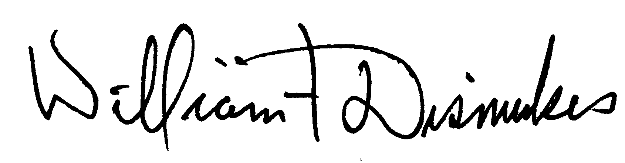
Bill Dismukes
Adjutant

Approved by: J.Wagner

