- Pledge of Allegiance: Dan Bernard May 21, 2019 @ 10:00AM

- Chaplin’s Prayer: Dan Bernard

- Roll Call:
  - Commander – J. Wagner - Absent
  - Senior Vice Commander - D. Bernard – Present
  - Junior Vice Commander - B. Kurland – Present
  - Adjutant - B. Dismukes - Present
  - Finance Officer - R. Johnston – Excused Absence
  - Sargent-At-Arms - J Connor – Present
  - Chapter Executive Committeeman – S. Fantino - Absent
  - Chapter Alternate Executive Committeeman – M. Gillenwater - Absent
  - Trustee Year 2 - R. Duffney - Present
  - Trustee Year 1 – Pete Palkowski - Present
  - Service Officer - J. Friese - Absent
  - Welfare Officer – Ed Charles - Present
  - Historian - N/A
  - Chaplain - D. Bernard - Present
  - Americanism Officer - Present
  - VA Representative - Pete Palkowski – Present

- Introduction of Guests and New Members:
  - Dave Walsh USMC – wounded in the Korean War October 1952
- Reading of the Minutes of the Last Meeting:
Adjutant read the minutes of April, 2019. Motion to accept, Seconded, and approved by all.
- Report of the Finance Officer: Balance = $4,814.45 bank balance
  - Bank deposits $500 from Kiwanis, $100.00 from Mel
  - To be deposited $421.63 from Walmart Collection
- Reading and Actions on Bill’s Payable:
  - None
- Reports of Committees:
  - None
  - Adjutant updated the committee on the ongoing actions at National.

- Unfinished Business:

- Old Business
  - Dan Bernard informed the committee on the results of the JROTC Awards. 14 Cadets received awards and one Cadet was awarded a $500 scholarship.
- New Business:
  - Adjutant requested a vote to approve $42.00 to be sent to the Department for the 10% from the collection at Walmart. Motion was presented for a Warrant, seconded and approved by all.
  - Ed Charles notified the committee that we are short both Violas and Arm bands for our next collection scheduled for the 4th of July. A motion was presented for the purchase of arm bands and Violas, seconded and approved by all.
  - Dan Bernard will meet with the museum after the meeting to register MOPH in the parade Monday (Memorial Day). We will meet at the Museum at 11:00 in the parking lot.

- Good of the Order:
  - Meeting Adjourned: A Motion by Jim Connor and 2nd by Ed Charles at 11:10 was approved by all present.

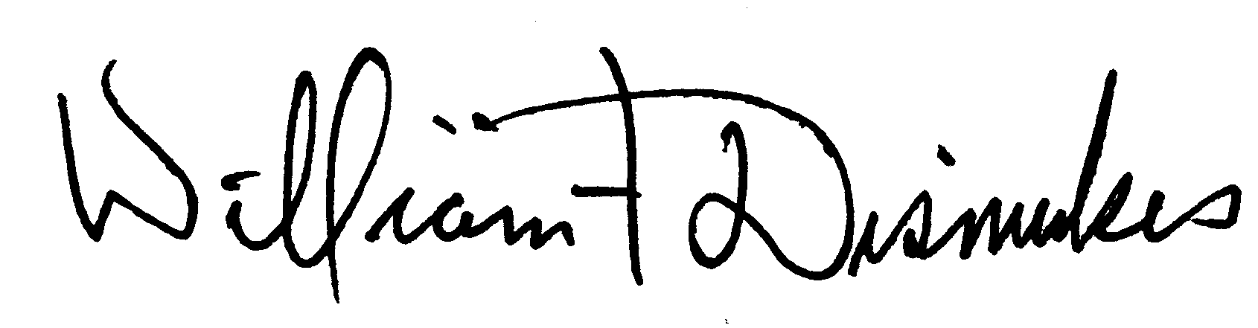
Bill Dismukes
Adjutant
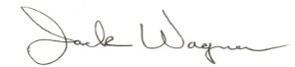
Approved by: J.Wagner

