- Pledge of Allegiance: Jack Wagner November 19, 2019 @ 10:00AM

- Chaplin’s Prayer: Dan Bernard

- Roll Call:
  - Commander – J. Wagner - Present
  - Senior Vice Commander - D. Bernard – Present
  - Junior Vice Commander - B. Kurland – Present
  - Adjutant - B. Dismukes - Present
  - Finance Officer - R. Johnston – Present
  - Sargent-At-Arms - J Connor – Present
  - Chapter Executive Committeeman – S. Fantino - Absent
  - Chapter Alternate Executive Committeeman – M. Gillenwater – Absent
  - Trustee Year 2 - R. Duffney - Absent
  - Trustee Year 1 – Pete Palkowski - Absent
  - Service Officer - J. Friese - Present
  - Welfare Officer – Ed Charles - Present
  - Historian - N/A
  - Chaplain - D. Bernard - Present
  - Americanism Officer – R. Duffney - Absent
  - VA Representative - Pete Palkowski – Absent

- Introduction of Guests and New Members:
  - None
- Reading of the Minutes of the Last Meeting:
Adjutant read the minutes of October, 2019. Motion to accept, Seconded, and approved by all.
- Report of the Finance Officer: Balance = $ 6,592.89
  - Bank deposits
    - $100.00 Mel Gillenwater
    - $1,000 Kiwanis
    - $246.75 Walmart Collection
- Reading and Actions on Bill’s Payable:
  - $50.00 News Paper Photo Veterans Day
  - $24.65 Department of Florida Viola 10%
- Reports of Committees:
  - None

- Unfinished Business:
  - None

- Old Business
  - Commander and Adjutant attended a celebration for Vietnam Veterans at Jet Blue Park. Guest speakers included the Governor Rick DeSantis and Wife, Lt Governor, Congressman Alan King and Joe Galloway Reporter from the Idrang Valley.
  - A special thanks to the chapter members that supported Pride and Patriotism this year.
  - Commander and adjutant supported the Cape Coral Museum where approximately 80 high school students from Naples received briefings and a tour of the museum.
  - Commander and Adjutant completed the MOU for the transfer of the Memorial Mural from the Department of Florida to Chapter 696. We further executed an MOU between Chapter 696 and the Museum. Both MOU’s were forwarded to the Department Commander and Adjutant as well as the Department Finance Officer.
  - The Adjutant briefed the executive committee on the results of the lawsuit with the Foundation. MOPH is allowed to raise funds as long as we use MOPH vice Purple Heart in the banner. It is ok to use the term Purple Heart when talking about you own award. More information will be provided as we receive the final ruling of the Judge.

- New Business:
  - The Adjutant and Roger Murry arranged to sponsor a presentation from “Golden Paws” a Naples based Veterans assistant dog program. Three dogs attended the meeting as the committee listened to the program that supports Veterans. After the briefing the committee agreed that we will work with “Golden Paws” in becoming a Purple Heart Entity. Action – Adjutant.

- Good of the Order:
  - Meeting Adjourned: A Motion by Jerry Frease and 2nd by Dan Bernard at 11:40 was approved by all present.

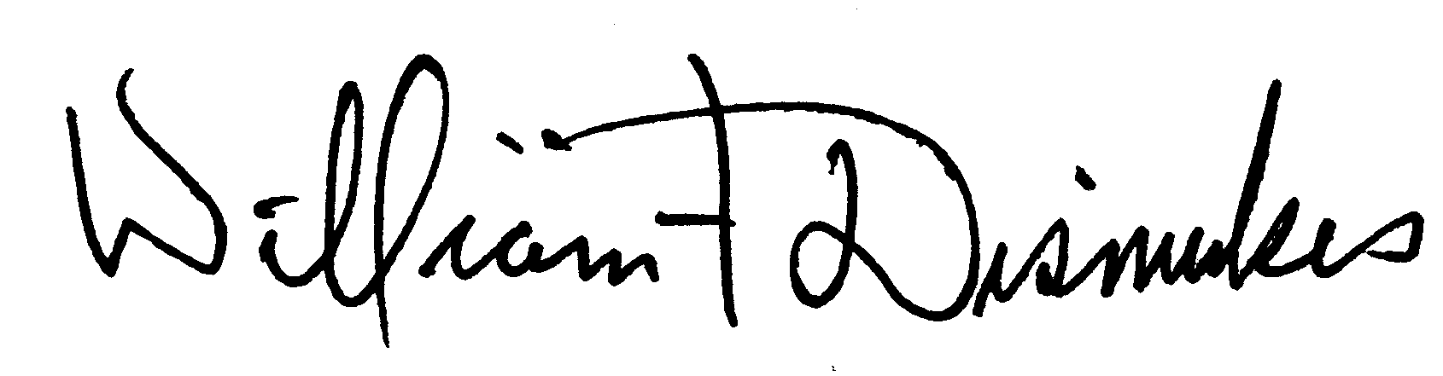
Bill Dismukes
Adjutant
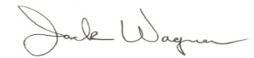
Approved by: J.Wagner

