- Pledge of Allegiance: Dan Bernard October 15, 2019 @ 10:00AM

- Chaplin’s Prayer: Dan Bernard

- Roll Call:
  - Commander – J. Wagner - Absent
  - Senior Vice Commander - D. Bernard – Present
  - Junior Vice Commander - B. Kurland – Absent
  - Adjutant - B. Dismukes - Present
  - Finance Officer - R. Johnston – Present
  - Sargent-At-Arms - J Connor – Present
  - Chapter Executive Committeeman – S. Fantino - Absent
  - Chapter Alternate Executive Committeeman – M. Gillenwater – Absent
  - Trustee Year 2 - R. Duffney - Present
  - Trustee Year 1 – Pete Palkowski - Absent
  - Service Officer - J. Friese - Absent
  - Welfare Officer – Ed Charles - Present
  - Historian - N/A
  - Chaplain - D. Bernard - Present
  - Americanism Officer – R. Duffney - Present
  - VA Representative - Pete Palkowski – Absent

- Introduction of Guests and New Members:
  - None
- Reading of the Minutes of the Last Meeting:
Adjutant read the minutes of September, 2019. Motion to accept, Seconded, and approved by all.
- Report of the Finance Officer: Balance = $ 5,320.79 bank balance
  - Bank deposits
    - $100.00 Mel Gillenwater
- Reading and Actions on Bill’s Payable:
  - $500.00 South West Florida Military Museum
  - $750.00 Pride and Patriotism
- Reports of Committees:
  - None

- Unfinished Business:

- Old Business
  - None

- New Business:
  - Reminder of our support for Pride and Patriotism for the presenters to be at Barbara B. Mann at 6 PM.
  - Dan Bernard will be narrating the Missing Man Table
  - Next Fund Raiser is Scheduled for 7 November at Walmart

- Good of the Order:
  - Meeting Adjourned: A Motion by Ed Charles and 2nd by Bill Dismukes at 11:10 was approved by all present.

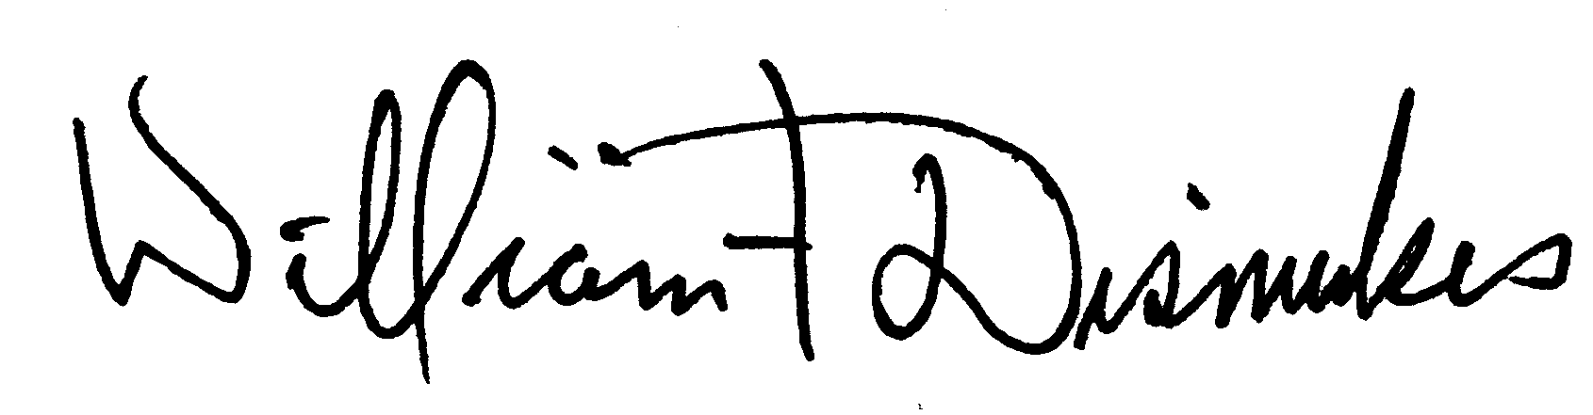
Bill Dismukes
Adjutant
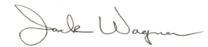
Approved by: J.Wagner

