- Pledge of Allegiance: Jack Wagner September 17, 2019 @ 10:00AM

- Chaplin’s Prayer: Dan Bernard

- Roll Call:
  - Commander – J. Wagner - Present
  - Senior Vice Commander - D. Bernard – Present
  - Junior Vice Commander - B. Kurland – Present
  - Adjutant - B. Dismukes - Present
  - Finance Officer - R. Johnston – Present
  - Sargent-At-Arms - J Connor – Present
  - Chapter Executive Committeeman – S. Fantino - Absent
  - Chapter Alternate Executive Committeeman – M. Gillenwater – Absent
  - Trustee Year 2 - R. Duffney - Present
  - Trustee Year 1 – Pete Palkowski - Absent
  - Service Officer - J. Friese - Absent
  - Welfare Officer – Ed Charles - Present
  - Historian - N/A
  - Chaplain - D. Bernard - Present
  - Americanism Officer – Rob Duffney - Present
  - VA Representative - Pete Palkowski – Absent

- Introduction of Guests and New Members:
  - None
- Reading of the Minutes of the Last Meeting:
Adjutant read the minutes of June, 2019. Motion to accept, Seconded, and approved by all.
- Report of the Finance Officer: Balance = $6.470.79

- Reading and Actions on Bill’s Payable:
  - None
- Reports of Committees:
  - None

- Unfinished Business:
  - Commander Wagner thanked those that were able to attend the Purple Heart Day activities held at the casino near Fort Lauderdale. He also mentioned that those on attendance at Jet Blue Park for the raveling wall were also appreciated.

- Old Business
  - None

- New Business:
  - Commander Wagner brought up the upcoming Pride and Patriotism event scheduled for November 7th at Barbara B Mann and asked for the group to let him know who would be in attendance. Senior Vice Commander Dan Bernard motioned that the chapter provide $750.00 as we have in the past. The motioned was seconded and approved by all.
  - Adjutant Bill Dismukes motioned that the chapter make a donation of $500.00 to the Southwest Veterans Library and Museum. The motion was seconded and approved by all.
  - Adjutant Bill Dismukes gave a brief update on the status of the National Headquarters. We are back in business with 95% of all unpaid bills taken care of the remaining are in final process. The National Hq. will no longer be supporting the Service Officer program. All current files are being transferred to other agencies performing this function. The Service Foundation is providing $50,000 monthly. The court case for the Hq. to get our Purple Heart logo back from the Foundation is ongoing and will be back in court on 23 September. More info will be provided as information is released.
  - The group ok’d the US flag presented to us by United Airlines which flew over their facility in Afghanistan be donated to the Museum and placed in the area with the Purple Heart Wall. Ralph Santillo, CEO of the museum, accepted the check and flag.

- Good of the Order:
  - Meeting Adjourned: A Motion by Rob Duffney and 2nd by Bert Kurland at 11:15 was approved by all present.

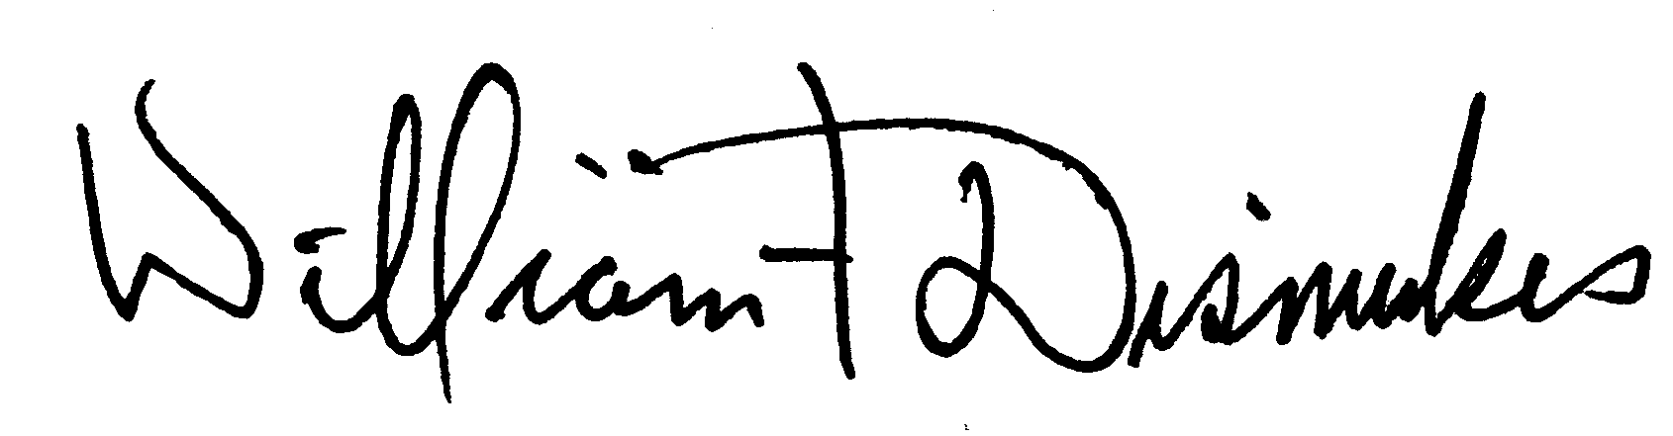
Bill Dismukes
Adjutant
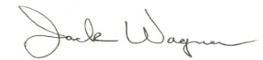
Approved by: J.Wagner

