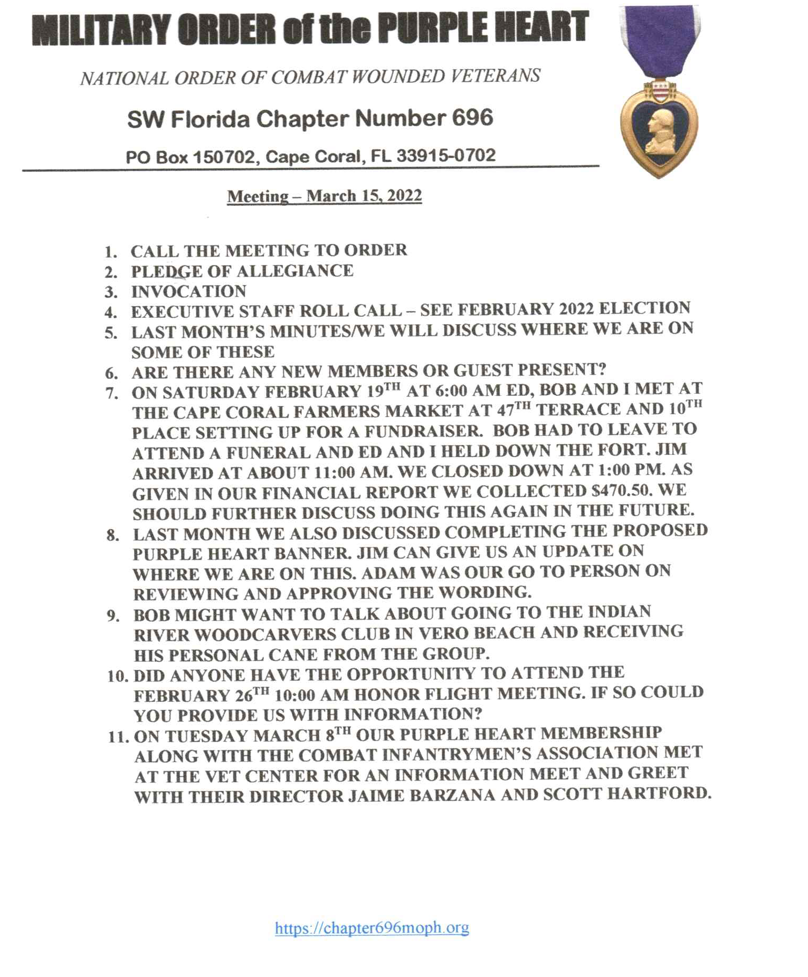

Meeting called to order: 10oo hrs by CO Jack Wagner

Pledge of Allegiance and Prayer: Given

Exec. Staff Roll Call: Taken with quorum existing.

Guest(s): Spider Tranthan from Naples attended with intention to transfer to 696. Former member of 101st Abn.

Reading of previous meeting: Minutes of 15 Feb. 2022, not read.

Announcing death of a member: None

Financial Report: $473.00 taken in from attending Farmers Market, with total balance of $24,725.49

Committee Reports:
- Membership: None
- Welfare: None
- Americanism: None
- Special Committee's: None
Old Business:
- MOPH Banner status. Not ready yet. Jim Connor to check on progress.
- Status of plaques to be made: 1. Steve Hall No Action 2. Kim @ Trophy Case No Action 3. Ft. Myers Mayor Kevin Anderson No Action
New Business: Motion by Dan Bernard, 2nd by Bob Johnston to expend $500.00 for scholarship award to JROTC. PASSED

Good of the Chapter:
- Meeting with MOPH members and Councilors at the Vet Center went well.
- Roger Murray said it was noted on CHARITY WATCH (Military Charities) That the rating was "F"
- Once again, a Informational Table will we set up at the Farmers Market at "Club Square" Cape Coral Sat. 19 Mar. 2022
Meeting Adjourned 1110 hrs.

