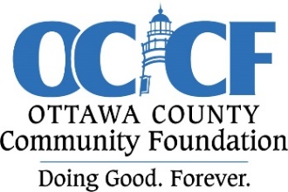
Ottawa County Community Foundation

RAPID RESPONSE GRANT APPLICATION

The Ottawa County Community Foundation, Inc. (OCCF) is a public charitable organization created by the citizens of Ottawa County to enrich the quality of life for individuals and families in Ottawa County. The Foundation has started a Rapid Response fund that is now able to award grants outside of the regular grant cycle to Ottawa County nonprofits experiencing urgent needs or increased demand for services. Our focus includes, but is not limited to, the areas of social services.

To be eligible, an organization must provide services to residents of Ottawa County. Grants will only be awarded to tax-exempt organizations classified as 501(c)(3) charities by the Internal Revenue Service (IRS). Applications may be submitted by email to ottawaccf@gmail.com or by mail to Ottawa County Community Foundation, Inc., P.O. Box 36, Port Clinton, Ohio 43452. All grant applications will be reviewed as they are received by a committee appointed by the Foundation’s Board of Trustees. Applicants will be notified within thirty days of funding consideration.

GRANT PROPOSAL REQUIREMENTS
One page only, please

- Organization Information: Name, address, phone, email, and date of application

- Contact Person Information: Name, address, phone, and email

- Purpose and need: What are your goals? What need will be addressed? Who will benefit from the grant?

- Implementation: How will you implement your plan? What is your timeline?

- Project Budget: Amount requested? Provide a brief budget to explain how grant funds will be used.

- Please attach a copy of your 501(c)3 tax exemption determination letter from the Internal Revenue Service. (Certification from the Ohio Secretary of State or IRS Employment Identification Number is not acceptable.)

If your grant application is approved and you are awarded a grant, we ask that you share with us the good that was done by your project.

Questions? Please contact us!

419.635.7750 (Shea McGrew, Executive Director) 419.341.7400 (Mary Coffee, Grants Chair)
email: ottawaccf@gmail.com email: msmscoffee@gmail.com

