**Wellington Community Association Survey**

**Final Results and Summary (November 2023)**

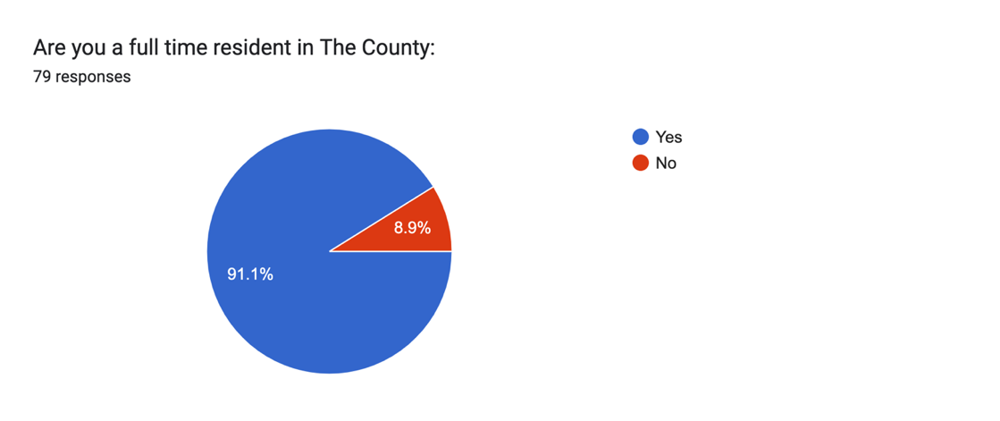

Forms response chart. Question title: What Ward do you live in?
. Number of responses: 78 responses.

Age breakdown of all survey respondents and their family members:

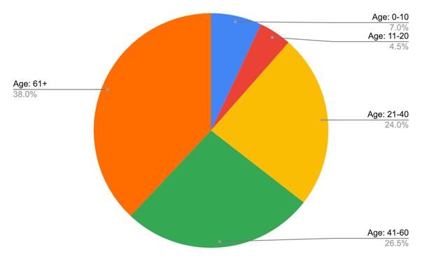

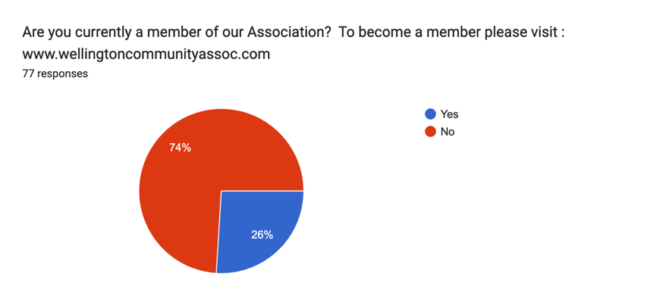

**REPORT:**

Based on the responses provided to the questions in the survey here is a synopsis of the overall results:

**Community Strengths:**

**Amenities:** Many expressed their appreciation of the small-town feel and amenities provided.

**Natural Beauty**: Wellington is appreciated for its natural beauty, waterfront location, and scenic surroundings.

**Community Involvement**: There is a strong sense of community involvement and a desire to work together for positive change.

**Local Businesses**: Respondents expressed support for local businesses, artisans, and farmers, markets, highlighting the importance of these enterprises in the community.

**Events and Festivals**: The various events and festivals in Wellington were identified as strengths that bring the community together.

**Community Concerns:**

**Healthcare**: Lack of access to healthcare, including the need for more doctors or nurse practitioners, was a major concern.

**Affordable Housing**: The lack of affordable housing options was a recurring concern.

**Cork and Vine Development**: The Cork and Vine development project raised concerns regarding its impact on the character of Wellington.

**Community Input**: Many respondents emphasized the importance of community input and decision-making in shaping the future of Wellington and the need for transparency between Council and the community.

**Recreation Facilities**: There is a desire for more recreation facilities, such as an indoor pool, a fitness centre and a community centre.

**Visitor Management**: Concerns were raised about how to manage tourists, their parking habits, the growing number of Airbnb’s and the need to ensure that the community remains attractive to residents.

**Diverse Businesses**: Respondents expressed a desire for more diverse businesses, affordable eateries, and shops catering to residents.

**Infrastructure**: Issues with infrastructure were highlighted, including parking, road repairs, and garbage disposal.

**Suggestions for Improving the Community:**

Respondents offered suggestions like;

* addressing concerns about healthcare access
* creating more affordable housing
* increasing communication with local government and about local events
* offering more diverse restaurant and café options for residents
* reducing the speed limit in the village
* improving beach and provincial park access for residents
* enhancing the beach facilities
* creating a recreation/community centre.

**Identified Shortcomings:**

Commonly identified shortcomings;

* healthcare access
* affordable housing
* the need for more community input
* recreation and community facilities
* more diverse businesses
* visitor management
* infrastructure issues (e.g., road repairs and garbage disposal).

**Do’s & Don’ts:**

There was a consensus on the importance of;

* engaging the entire community in future plans, including newcomers and youth
* accepting development while keeping a sense of small-town community spirit with emphasis on preserving the unique character of the community.
* Open and transparent communication between the association, residents, and local government
* Balancing the needs of residents and tourists was seen as a priority with particular attention to managing the growth in visitor numbers.

**Other Additional Comments:**

**Preserving the small-town feel;** Respondents emphasized the importance of preserving the small-town architectural aesthetic as the community grows.

**Cork and Vine**: Respondents were concerned about the Cork and Vine development project.

**Elderly Involvement**: Suggestions to involve the elderly in community committees to tap into their valuable knowledge.

**Speed Limits**: There was a suggestion to reduce the speed limit within the village and remove the sidewalk patios.

**Beautification**: Residents desired seasonal decorations, such as summer planters and Christmas decorations, to enhance the town’s atmosphere.

**Membership Fees**: A recommendation to create a sliding scale for membership fees to make community involvement more accessible.

**Community Support**: Many expressed gratitude and support for the community association’s initiatives.

**Overall Impression:**

Overall, the survey results reveal a strong sense of community, a sense of pride and attachment to their community and a commitment to making it a better place for everyone. The results reflect a community deeply concerned about preserving the character and aesthetics of Wellington while managing responsible development, its overall growth and its tourism. The challenges outlined, range from healthcare access to housing affordability and developments, and there is a call for community-driven decision-making and involvement to address these issues that will require collaborative efforts and support from local organizations and government to address them effectively. The survey serves as valuable input for the community association and local government to address key priorities and improve the overall quality of life in Wellington.