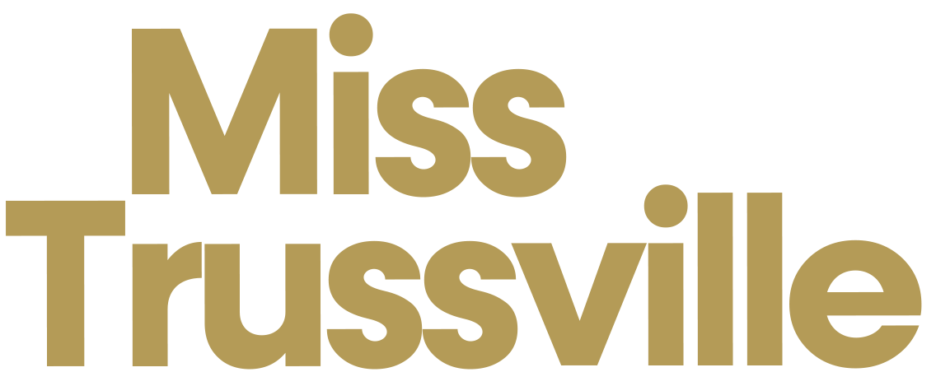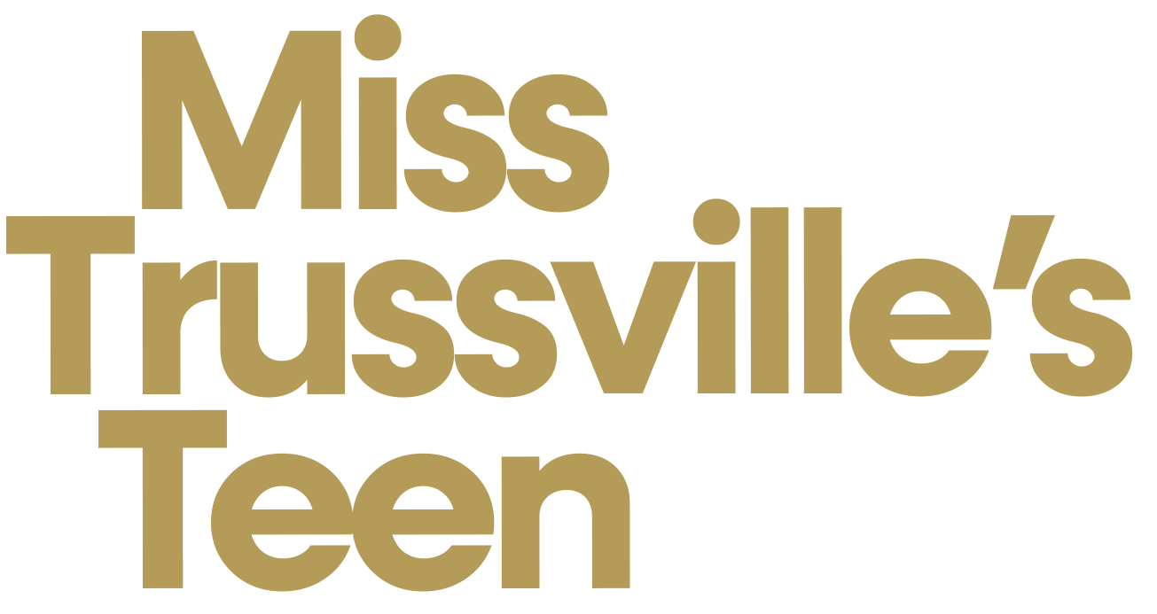

LOCAL CONTRACT

INTRODUCTION
By entering into this contract with the Miss Trussville Scholarship Program, which is one and the same as its Executive Directors, Christy Taylor and Sherry Pair, upon execution of same which shall be deemed complete upon my signature hereto, I: (contestant clearly print your full legal name) agree to fully and completely abide by all of the terms herein to the satisfaction of the above-listed Executive Director(s).
I understand that I am applying to become a contestant in the Miss Trussville Scholarship Competition, and I understand that one titleholder will be so designated from the eligible contestants at the conclusion of the Miss Trussville Scholarship Competition, and that titleholder will be known as “Miss Trussville” and “Miss Trussville’s Teen.”
I understand that the primary role of Miss Trussville/Miss Trussville’s Teen is to serve as a representative and spokesperson for the Miss Trussville Scholarship Program, and to utilize every reasonable opportunity available to maximize her ability to win the title of Miss Alabama/Miss Alabama's Teen. I further understand that Miss Trussville/Miss Trussville’s Teen represents the Executive Directors of the Miss Trussville Scholarship Program, and all sponsors of the Miss Trussville Scholarship Program as defined and determined by the Executive Directors.

ABILITY TO COMPETE
I certify and attest that I am in reasonably good health to the best of my knowledge, and that I can participate fully and without limitations in all competition activities. Miss contestants: I understand and agree to deliver a “no-show” fee of $50.00 in the form of a check payable to “Miss Trussville” or Venmo to @MissTrussville before the deadline when contestant paperwork is due for entry into the Miss Trussville Scholarship Competition. This fee will be returned to me upon arrival at the Miss Trussville Competition. Teen contestants: I understand and agree to pay a $100 contestant fee in the form of a check payable to “Miss Trussville” or Venmo to @MissTrussville before the deadline when contestant paperwork is due for entry into the Miss Trussville Scholarship Competition.

RULES AND REGULATIONS
I agree to participate in the series of events leading up to the final selection of Miss Trussville/Miss Trussville's Teen and to abide by and be bound by the rules and regulations governing the competition and the awarding and supervision of the scholarships and other prizes awarded. If I am selected as Miss Trussville/Miss Trussville's Teen, I agree to make myself available for public appearances at the request of the Executive Directors. The Executive Directors must approve all appearances of Miss Trussville/Miss Trussville's Teen prior to each appearance. When appearing as Miss Trussville/Miss Trussville's Teen, I will always dress appropriately for the occasion with groomed hair and nails and make-up applied suitably.
I agree to stay abreast of current events and important and relevant world issues to a degree which would allow me to engage in a meaningful and substantial discussion of such events and issues. I agree to attend all mock interview sessions scheduled for me, talent rehearsals, fittings, consultations, meetings and other scheduled events in preparation for the Miss Alabama/Miss Alabama's Teen Competition.

MORALITY/CHARACTER

I certify and attest that my morality and character meets the contemporary community standards of the State of Alabama; that I am not currently pregnant; that I have never been charged with a criminal offense in any jurisdiction whatsoever (other than a minor traffic violation); that no criminal charges are currently pending against me in any jurisdiction whatsoever; that I have never committed an act of moral turpitude as defined by the laws of the State of Alabama; that I have never engaged in any act or activity which is or could considered to be dishonest, fraudulent, immoral, immodest, indecent, obscene, offensive or in bad taste according to the contemporary community standards of the State of Alabama.

LIABILITY
I agree that neither the Miss Trussville Scholarship Program nor its Executive Directors, nor the Miss Alabama Organization, nor any director, officer, agent, employee, successor, assign, or any person or any entity associated in any way whatsoever with the Miss Trussville Scholarship Program shall be liable in any manner whatsoever for any accident which should occur or any damages whatsoever, physical or otherwise, which I may suffer during any pre-competition activities, during the competition itself, or during my reign as Miss Trussville/Miss Trussville's Teen.

JUDGING AND COMPETITION PRODUCTION
I agree that the manner and method of conducting the Miss Trussville Scholarship Competition shall be at the sole discretion of the Executive Directors, the Miss Alabama Organization, and the Miss America Organization, and I further agree that the time, method and manner of judging, and the award and distribution of the scholarships and prizes shall be within the sole discretion of the Executive Directors. I agree that I will not publicly criticize or question the results of the competition, the method and manner of judging, the decisions, or opinions of the Executive Directors, and further that I will not make any statement publicly which a reasonable person could construe as criticism or doubt of the same, or as a reflection of negativity toward the Miss Trussville Scholarship Competition or its Executive Directors.
I understand that the style, tone, theme, pace, tempo, music, characteristics, production, special guests and attendees, and direction of the Miss Trussville Scholarship Competition within the sole discretion of the Executive Directors, and that the same may change from year to year and may vary greatly from year to year. I agree to follow the direction of the Executive Directors with regard to the same.

REPRESENTATIONS AND WARRANTS
If the Executive Directors determine that any of the representations, warranties, certifications, assertions, statements and/or agreements I make herein prove to be false, fictitious, fraudulent, exaggerated, and/or deceptive, or if the Executive Directors determine that I have engaged or am engaging in any of the acts prohibited or disallowed herein, or if the Executive Directors determine that I have failed or am failing to conduct myself in a manner which in the opinion of the Executive Directors does not totally conform to the terms herein expressed or in a manner which the Executive Directors, the Miss Alabama Organization and/or the Miss America Organization determine are improper, or if I suffer any injury, ailment, disability or deformity which, in the sole and exclusive judgment of the Executive Directors, may impair in any way whatsoever my ability to perform my duties as Miss Trussville/Miss Trussville's Teen to the best of my abilities or to compete in the Miss Alabama/Miss Alabama's Teen Competition to the best of my abilities in any way whatsoever, then I understand, agree and consent that the Executive Directors may terminate my right to participate in the Miss Alabama/Miss Alabama's Teen Competition during the year of my reign as Miss Trussville/Miss Trussville's Teen, as well as my right to continue as the titleholder known as Miss Trussville/Miss Trussville's Teen, and I will return all crowns, sashes, awards, scholarships, prizes, and products which were bestowed upon me as Miss Trussville/Miss Trussville's Teen to the Executive Directors in excellent condition, or, if not returnable, will reimburse the Miss Trussville Scholarship Program for the monetary value thereof, and I will forfeit forever all of the rights, interests and benefits whatsoever to which I would otherwise be entitled as Miss Trussville/Miss Trussville's Teen.

SCHOLARSHIPS/AWARDS/PRIZES

I understand that I must claim, in email form, any and all scholarships, awards and prizes offered to me as Miss Trussville/Miss Trussville's Teen, as an alternate to Miss Trussville/Miss Trussville's Teen, as a special award winner of Miss Trussville/Miss Trussville's Teen, or otherwise offered to me in connection with my participation in the Miss Trussville Competition within thirty (30) days after the date of the Miss Trussville Competition in which such was awarded to me. I further understand and agree that if I do not claim the same within the time specified herein then the same will be forfeited forever. I understand and agree that scholarships shall only be used to pay expenses related to tuition, fees, books, student loan debt and other expenses directly related to my education. I agree that I am required to provide the Executive Directors with the name of the educational institution to which scholarship money should be delivered, along with the address for the institution’s student financial affairs division and my student identification number before scholarship money will be paid on my behalf. If I am not enrolled in school or have outstanding school loans or debt for which payment can be made then the Executive Directors shall within their sole discretion determine the method and manner of payment of scholarship money and how said money may be utilized and applied by the recipient. Further, if I am named as an alternate to the title of Miss Trussville/Miss Trussville's Teen, or as the Talent Award winner, or if I am awarded any scholarship, award or prize in connection with my participation in the Miss Trussville Scholarship Competition which is sponsored by a business, individual or organization, then I agree to write a respectable and suitable thank you note to the designated sponsor within thirty (30) days of the announcement of the same, and I will ensure delivery of the thank you note to the appropriate sponsor, and provide the Executive Directors with a copy of said thank you note upon its delivery to the sponsor. Miss Trussville/Miss Trussville's Teen shall provide thank you notes to all competition sponsors, judges, volunteers and donors in the same manner.

I further agree that if I am named Miss Trussville/Miss Trussville's Teen and, unless approved by Executive Directors, I miss a mandatory appearance, as set forth in Paragraph X subparagraphs A-R, below, I agree that the first such occurrence will result in a loss of 25% of the initial total scholarship winnings awarded to me as Miss Trussville/Miss Trussville's Teen; the second such occurrence will result in the loss of an additional 50% of my initial total scholarship winnings; and the third such occurrence may result in the loss of the title of Miss Trussville/Miss Trussville's Teen, in the sole discretion of the Executive Directors.
Miss Trussville/Miss Trussville's Teen’s scholarship award(s) will be dispersed on the following schedule:
  - 100% following participation in the Miss Alabama/Miss Alabama's Teen Competition AND crowning a successor at the Miss Trussville competition.

SPECIFIC DUTIES OF Miss Trussville/Miss Trussville's Teen
To ensure efficient management of Miss Trussville/Miss Trussville's Teen and her appearances, I agree and consent that if I am chosen as Miss Trussville/Miss Trussville's Teen I will do the following to the full satisfaction of the Executive Directors:
  - Refer all appearance requests to the Executive Directors;
  - Refer all press, radio, newspaper, magazine, website, internet, television, podcast, Skype, and/or webcam requests to the Executive Directors;
  - Honor and fulfill all scheduled appearances for Miss Trussville/Miss Trussville's Teen;
  - Prepare myself in conjunction with the Miss Trussville Scholarship Program and the Executive Directors to successfully compete in the Miss Alabama/Miss Alabama's Teen Competition to the best of my abilities;
  - To throughout my reign as Miss Trussville/Miss Trussville's Teen at reasonable intervals, provide community service work related to my social impact initiative;
  - Obtain the express permission of the Executive Directors before authorizing the use of any photography, video, digital recording, audio recording, recording of any type whatsoever, and/or depiction or likeness of myself whatsoever as Miss Trussville/Miss Trussville's Teen, and that such use will be for the benefit, promotion and success of the Miss Trussville Scholarship Program;
  - Refrain, decline and refuse from being involved in any advertisements, promotions, campaigns, fundraisers, appearances, and/or events whatsoever without the express consent and

approval of the Executive Directors, the Miss Alabama Organization and/or the Miss America Organization;
  - Provide my own complete wardrobe, accessories, make-up, shoes, beauty products, costumes, attire and any other product, item or thing necessary for all appearances, events, competitions and productions of the Miss Alabama/Miss Alabama's Teen Competition, subject to the approval of the Executive Directors;
  - Maintain my wardrobe in a neat, clean, pressed and steamed condition;
  - Maintain personal grooming at all times, including times when I am not appearing in my official capacity as Miss Trussville/Miss Trussville's Teen, in a manner and condition which reflects a positive image;
  - Show appreciation and write thank you notes to competition sponsors, volunteers, supporters, and others at the direction of the Executive Directors;
  - Provide my own transportation at my own expense to and from all scheduled appearances, unless directed otherwise by the Executive Directors;
  - Be prompt and on time to every engagement, appearance, meeting or event which I attend as Miss Trussville/Miss Trussville's Teen; I understand that arriving late to any of the same is totally unacceptable;
  - Obtain the prior approval of the Executive Directors before traveling with any individual other than a direct family member to and from any engagement, appearance, meeting or event whatsoever which I attend as Miss Trussville/Miss Trussville's Teen;
  - Provide all photographs needed for the Miss Alabama/Miss Alabama's Teen Competition, the Trussville Chamber of Commerce, and the Miss Trussville Competition during the time I hold the title of Miss Trussville/Miss Trussville's Teen, but submitted photographs are subject to the prior approval of the Executive Directors;
  - During my reign as Miss Trussville/Miss Trussville's Teen I understand that I am not allowed to compete in any state or national level competition. By doing so I agree to resign my title as Miss Trussville/Miss Trussville's Teen;
  - Exemplify a positive role model at all times;
  - Never use the title of Miss Trussville/Miss Trussville's Teen to promote myself (other than as biographical information) or any business or economic interest after my reign;
  - Timely raise any funds in the necessary amount as requested by the Miss Alabama Organization or the Miss America Organization;
  - Timely organize and secure, if required, a golf team for the Miss Alabama Competition golf tournament;
  - Timely sell raffle tickets in the manner and amounts determined by the Miss Alabama/Miss Alabama's Teen Competition, if required;
  - Show grace, poise and appreciation at all appearances; never take advantage of any host’s hospitality; and never give the impression when appearing as Miss Trussville/Miss Trussville's Teen that I am sick, bored, tired, annoyed, angry, upset, anxious or disinterested;
  - Ensure that, at all times, any of my social media profile pages, websites, and/or internet domains, AS WELL AS THOSE OF ANY INDIVIDUAL DESIGNATED THEREON AS A MEMBER OF MY FAMILY OR WITH WHOM I AM IN A RELATIONSHIP, do not contain
any word, phrase, sentence, discussion, image, symbol, photograph, recording, video or representation which may be construed by a reasonable person in the sole discretion of the Executive Directors as obscene, immoral, illegal, unlawful, sinister, racist, sexist, hateful, mean spirited, homophobic, slanderous, false, surreptitious, demeaning, religiously or politically insensitive or disrespectful, dishonorable, inappropriate, inhumane, divisive, or in any manner or form tends to negatively reflect on the Miss Trussville Scholarship Program as determined in the sole discretion of the Executive Directors, and I will immediately remove or caused to be removed anything thereon as is requested by the Executive Directors;
  - Will accept the “friend requests” of the Executive Directors and allow the Executive Directors the access necessary to efficiently and consistently monitor Miss Trussville/Miss Trussville's Teen’s social media profile pages, websites, and/or Internet domains;

  - Refrain from the public display of affection of any individual with whom I am in any sort of romantic relationship whatsoever while appearing as Miss Trussville/Miss Trussville's Teen including on any social media profile pages, websites, and/or Internet domains
  - Refrain from speaking negatively in public about any other contestant in any preliminary competition to the Miss Alabama Organization or any other contestant in the Miss Alabama Organization, or her family, friends, or director(s); and refrain from speaking negatively in public about any member of the Board of Directors of the Miss Alabama Organization or any local preliminary director.
  - Agree to have weekly communication in some form with the Executive Directors. I agree to respond in a timely manner to texts and/or emails with a maximum time of 12 hours.
  - Agree to have regular communication and mentor your Rising Star(s).

MANDATORY APPEARANCES
I understand, consent and agree to attend the following mandatory appearances as Miss Trussville/Miss Trussville's Teen at my own expense:
  - Visit local sponsors and donors
  - Group photo session including Rising Stars
  - Participate in the Community Tree Lighting on November 29, 2026
  - Participate in the Trussville Christmas Parade on December 12, 2026
  - Meet with Trussville Chamber of Commerce Director to discuss calendar and plan appearances
  - Miss- Keynote speaker at Chamber Luncheon( May 20, 2027)before Miss Alabama/ Teen- appearance and speaker if invited
  - Meet with Trussville Mayor to discuss calendar and plan appearances
  - Speak at Trussville City Council meeting (prefer one at the beginning of reign and one before giving up title)
  - Attend Trussville Dog Daze in August 1, 2026
  - Participate in the Miss Hewitt Pageant August 22, 2026
  - Send off receptions for your Miss Trussville/Miss Trussville’s Teen
  - Teen- Attended orientation, workshop and the Miss Alabama’s Teen Competition in the year of my reign.
  - Miss- Attend orientation, workshop, gala and the Miss Alabama Competition in the year of my reign
  - Participate in the Miss Alabama Top 12 Fashion Show, which occurs following the Miss Alabama Competition in which I represented the Miss Trussville Scholarship Program, if applicable.
  - Visit Trussville schools, when invited.
  - Attend Ribbon Cuttings for new businesses in Trussville, when invited.
  - Participate in Trussville School Pageants, when invited.
  - Participate in the Miss Trussville/Miss Trussville's Teen Competition in order to crown my successor.
  - At any and all other appearances which the Executive Directors designate as mandatory.

*See Scholarship Rules in section VII for further details regarding mandatory appearances.
I further agree to keep, update and maintain an appearance journal throughout my reign which documents every official appearance I make as Miss Trussville/Miss Trussville's Teen, including the date, time, location, nature of the event, length of time of attendance and any photographs, brochures, programs or other written materials from the event.

PARTICIPATION IN STATE COMPETITIONS
I agree and consent to have my entire and complete wardrobe, costumes, gowns, dresses, shoes, accessories, make-up, hair products, hairstyles and clothing items which I will wear and/or use during all events and all phases of competition at the Miss Alabama/Miss Alabama's Teen Competition at which I

am appearing as Miss Trussville/Miss Trussville's Teen prepared for viewing by the Executive Directors no later than TWO WEEKS before due to Miss Alabama/Miss Alabama's Teen. I further agree and consent that I must obtain the prior approval of the Executive Directors regarding my complete wardrobe, costumes, gowns, dresses, shoes, accessories, make-up, hair products, hairstyles and clothing items which I will wear and/or use during all events and all phases of competition at the Miss Alabama/Miss Alabama's Teen Competition at which I am appearing as Miss Trussville/Miss Trussville's Teen. I understand that the Executive Directors have the final decision-making authority on each of the above listed issues. I further understand that I must preview my talent selection for the Executive Directors by the deadline which the Executive Directors will set at the beginning of my reign. The Executive Directors shall have the final decision-making authority regarding all aspects related to my talent selection and the performance thereof.
I agree and consent that I will have my Community Service binder completed for review by the Executive Directors at least two weeks before due to the Miss Alabama Organization and that my binder will comply with the guidelines and regulations set forth by the Miss Alabama Organization. I will make every reasonable effort to present the most thorough, complete and impressive binder possible.

COACHING/CONSULTING

Miss Trussville/Miss Trussville's Teen is strictly prohibited from receiving any coaching, training, consulting or advice from anyone other than the Executive Directors unless otherwise approved.
I agree and understand that I shall not in any way whatsoever seek, request, accept, obtain and/or receive any advice, coaching, training, consulting, or feedback of any sort or type whatsoever regarding anything related in any way whatsoever to my performance as a competition contestant from any individual, person, coach, consultant, judge, advisor, paid or voluntary, other than the Executive Directors unless I have the express prior approval of the Executive Directors. If the Executive Directors expressly give prior approval, then I may only act in this regard as specifically directed by the Executive Directors.
***IF THERE IS ANY QUESTION WHATSOEVER REGARDING THIS CLAUSE, I AGREE TO ASK THE EXECUTIVE DIRECTORS FOR CLARIFICATION BEFORE I SIGN THIS CONTRACT***

SUCCESSION GUIDELINES
If Miss Trussville/Miss Trussville's Teen cannot complete her reign for any reason whatsoever, including but not limited to forfeiting her title at the request of the Executive Directors, then the Executive Directors shall have the sole discretion to decide whether or not to bestow the title on a qualifying alternate before the next Miss Trussville Competition. In no event is any successor who assumes the title of Miss Trussville/Miss Trussville's Teen after forfeit, resignation or removal of an ousted titleholder entitled to receive any scholarships, awards and prizes. If the successor accepts the title, then she shall be bound by this contract and all of its terms. If Miss Trussville/Miss Trussville's Teen is crowned Miss Alabama/Miss Alabama's Teen in the year she competes as Miss Trussville/Miss Trussville's Teen, then no successor to the title of Miss Trussville/Miss Trussville's Teen will be named to complete the reign.

IMAGE RELEASE
All photographs, videos, motion picture films, digital recordings, audio recordings, or recordings, photos or images of any sort or type whatsoever which are made of me or represent my likeness as a contestant in the Miss Trussville Competition, an alternate, special award winner or as the titleholder, Miss Trussville/Miss Trussville's Teen, either individually or as a group shall be the sole property of the Miss Trussville Competition, the Miss Alabama Organization and the Miss America Organization, and the same may be used by them, their successors, assigns, and designees for any purpose. I hereby release the same to the Miss Trussville Competition and its Executive Directors and give my authorization and

permission for the use of the same. I acknowledge that it is my responsibility to obtain copyright permission for said images to be used, and I hereby hold harmless the Miss Trussville Competition, its Executive Directors and its sponsors from any liability therein.

OTHER CONTRACTS
If I am currently obliged by any other contract involving any other competition whatsoever, including but not limited to any other official local Miss Alabama/Miss Alabama's Teen preliminary competition, I will list the name of said competition below and attach a copy of the contract hereto.

Name of Other Contract Under Which I am Currently Obligated (Copy of contract attached)

ACKNOWLEDGMENT

BY SIGNING MY NAME BELOW, I CERTIFY AND ATTEST THAT I HAVE READ THE ABOVE CONTRACT IN ITS ENTIRETY, AND AGREE TO ABIDE BY ALL OF THE OBLIGATIONS, REQUIREMENTS AND CONDITIONS THERETO AS SO DIRECTED.

CONTESTANT SIGNATURE DATE

PARENT/LEGAL GUARDIAN SIGNATURE DATE
[Only required if contestant is under age eighteen (18)]

