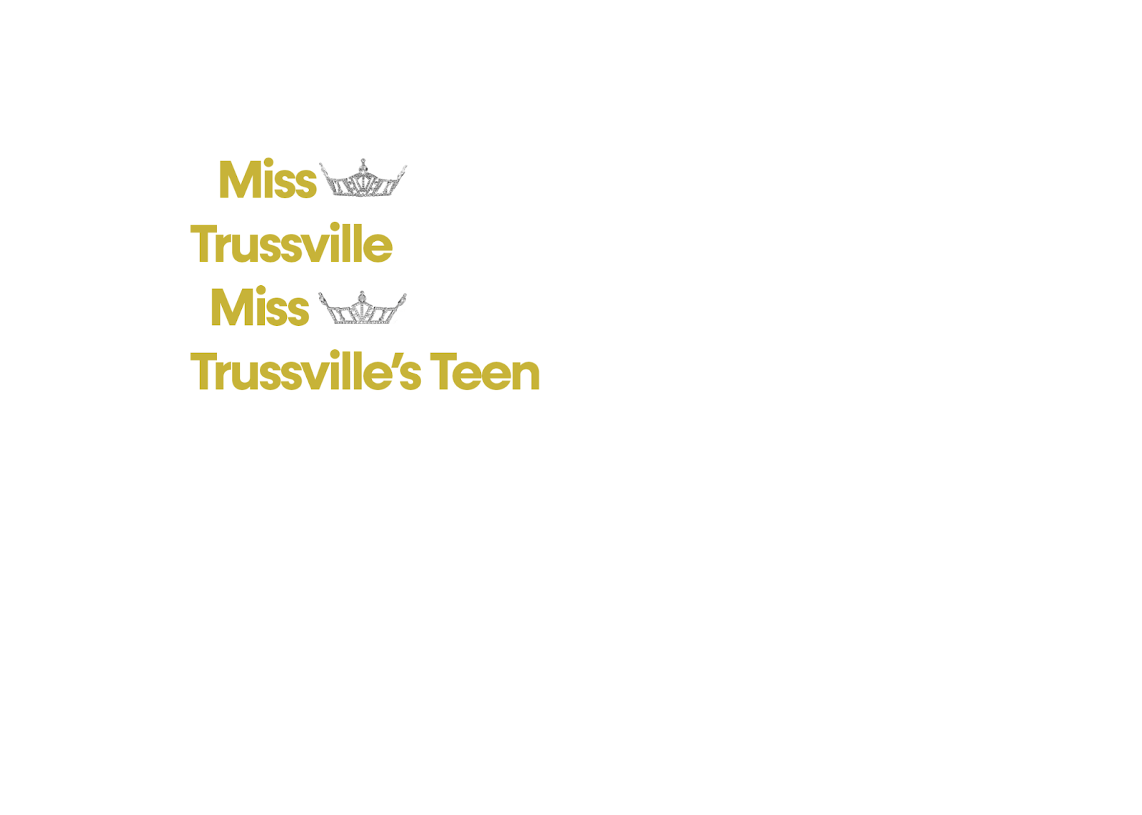
Welcome to the Miss Trussville & Miss Trussville’s Teen competition. We are excited to have you as a contestant and are looking forward to meeting you! Our preliminary will be held on Saturday, July 11th at 5pm at Hewitt-Trussville Middle School. Tickets will be $20 ($10 for current titleholders & former Trussville titleholders) payable via Venmo or cash.

Contacts
- Directors: Christy Taylor & Sherry Pair
- Email: misstrussvillemao@gmail.com
- Cell: 205.368.7889/205.746.5758
Competition

- Venue: Hewitt-Trussville Middle School
5275 Trussville Clay Road
Trussville, AL 35173
- Tentative arrival time: 9AM
- Detailed itinerary will be sent the week of competition

Competition Details

- Theme: Barbie!
- Opening Number- Pink outfit/top/ dress of your choice
- On Stage Conversation 10%- while in opening number outfit/dress
- Health & Fitness 20% – Contestants MUST wear Red athletic wear.
  - Rebel Athletic Wear is required for State Competitions and can be purchased from the following website: https://rebelathletic.com/collections/curated-styles-for-miss-america-organization.
  - Your fitness introduction (2-3 sentences on why/how you are heart healthy) will be read on stage during your upbeat modeling walk.
- Talent/HERStory 20%
- Evening Gown “Red Carpet” 20%
- Private Interview 30% - Both Miss and Teen contestants will have a 10 minute interview. Contestants will begin their interview with a 30 second opening of their choice. After 30 seconds, questions will begin. When time is called, there will be 30 seconds for a closing statement.

Important Details
*Every Contestant must complete the full registration process with Miss America via:
https://www.club.missamerica.org/ma-membership
(annual $49.99 subscription fee to the MAO)
*Once registered, you must also register for our LOCAL pageant here:
https://www.club.missamerica.org/club-membership
*Once completed you will receive detailed instructions for Spotfund. All contestants must raise $30 per local preliminary for the American Heart Association prior to the local competition.

Paperwork

Deadline to receive documents is Sunday, July 5th
- Email
  - Interview Fact Sheet
  - Community Service Essay
  - Headshot Photo
  - Copy of Birth Certificate
  - Talent Music (Mp3 or Mp4 format)
  - Contestant Information Sheet (signed & dated)
  - Eligibility Documents (i.e. copy of Driver's License, lease/utility bill, transcript, etc.)
  - Local Contract (signed)

- Venmo or Mail
  - $50 No Show fee mailed or Venmo @MissTrussville
    - this will be returned/refunded to you at the preliminary
*Mail to: Christy Taylor
85 Gin Street
Springville, AL 35146

- Required items you MUST bring on competition day
  - Certified Birth Certificate
  - Backup Talent CD/copy on your device
Pageant Day

- Teens arrive interview ready (you will have time to change and freshen up)
- Wear comfortable clothes when you arrive
- Parents and friends MUST leave after helping unload (no parent meeting)
- No contestants may leave the venue during competition day
- Dressing Room moms will be available to assist you throughout the day
- All meals, water & snacks will be provided
- Label anything that you wish to keep – any items left without a label cannot be returned. If you realize an item has been left after the competition, please email the director promptly.
- We will have a limited number of power strips, garment racks and full-length mirrors. You are welcome to bring your own.

