HUMC Connections
Women’s Coffee Klatch meets weekly Wednesday at 10 a.m.
Men’s group meets every Wednesday at 6 p.m.
Prayer Meeting held every Sunday at 8:30 a.m.
Potluck the last Sunday of every month (Dec 28th is the next one)
United Women of Faith Christmas dinner Dec 6th at Hub Central contact Arlene(269-449-2127) if you are going.
Community Outreach
AA meets every Monday and Thursday 8 p.m.
Food Pantry Thursday 4-7pm: Need donations and collecting macaroni and cheese, soup and tuna. Last week we served 225 families. If you would like to be a part of this mission please contact the church office.
Backpack Mission: We prepared and delivered 93 bags to Redwood this week.
Dec 5th Hartford Movie Night 6 pm “The Best Christmas Pageant Ever”
Dec. 6th, Saturday, Christmas in Hartford at 6 pm parade
Dec. 22, Monday, Blue Christmas Service at 6 pm here at Hartford
Dec 24th Christmas Eve Service will be 4 pm here and 7 pm at Lawrence UMC

Time, Talents and Treasures
Ways to give: Donate via Venmo, Vanco, PayPal, also Reoccurring Bill Pay through your bank

Harding’s: Please collect your points and give back to the Cooperating Ministries

Service opportunities: senior lunches, cleaning, gardening, maintenance, greeters

Office Phone: 269.621.4103

Pastor Doug Tipken
Cell: 269-873-0014
E-mail: pastordougumc@gmail.com
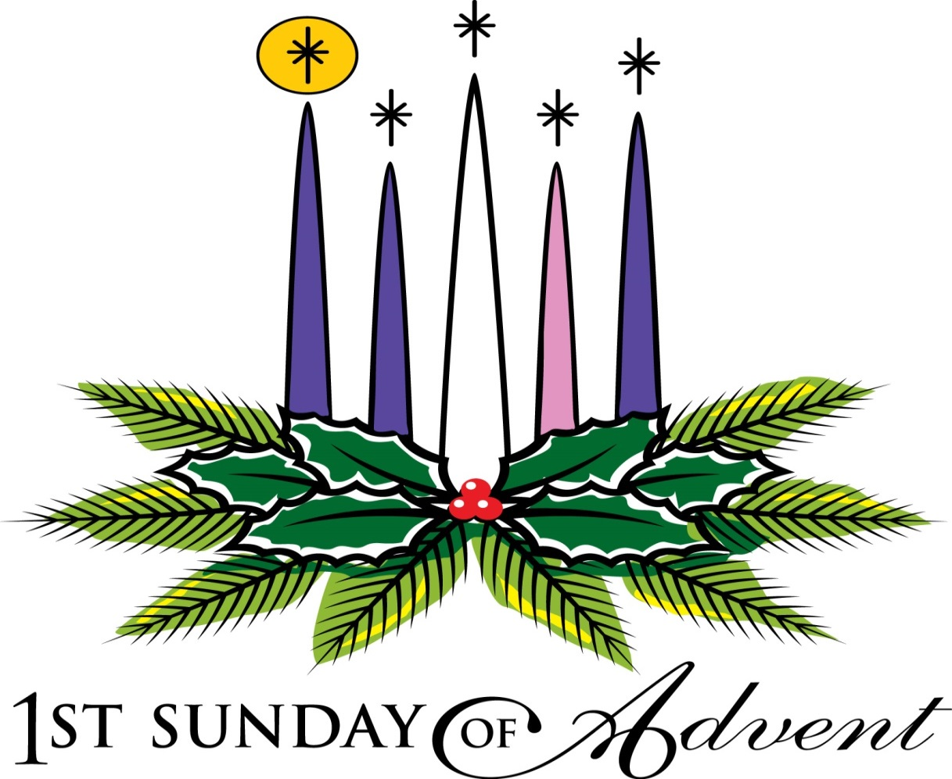

Hartford United Methodist Church
425 E. Main Street, Hartford, MI 49057
Office: 269.621.4103 Email: hartfordmethodist@gmail.com

Pastor Doug Tipken
Cell: 269-873-0014 E-mail: pastordougumc@gmail.com

Office Hours: Monday- Friday 9 to 12 pm

Hartford United Methodist Church

November 30, 2025

The Hanging of the Greens

Welcome

Song: “O Come, O Come Emmanuel” #211 Hymnal
“All Earth is Waiting” #210 Hymnal

The Bible bearer is Larry Woodley

*Responsive Reading
*The people standing as able. Congregational responses are in bold.
* Based on Genesis 1:1-5

Leader: In the beginning when God created the heavens and the earth, the earth was a
formless void and darkness covered the face of the deep

People: A wind from God swept over the face of the waters. Then God said, “Let
there be light.”

Leader: And there was light. And God saw that the light was good.

People: God separated the light from the darkness. God called the light Day, and
darkness He called Night.

All: And there was evening and there was morning, the first day.

“O Come, All Ye Faithful” (Verses 1, 2, 3) #234 Hymnal
Candles are carried by Arlene Alsup, Cheyana Talmage

Acolytes Becky Woodley

“It Came Upon a Midnight Clear” #218 Hymnal

Wreath is carried by Jeff Heuser

Greens are placed by: Jeff Heuser, Rich Hunt, Myra Weberg, Bill Schuler

Prayer of the People:

Gracious God, we pause from our busyness and our waiting to worship you this day. We admit it is difficult to wait, especially when we are excited. Help us to open our hearts and ready ourselves to be used by you to serve others, just as Mary was ready. In Christ’s name we pray. Amen.

Advent Candles

Reader 1: Susie McGowan

Congregation: Today, we choose to live in hope, believing that the time of God’s reign has come and is coming among us.

Reader 2: Autumn Schmaltz

(Butch and Sandy Drumm lights the 1st candle during the second reading)

Decorating the Tree All are invited to come forward to hang the Chrisoms

Songs “Hark the Herald Angels Sing” #240 Hymnal
“The First Noel” (Verses 1 & 2) #245 Hymnal

Message Pastor Doug

Song: “What Child Is This” #219 Hymnal

Nativity carried forward by Rick Anthony, Betty Krell, Roger and Holly Danneffell

Song: “Joy to the World” #246 Hymnal

Closing Prayer Pastor Doug

