**Welcome to the**

**Hartford United Methodist Church**

**Epiphany Sunday January 2, 2022**

**Welcome**

**Announcements (on Screen)**

**Songs: We Three Kings Hymnal 254**

**Tis So Sweet To Trust In Jesus Hymnal 462**

**Opening Prayer Pastor Doug Tipken**

**Scripture Isaiah 43:18-19 Arlene Alsup**

**Message “New Year – New Beginning” Pastor Doug**

**Presenting Our Tithes, Offerings, and Commitments**

**Doxology**

**Prayer/Lord’s Prayer**

**Communion:**

**Song: Amazing Grace/My Chains are Gone Screen**

**Here I am Lord Hymnal 593**

**Benediction**



Our Mission is to make disciples of Jesus Christ for the transformation of the world.

**HUMC News & Information 1/2/22**

* **ATTENDANCE:** In Person – Christmas Eve 7 pm -54

Christmas Eve 11 pm -24

Sunday 10 a.m. - 40

* **BUDGET:** Needed Weekly: $3827

Collected 12/26 $ 944.66

* **FOOD PANTRY:** Need donations and **c**ollecting macaroni and cheese, soup and tuna. 12/23 75 families served because it was Thanksgiving
* **BACKPACK MISSION**: filling 0 bags which fed 0 students. If you can help contact the office.
* **Harding’s**: When you shop please use 269-621-4103 and a percentage of your bill will come back to the church.
* **OFFERING/GIVING NEWS:** Give via Venmo, Vanco, PayPal, credit or debit, also Reoccurring Bill Pay through your bank (There is no fee for you or the church; it can be automatic or one time). Contact Robin, in the Office for Details.
* **Men’s group** meets weekly on Wednesday Night at 6:00 p.m.
* **Backpack teams** pick up the new calendar from Nancy
* **Starting Feb 6th**  Adult Education Class 8:45-9:45 Sundays for five weeks. “I Love my Church” please sign up starting today.
* **Please stay after church today for a few minutes and help us take down Christmas.**



**Office Hours: Monday–Friday, 9-2 p.m.**

**425 E. Main Street, Hartford, MI 49057**

**Office Phone: 269.621.4103**

**Email: hartfordmethodist@gmail.com**

**Prayer Chain Contact:**

**Email: humcprayerchain@gmail.com**

**Call or Text: 802.949.0577**

**Website: hartfordumc.org**

Our Mission is to make disciples of Jesus Christ for the transformation of the world.

**Melissa Nelson, 4**

**Lindsy Morsaw, 8**

**Doug Nelson, 9**

**Matt Geer, 9**

**Prayer Wall (Addresses can be obtained in the office)**

**Ramon Beltron Barb Huffman**

**Cindy Birmele Patsy Kolhoff**

**Mary Birmele Carolyn Martin**

**Jim Cobianco Delores Miller Lynne Cobianco Dwight Peters**

**Lois Dickhaut-Furzey Maci Ray Rosen Ruth/Eugene Gatchell Caryl Snider**

**Anna Hudson Dick Showerman**

**Leon Hudson Jimmy Stone**

**Gale Weberg**

**Office Phone: 269.621.4103**

**Email: hartfordmethodist@gmail.com**

**Prayer Chain Contact:**

**Email: humcprayerchain@gmail.com**

**Call or Text: 802.949.0577**

**Website: hartfordumc.com**

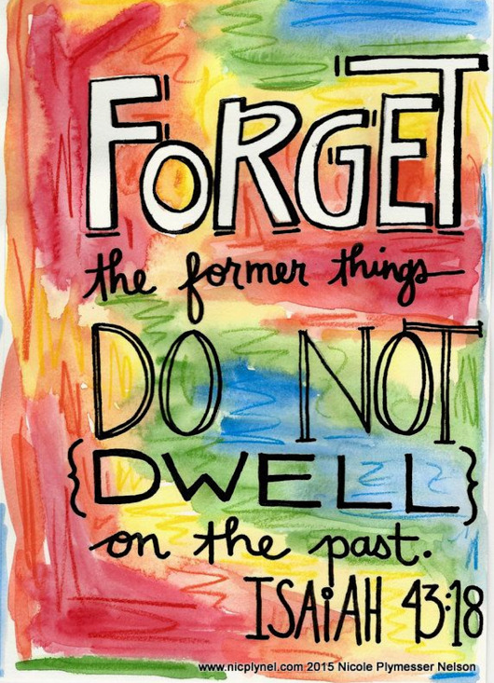

**Isaiah 43:18-19**

**Pastor Doug Tipken**

**425 E. Main Street, Hartford, MI 49057**

**Cell: 269-873-0014**

**E-mail:** [**pastordougumc@gmail.com**](mailto:pastordougumc@gmail.com)

**Pastor Office Hours 9-2 M- Th. or prearranged**

**Social Sites**

**Facebook: The Bridge at Hartford UMC or Hartford UMC**

**Twitter: The Bridge at Hartford UMC**

**Instagram: The Bridge at Hartford UMC**

**Yelp: Hartford United Methodist Church**