Welcome to the
Hartford United Methodist Church
Third Sunday after Pentecost June 26, 2022

Welcome

Announcements (on Screen)

Songs: God of Grace and God of Glory Hymnal 577
Lord, Listen to Your Children Praying F.W.S. 2193

Opening Prayer Pastor Doug Tipken

Scripture Luke 18: 1-7

Message “The Power of Persistent Prayer” Pastor Doug

Presenting Our Tithes, Offerings, and Commitments
Doxology
Prayer/Lord’s Prayer

Song: In Moments Like These Screen
Spirit Song Hymnal 347

Benediction

Our Mission is to make disciples of Jesus Christ for the transformation of the world.

HUMC News & Information 6/26/22
- ATTENDANCE: In Person – 38

- BUDGET: Needed Weekly: $3058.73
Collected 6/19 $ 1610.49

- FOOD PANTRY: Need donations and collecting fruit and cereal. 6/16 98 families served

- Harding’s: When you shop please use 269-621-4103 and a percentage of your bill will come back to the church.

- OFFERING/GIVING NEWS: Give via Venmo, Vanco, PayPal, credit or debit, also Reoccurring Bill Pay through your bank (There is no fee for you or the church; it can be automatic or one time). Contact Robin, in the Office for Details.

- Wednesday Coffee Klatch All Women are welcome to join the Coffee klatch at 10:30 a.m. every Wednesday. This will be a time for Devotion, prayers and socializing

- Men’s group meets weekly on Wednesday Night at 6:00 p.m.

- Sunday, June 26th, Breakfast After Church today

- Tuesday, July 12th at 11 a.m. Worship Committee meeting

- Thursday, July 28th Red Cross drive 11-5 in the AA room

Office Hours: Monday–Friday, 9-2 p.m.
425 E. Main Street, Hartford, MI 49057
Office Phone: 269.621.4103
Email: hartfordmethodist@gmail.com
Prayer Chain Contact:
Email: humcprayerchain@gmail.com
Call or Text: 802.949.0577
Website: hartfordumc.org

Our Mission is to make disciples of Jesus Christ for the transformation of the world.
Dale Kaucher, 27
Rebecca Heffner, 27
William Weeden, 29
Robert Kuehnle, 1
Harold Walker , 2

Prayer Wall (Addresses can be obtained in the office)
Ramon Beltron Barb Huffman
Cindy Birmele Patsy Kolhoff
Jeff Briney Doug Nelson
Jim Cobianco Carolyn Martin
Lynne Cobianco Delores Miller
Lois Dickhaut-Furzey Betty Molter
Maci Ray Rosen Dwight Peters
Max/Eugene Gatchell Caryl Snider
Anna Hudson Claude Snider
Leon Hudson Jimmy Stone
Office Phone: 269.621.4103
Email: hartfordmethodist@gmail.com
Prayer Chain Contact:
Email: humcprayerchain@gmail.com
Call or Text: 802.949.0577
Website: hartfordumc.com

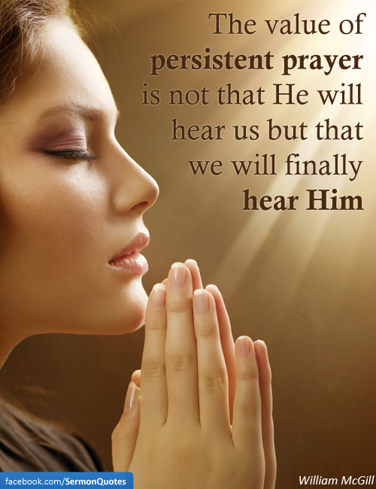

Luke 18: 1-7

Pastor Doug Tipken
425 E. Main Street, Hartford, MI 49057
Cell: 269-873-0014
E-mail: pastordougumc@gmail.com
Pastor Office Hours 9-2 M- Th. or prearranged

Social Sites
Facebook: The Bridge at Hartford UMC or Hartford UMC

Twitter: The Bridge at Hartford UMC

Instagram: The Bridge at Hartford UMC

Yelp: Hartford United Methodist Church

