**Welcome to the**

**Hartford United Methodist Church**

**14th Sunday after Pentecost August 29, 2021**

**Welcome**

**Announcements (on Screen)**

**Songs: Come As You Are**

**The Father’s House**

**Opening Prayer**

**Message:“Are We Ready For Our Promised Land?” Pastor Doug**

**Scripture: Joshua 1:1-9**

**Presenting Our Tithes, Offerings, and Commitments**

**Doxology**

**Prayer/Lord’s Prayer**

**Song: How Firm A Foundation Hymnal 529**

**Trust and Obey Hymnal 467**

**Benediction**

Our Mission is to make disciples of Jesus Christ for the transformation of the world.



**HUMC News & Information 8/29/2021**

* **ATTENDANCE:**  In-Person: 47

* **BUDGET:** Needed Weekly: $3413.46

Collected 8/22 $ 1890.67

* **FOOD PANTRY:** Need donations and **c**ollecting macaroni and cheese, soup and tuna. 8/19 over 49 families were served.
* **Harding’s**: When you shop please use 269-621-4103 and a percentage of your bill will come back to the church.
* **OFFERING/GIVING NEWS:** Give via Venmo, Vanco, PayPal, credit card, or debit , also Reoccurring Bill Pay through your bank (There is no fee for you or the church; it can be automatic or one time). Contact Robin, in the Office for Details.
* **College Students:** If you know of any college students that are connected to our church please let Nancy know because the district is trying to compile a list of them.
* **Meeting today after worship about communication of finances, facilities, and a second worship.**
* **Finance Team Meeting** on Tuesday August 31st at 7 p.m**.**



**Dylan Kuehnle, 30**

**Searra Kinchen, 2**

**David Kling, 2**

**Bernice Rudell, 3**

**Alyvia Williams, 4**

**Prayer Wall (Addresses can be obtained in the office)**

**Barbara Blacksten Leon Hudson**

**Ramon Beltron Barb Huffman**

**Cindy Birmele Patsy Kolhoff**

**Mary Birmele Linda Jennings**

**Jim Cobianco Carolyn Martin Lynne Cobianco Dwight Peters**

**Jeanette DeLoach Maci Ray Rosen Lois Dickhaut-Furzey Caryl Snider**

**Anna Hudson Dick Showerman**

**Bill Weeden**

**Office Phone: 269.621.4103**

**Email: hartfordmethodist@gmail.com**

**Prayer Chain Contact:**

**Email: humcprayerchain@gmail.com**

**Call or Text: 802.949.0577**

**Website: hartfordumc.com**

**Pastor Stephanie Norton**

**425 E. Main Street, Hartford, MI 49057**

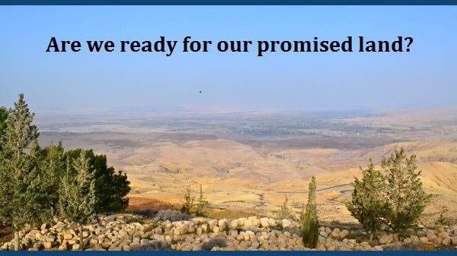

**Joshua 1:1-9**

**Pastor Doug Tipken**

**425 E. Main Street, Hartford, MI 49057**

**Cell: 269-873-0014**

**E-mail: pastordouglasumc@gmail.com**

**Pastor Office Hours 9-2 M- Th. or prearranged**

**Social Sites**

**Facebook: The Bridge at Hartford UMC or Hartford UMC**

**Twitter: The Bridge at Hartford UMC**

**Instagram: The Bridge at Hartford UMC**

**Yelp: Hartford United Methodist Church**