Welcome to the
Hartford United Methodist Church
9th Sunday after Pentecost July 25, 2021

Welcome
Announcements (on Screen)
Songs: They Will Know We Are Christians By Our Love
When Death was Arrested

Opening Prayer/Lord’s Prayer
Message “What is community” part III Pastor Doug
Sin in the Church
Scripture Matthew 18:15-20

Song: Living Hope
Great Are You Lord
Benediction

Our Mission is to make disciples of Jesus Christ for the transformation of the world.

Weekly Prayer requests
Healing prayers for Garry Melvin.

Prayers for Lois Dickhaut-Furzey- she had her hip replaced on Friday.

T. J. asked for unspoken prayers.

Autumn’s friend Margo is dealing with a brain tumor.

Travel mercies for Larry and Becky as they head up north and Larry’s son as they travel south.

Prayers for a friend of Pastor Doug who had a death in the family.

Prayers for a youth with Asperger who tried to commit suicide.

Prayers for Judy who lost her family pet and is having a hard time emotionally.

Prayers for Deanna on the loss of her aunt.

HUMC News & Information 7/25/2021
- ATTENDANCE: In-Person: 43

- BUDGET: Needed Weekly: $3413.46
Collected 7/18 $ 2187.62

- FOOD PANTRY: Need donations and collecting macaroni and cheese, soup and tuna. 7/15 over 47 families were served.

- BACKPACK MISSION: If you can help contact Marcia Kelley. We filled 15 bags this past week which fed 60 children.

- Harding’s: When you shop please use 269-621-4103 and a percentage of your bill will come back to the church.

- OFFERING/GIVING NEWS: Give via Venmo, Vanco, PayPal, also Reoccurring Bill Pay through your bank (There is no fee for you or the church; it can be automatic or one time). Contact Robin, in the Office for Details.
- Thursday & Friday July 29th & 30th -We along with the Bible church will be hosting a recycle event. The Hartford Lions club will have a trailer here and you can bring items to be recycled. There will be a small fee for tires and TV/monitors.

- Tuesday August 3rd: United Methodist Women will be having their Picnic potluck at Tammy Kling’s house (8867 red Arrow Highway, Watervliet) at 6:30 p.m. Table ware and drinks will be provided. Just bring a dish to pass. All women are invited for a time of fellowship.

Dan Fitch, 28
Ronda Kaucher, 29

Prayer Wall (Addresses can be obtained in the office)
Barbara Blacksten Leon Hudson
Ramon Beltron Barb Huffman
Cindy Birmele Patsy Kolhoff
Mary Birmele Carolyn Martin Jim Cobianco Dwight Peters
Lynne Cobianco Maci Ray Rosen Jeanette DeLoach Caryl Snider
Lois Dickhaut-Furzey Dick Showerman
Anna Hudson Bill Weeden

Office Phone: 269.621.4103
Email: hartfordmethodist@gmail.com
Prayer Chain Contact:
Email: humcprayerchain@gmail.com
Call or Text: 802.949.0577
Website: hartfordumc.com

Pastor Stephanie Norton
425 E. Main Street, Hartford, MI 49057

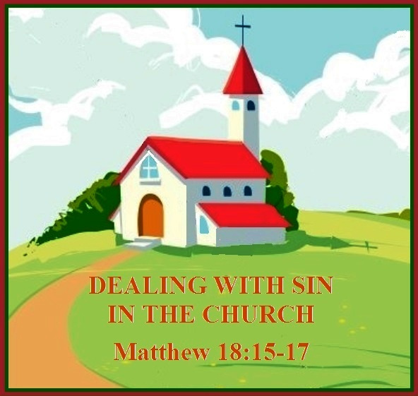

Matthew 18:15-20

Pastor Doug Tipken
425 E. Main Street, Hartford, MI 49057
Cell: 269-873-0014
E-mail: pastordouglasumc@gmail.com
Pastor Office Hours 9-2 M- Th. or prearranged

Social Sites
Facebook: The Bridge at Hartford UMC or Hartford UMC

Twitter: The Bridge at Hartford UMC

Instagram: The Bridge at Hartford UMC

Yelp: Hartford United Methodist Church

