SHARON POLICE DEPARTMENT
April 2021
ADMINISTRATIVE REPORT

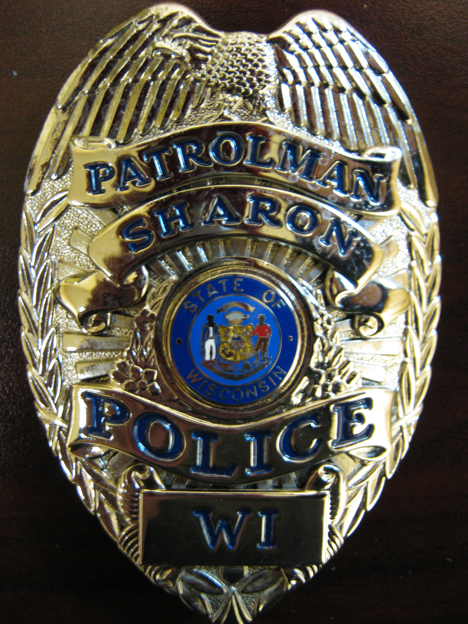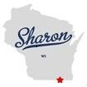

■ We have had some Covid concerns where officer’s kids are testing positive for Corona. I
have advised the Village Admin. and after tests are complete, we will know if there is some
quarantining that needs to occur.

■ Squad #2 received a used engine last week. (engine has 66,000 miles with 1 year warranty)

■ Kunes Ford advised that the new squad car should arrive around the 3rd week of April.

■ Officer Diderich and Chief Buchholz responded to a Rescue Call last week where a young
male adult may have overdosed. Officers performed Call and Pump (CPR) for
approximately 6-8 minutes and administered Narcan. The subject, who was later listed as
flatlined by EMT’s, came back and to my understanding has made a full recovery. (Charges
may be forthcoming)

■ The PD is aware of the passing of the new state liquor law “Drinks to Go” that allows
restaurants and taverns to distribute liquor in packaging that you can carry out of the
establishment. Follow this link for more information.
http://a.msn.com/06/enus/BB1f4eaJ?ocid=se

■ Matthew Davis is doing well at the Academy and continues to score high marks in his class.
Matthew is continuing to do rid- a-longs with our department on his spare time on
weekends.

■ The Department has listed part time openings on WILENET in hopes we can cover the
numerous open shifts we are experiencing.

■ The PD will be having its annual departmental meeting this Friday. We will be recertified in
CPR and then going over important agency matters later in the afternoon. Anyone that
wants to stop by after 12 pm and ask questions of the officers are more than welcomed.

■ 632 recorded Calls of Service for Month of March.

■ There were no major calls for service during Easter weekend.

■ Training: Officers: CPR Training
Officers: Firearms Training

■ Vehicle Mileage: SUV 1 (2017) 75,915 Miles SUV 2 (2014) 109,652 original Miles (now 66,000)
■ Social Media: Facebook: 3,096 “Followers”
.

