FILOSOFIA DAS VIRTUDES

All 5 Virtue Tiers vs. The World's Sacred Traditions
Virtude de Essência · Virtudes de Fundação · Virtudes de Edificação · Virtude de Proteção · Virtude do Divino

■ Virtude de Essência
■ Virtudes de Fundação
■ Virtudes de Edificação
■ Virtude de Proteção
■ Virtude do Divino

Compared against: Christianity · Islam · Judaism · Buddhism · Hinduism · Confucianism

Based on: José Caetano de Mattos — Filosofia das Virtudes: Manifesto das Virtudes (Rio de Janeiro, 2023)
Comparative Report — March 2026

1. Executive Summary
This report compares all five tiers of the Filosofia das Virtudes (FdV) virtue hierarchy — Virtude de Essência (Freedom), Virtudes de Fundação (12 Foundation Virtues), Virtudes de Edificação (86 Building Virtues), Virtude de Proteção (Right to Bear Arms), and Virtude do Divino (Critical Thinking / Unveiling) — against six major world religious traditions.
The earlier versions of this report covered only Foundation and Building virtues. This edition adds the full comparison including the three most philosophically distinctive FdV tiers: Essência, Proteção, and Divino — the tiers where FdV most clearly extends beyond classical religious virtue ethics.
Key findings across all 5 tiers:
- Virtude de Edificação (Building): Highest convergence across all traditions (avg 8.4/10). Buddhism leads at 9.0, Hinduism at 8.8. This is the most universal tier.
- Virtude de Fundação (Foundation): Second highest (avg 8.5/10). Islam leads at 8.8, Judaism at 8.7. Near-universal convergence on Love, Justice, Honesty, Life, and Courage.
- Virtude do Divino (Unveiling): High convergence (avg 7.8/10). Buddhism (9.0) and Hinduism (8.5) show strongest alignment. This tier is FdV's most distinctive convergence with Eastern spirituality.
- Virtude de Essência (Freedom): Moderate convergence (avg 6.8/10). Buddhism (8.5) and Hinduism (7.5) are closest — through Moksha/Nirvana = ultimate inner liberation. Confucianism is lowest (5.5).
- Virtude de Proteção (Arms): Lowest convergence (avg 4.3/10) and highest variation. Judaism (6.0) and Islam (5.5) score highest via self-defence law and jihad doctrine. Buddhism scores 2.0 — direct conflict with Ahimsa.
"The Protection Virtue is the Guardian of Freedom and all other Virtues." — Mattos, 2023. This tier is FdV's most politically radical departure from classical religious virtue ethics.

2. FdV — The 5-Tier Virtue Hierarchy
The Filosofia das Virtudes proposes exactly 101 Universal Human Virtues organised in five hierarchical tiers. Each tier is a precondition for the next: without Freedom (Essência), all other virtues collapse; without Foundation, Building virtues have no ground; without Protection, Freedom itself is unguaranteed; without the Divine (Desvendar), wisdom cannot reach its apex.

Tier | FdV Designation | Content | Role in hierarchy | Distinct colour
I | Virtude de Essência | Liberdade (Freedom) | The Elementary Virtue — precondition of all others | ■ Deep Green
II | Virtudes de Fundação | 12 virtues: Love, Courage, Justice… | Structural pillars — foundation of the human person | ■ Blue
III | Virtudes de Edificação | 86 virtues: Compassion, Wisdom, Peace… | Building dimensions of human fullness and potential | ■ Purple
IV | Virtude de Proteção | Porte de Armas (right to bear arms) | Material guarantee of Freedom and all other virtues | ■ Amber-Brown
V | Virtude do Divino | Desvendar (critical thinking/unveiling) | Supreme elevation: wisdom, illumination, nirvana | ■ Teal

3. The Three Distinctive Tiers — In Depth

3.1 Virtude de Essência — Liberdade (Freedom)
"Freedom is the Elementary Virtue, the Element. All other Virtues are composed of Freedom. Without it, all other Virtues are subjugated, lose their meaning, succumb, weaken, fall, reduce themselves, kneel." — Mattos, 2023.
FdV is unique among philosophical and religious virtue frameworks in elevating Freedom to the status of the single foundational virtue — the condition of possibility for all other virtues. No sacred text makes this explicit claim in this form. However, this report shows that the concept exists in all six traditions, expressed as inner liberation, free will, or the purpose of the spiritual path itself.
Freedom in FdV encompasses: freedom of thought, expression, movement, religion, work, family formation, property ownership, self-defence, health decisions, and most importantly, inner spiritual freedom. It is the virtue that makes all other virtues voluntary — and therefore genuinely virtuous — rather than coerced.
- Christianity: Free will (Autexousion) is theologically essential for sin and salvation. But institutional Church structures historically constrained some expressions. The Reformation was itself a freedom movement.
- Islam: Ikhtiyar (choice) + Islam (submission). The highest freedom is submission to God — a paradox that resonates with FdV's inner freedom. Outer freedom less emphasised than inner freedom.
- Judaism: The Exodus is the paradigmatic freedom narrative of Western civilisation. The covenant presupposes a people capable of free choice. Free will is a cornerstone of Jewish theology (Maimonides).
- Buddhism: Highest alignment (8.5). Liberation (Vimutti, Nirvana) IS the entire purpose of the path — the ultimate inner freedom from craving, delusion, and hatred. FdV's "inner freedom" is Buddhist liberation.
- Hinduism: Moksha (liberation from samsara, the cycle of rebirth) is the highest of the four life aims (Purusharthas). Atman's essential nature IS free. Very high alignment with FdV's inner freedom.
- Confucianism: Lowest (5.5). Freedom is not a primary virtue concept. The Junzi achieves self-cultivation within social roles, not freedom from them. Political liberty is absent as a virtue category.

3.2 Virtude de Proteção — Porte de Armas
"The Protection Virtue aims at the care, protection, and defence of the Virtues of Essence, Foundation, Building, and the Divine. It is the guarantee of the maintenance and development of Freedom and its derived Virtues." — Mattos, 2023.
This is the most controversial, politically distinctive, and academically novel tier in FdV. No classical virtue ethics — Greek, Christian, Islamic, Jewish, Buddhist, Hindu, or Confucian — systematically elevates armed self-defence to the status of a cardinal virtue. FdV's argument is structural: all virtues depend on Freedom; Freedom can be destroyed by tyranny; only an armed citizenry can protect against tyranny; therefore armed self-defence is a virtue.
The comparison reveals the greatest diversity of any tier:
- Judaism (6.0): The most explicit convergence. Rodef law (duty to use lethal force to stop a pursuer) and the Maccabean armed resistance to Hellenistic tyranny (celebrated in Hanukkah) create genuine doctrinal alignment. Self-defence is a halachic obligation.
- Islam (5.5): Second highest. Quranic permission for armed resistance to oppression (Quran 22:39-40). Defensive jihad includes protection of life, family, property, and religion against aggressors. Community protection as collective armed duty.
- Christianity (4.5): Just War tradition (Augustine, Aquinas) permits armed defence under strict conditions. Personal self-defence permitted in natural law theology. But pacifist strand (Sermon on the Mount) creates tension. No arms-as-virtue framework.
- Hinduism (4.0): Gita's central scene — Arjuna's duty to fight — is the most famous defence of armed combat in any scripture. But Kshatriya warrior virtue is caste-specific, not universal. Tension with Ahimsa (non-harm).
- Confucianism (3.5): Ruler's duty to protect people through military means is recognised. But individual armed virtue is absent. The Junzi does not bear arms as a moral practice.
- Buddhism (2.0): Lowest by far. Ahimsa (non-harm) is near-absolute. Killing is the gravest violation of the First Precept. Some Mahayana warrior-bodhisattva traditions exist marginally, but armed self-defence as virtue is fundamentally incompatible with Buddhist ethics.

3.3 Virtude do Divino — Desvendar (Unveiling / Critical Thinking)
"The Virtue of the Divine (or of the Unknown) means to remove the blindfold, to see, to search for light, wisdom, and truth... the frontier of knowledge, the threshold of new discoveries, the supreme elevation of the spiritual man, the victory of wisdom over ignorance, nirvana, enlightenment, heaven." — Mattos, 2023.
The Divine Virtue is FdV's highest intellectual and spiritual virtue. It is not faith, not revelation, but active unveiling — the lifelong pursuit of truth through critical examination of reality, both inner and outer. Mattos connects it to the human perceptual and intellectual limits: we are like amoebas trying to understand the cosmos, and the Virtue of the Divine is the aspiration to transcend those limits.
This tier achieves the highest convergence after Foundation and Building virtues, because every major tradition has a wisdom tradition (Greek: Sophia; Christian: Sapientia; Islamic: Hikmah; Jewish: Chokhmah; Buddhist: Prajna; Hindu: Jnana; Confucian: Zhi):
- Hinduism (8.5): Supreme alignment. Jnana Yoga — the path of direct knowledge of reality — is one of the three principal yoga paths in the Gita. The Upanishads are philosophical investigations into the nature of consciousness, reality, and existence. The pursuit of Brahman-knowledge IS the Divine Virtue.
- Buddhism (9.0): Highest. Prajna (direct wisdom-insight) is the third element of the Noble Eightfold Path. The Kalama Sutta instructs practitioners to test teachings for themselves — the most explicit ancient endorsement of critical thinking as virtue. Vipassana = direct examination of experience.
- Judaism (8.0): Talmudic argumentation (Machloket l'shem shamayim — dispute for heaven's sake) is the Jewish intellectual virtue par excellence. Maimonides systematically integrated Greek reason with Torah. The tradition of sacred questioning (Why? Why? Why?) at the Passover Seder encodes critical inquiry in ritual.
- Islam (7.5): "Seek knowledge even unto China." The Islamic Golden Age (8th–13th centuries) elevated astronomy, mathematics, philosophy, and medicine as acts of divine service. Hikmah (wisdom) is one of God's attributes. The Quran repeatedly commands believers to reflect and reason (2:219, 3:191).
- Christianity (7.0): The Logos (Divine Reason) theology of John's Gospel. Anselm's "faith seeking understanding." The Catholic intellectual tradition (Aquinas synthesising Aristotle with revelation). Moderate tension: some strands resist critical inquiry.
- Confucianism (7.0): The Great Learning's programme of Gewu (investigation of things) and Zhizhi (extension of knowledge) establishes rational inquiry as the foundation of moral self-cultivation. Good but less mystical than Eastern traditions.

4. Comparative Graphics — All 5 Tiers

Figure 1 — Radar: All 5 FdV Tiers vs. All 6 Traditions
The radar chart has exactly five axes — one per FdV tier. The dashed green circle at radius 10 is the FdV benchmark. Each tradition's polygon reveals its distinctive "virtue shape." Note the collapse toward the centre on the Protection axis (bottom-left), reflecting universal lower alignment with armed-citizen virtue.
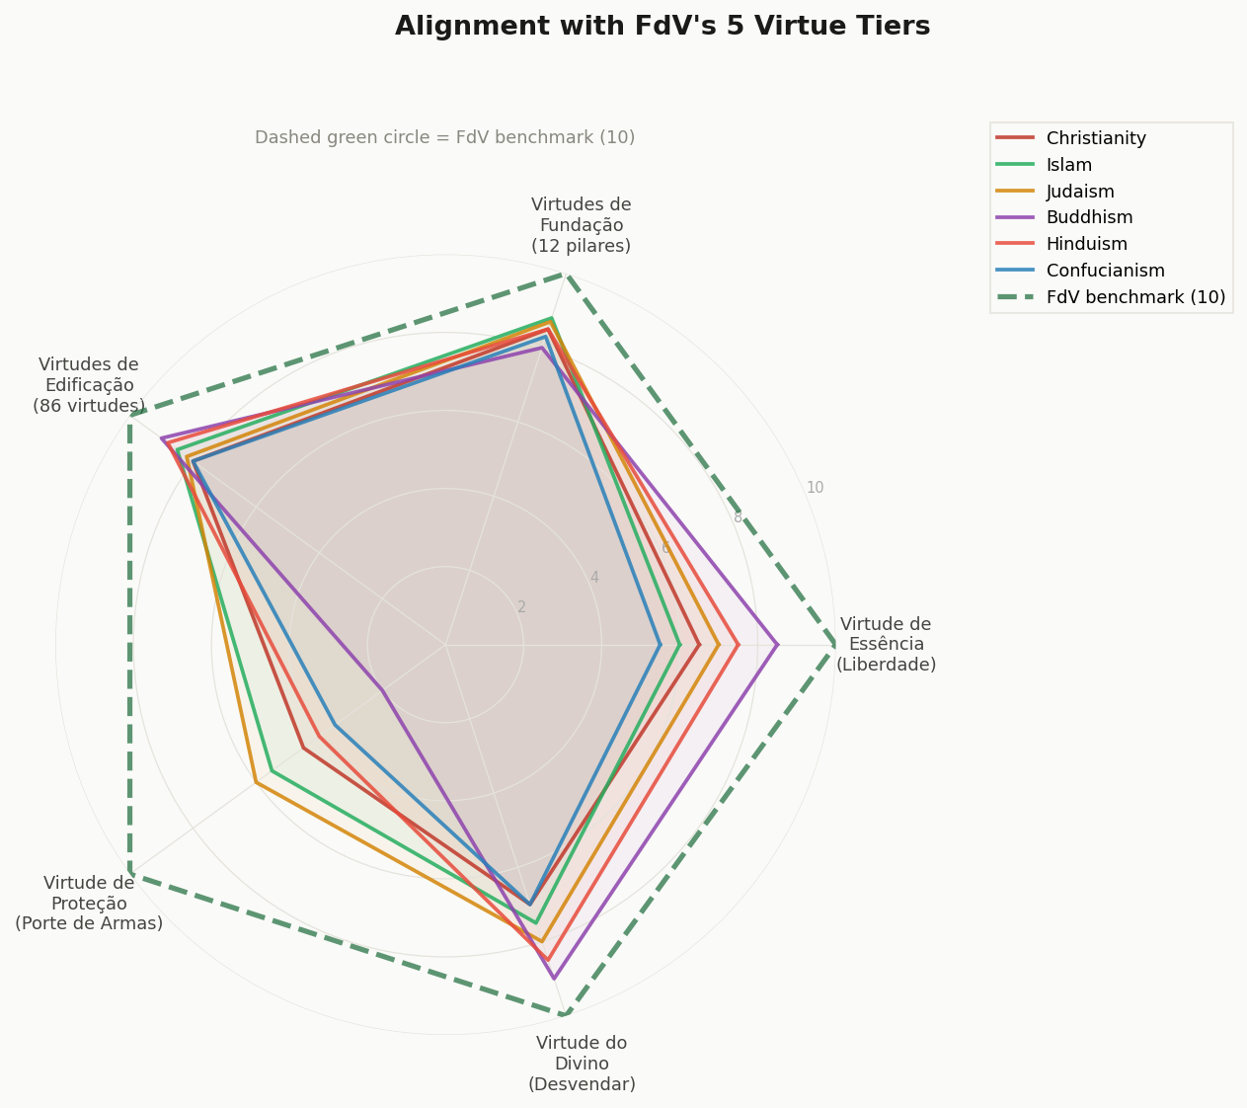
Figure 1 — Radar: 5 FdV tiers as axes (Essência, Fundação, Edificação, Proteção, Divino). Buddhism's polygon is nearly circular except for the deep notch at Proteção. Judaism's polygon is the most balanced. Confucianism shows the narrowest profile, with lowest scores on Essência and Proteção.

Figure 2 — Grouped Bar: Score per FdV Tier per Tradition
For each tradition, five grouped bars show the score on each FdV tier. The dashed green line marks the FdV maximum (10). The dramatic variation in the Proteção (amber-brown) bars — and the consistent height of the Edificação (purple) bars — are the most important patterns to observe.
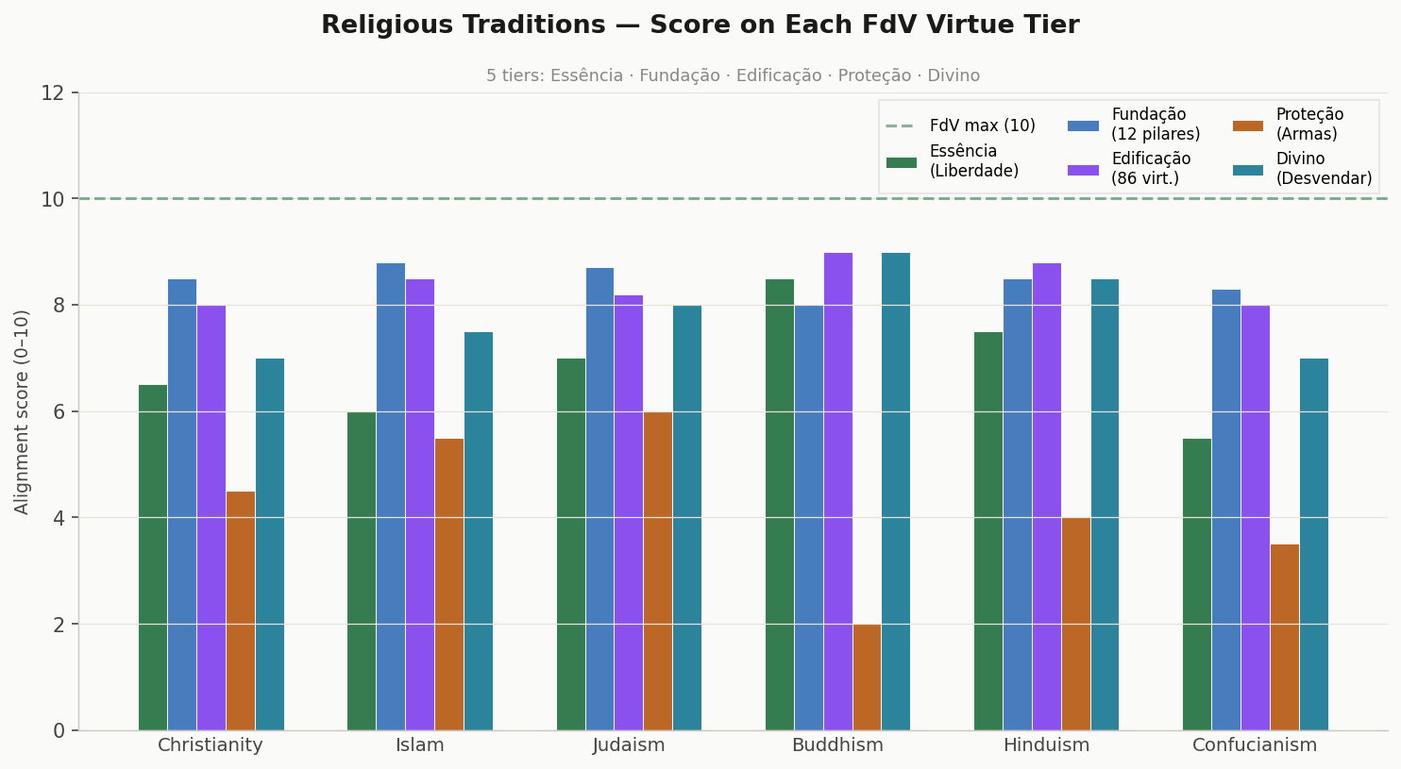
Figure 2 — Grouped bar. Edificação (purple) bars are consistently the tallest across all traditions. Proteção (amber-brown) bars show the greatest variation — from Judaism's 6.0 to Buddhism's 2.0. This chart makes FdV's uniqueness on the Protection tier visually unmistakable.

Figure 3 — Heatmap: 5-Tier Alignment Matrix
The heatmap presents the full 5×6 alignment matrix. Green intensity encodes alignment percentage. Coloured strips on the left identify each tier by its FdV colour. The Protection row stands out as the lightest (lowest alignment), while the Building row is consistently the darkest.
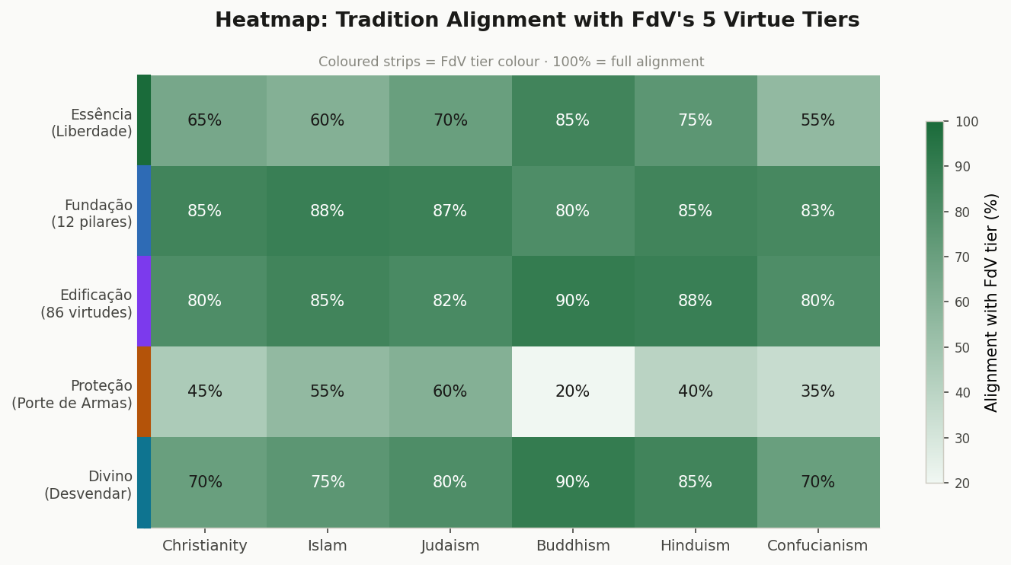
Figure 3 — Heatmap. Read row by row: Edificação (row 3) is the most uniformly dark. Proteção (row 4) is the lightest. Read column by column: Buddhism has a distinctive pattern — high on Essência, Edificação, and Divino, but very low on Proteção. Judaism is the most balanced column.

Figure 4 — Stacked Bar: Full Virtue Tier Profile
The stacked bar shows the cumulative alignment across all five tiers for each tradition, with each tier's contribution shown in its designated colour. The total score above each bar enables a quick overall ranking. The relative proportions reveal each tradition's distinctive moral "shape."
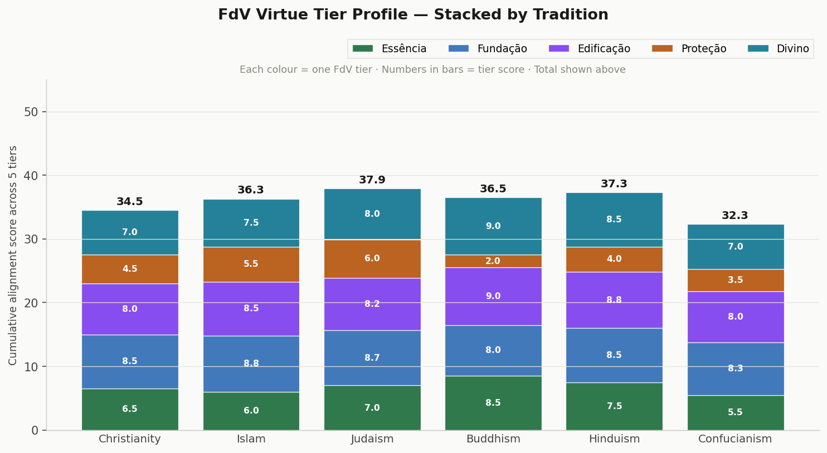
Figure 4 — Stacked profile. Judaism leads overall (37.9/50), followed by Islam (36.3/50) and Buddhism (36.5/50). Note that Confucianism's lower total (32.3/50) is driven primarily by lower scores on Essência and Proteção — not by weakness in the virtue content of its tradition.

Figure 5 — Deep Dive: Proteção and Divino Sub-Dimensions
This two-panel chart examines the two most philosophically novel FdV tiers in detail. Left panel: five sub-dimensions of the Virtude de Proteção. Right panel: five sub-dimensions of the Virtude do Divino. The contrast between the two panels is striking — the right panel (Divine) shows much higher and more consistent scores across all traditions.
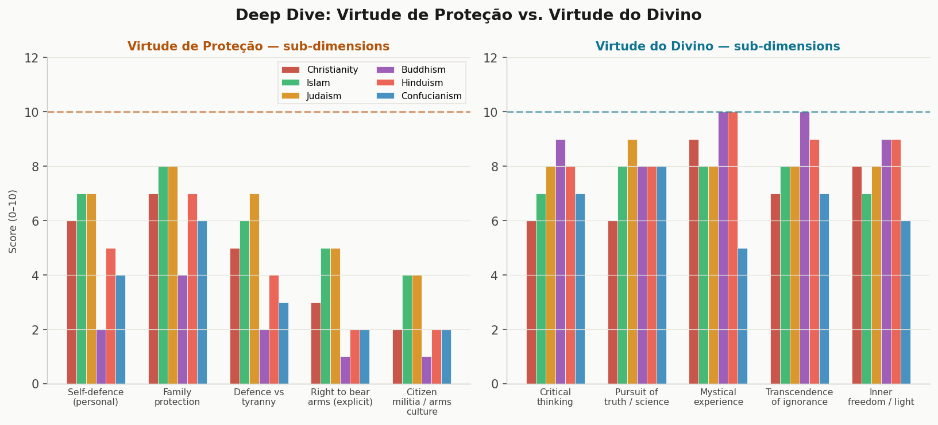
Figure 5 — Sub-dimension deep dive. Left (Protection): Judaism and Islam score highest on "Defence vs tyranny" and "Family protection." Buddhism scores near-zero across all Protection sub-dimensions. Right (Divine): Buddhism and Hinduism lead on "Mystical experience" and "Inner freedom/light," while Islam and Judaism lead on "Pursuit of truth/science."

5. Per-Tier Analysis — All 6 Traditions
The following sections provide detailed analysis for each of the five FdV tiers, with per-tradition scores and qualitative notes.

Virtude de Essência — Liberdade (Freedom)
The supreme Elementary Virtue: Freedom is the precondition of all other virtues. Without it, they are subjugated, emptied, and kneeled. It encompasses freedom of thought, expression, movement, religion, family, work, property, self-defence, and inner spiritual liberation.

Tradition | Score | Detailed alignment analysis
Christianity | 6.5 | Free Will (Autexousion) is a cornerstone theological doctrine. Individual conscience before God. Moderate: institutional Church historically constrained some expressions of freedom.
Islam | 6.0 | Ikhtiyar (free choice) is affirmed; balanced by submission (Islam = surrender) and divine decree (Qadar). Inner freedom through submission to God is the highest freedom.
Judaism | 7.0 | Exodus as the paradigmatic liberation narrative. Bechirah (free will) theologically central. Freedom is a lived covenant, not merely philosophical. Highest classical text alignment.
Buddhism | 8.5 | Highest score: Liberation (Vimutti/Nirvana) IS the supreme goal. Inner freedom from craving is the FdV "inner freedom" perfectly realised. Non-institutional, non-state religion.
Hinduism | 7.5 | Moksha (liberation) as life's ultimate purpose maps directly to FdV Freedom. Atman's essential freedom from material bondage. High alignment with inner freedom dimension.
Confucianism | 5.5 | Lowest score: freedom is role-defined and relational, not individual. The Junzi's autonomy is moral self-cultivation within social duties. Political liberty is not a virtue concept.

Virtudes de Fundação — 12 Pillars
Love · Science · Courage · Study · Family · Honesty · Justice · Free Will · Environment · Property · Work · Life. These are the structural bases of the fully human person. Without them, no Building Virtue can stand.

Tradition | Score | Detailed alignment analysis
Christianity | 8.5 | Strong across Love, Justice, Honesty, Courage, Free Will, Life. Family central. Science/Study and Environment partial; Property moderate (critique of wealth in NT). Very high overall.
Islam | 8.8 | Near-perfect on Honesty (Amanah), Justice (Adl), Work (Kasb), Life, Family, Love. Study highly valued (Ilm). Property in Fiqh. Environment growing. Highest Foundation score.
Judaism | 8.7 | Justice, Love (Chesed), Honesty (Emet), Family, Life, Study (Torah) all at maximum. Tikkun Olam adds Environment dimension. Property in law. Second highest Foundation score.
Buddhism | 8.0 | Love (Metta), Truth, Life (Ahimsa), Wisdom, Work, Free Will strong. Family less emphasised. Property (non-attachment/Aparigraha). Science moderate. Environment high (ecological ethics).
Hinduism | 8.5 | Love (Bhakti), Courage (Dhairya), Honesty (Satya), Life (Ahimsa), Work (Karma Yoga) all maximal. 26 divine virtues in Gita ch.16. Environment high. Property nuanced by non-attachment.
Confucianism | 8.3 | Justice (Yi), Family (Xiao), Honesty (Xin), Work, Love (Ren), Study (Xue) all strong. Environment moderate. Free Will partial. Property less developed as virtue concept.

Virtudes de Edificação — 86 Dimensions
The 86 Building Virtues (Adaptability, Joy, Compassion, Discipline, Gratitude, Humility, Patience, Peace, Serenity, Wisdom, Truth, Forgiveness, Integrity, Solidarity, Temperance, and many more) allow the person to build all dimensions of their unlimited creative potential.

Tradition | Score | Detailed alignment analysis
Christianity | 8.0 | Rich in Forgiveness, Mercy, Humility, Patience, Hope, Peace, Charity. Augustine and Aquinas map systematically. Some Building virtues less developed (entrepreneurship, performance, merit).
Islam | 8.5 | Sabr (Patience), Shukr (Gratitude), Hilm (Gentleness), Tawadu (Humility), Tawakkul (Trust) all maximal. Ihsan unifies all Building Virtues as excellence-in-practice. Very high.
Judaism | 8.2 | Chesed, Shalom, Anavah (Humility), Bitachon (Trust), Simcha (Joy) richly developed. Talmudic literature extends building virtues comprehensively. Near-maximal in core categories.
Buddhism | 9.0 | Highest: Brahmavihara (Metta, Karuna, Mudita, Upekkha) is a complete Building Virtue system. Mindfulness, Equanimity, Compassion, Serenity — multiple virtues at theoretical maximum.
Hinduism | 8.8 | Second highest: Gita ch.16's 26 divine qualities cover Ahimsa, Satya, Daya, Shaanti, Dama, Saucha, Santosha, Viveka and many more. Extraordinary breadth in Building Virtues.
Confucianism | 8.0 | Ren, Li, He (Harmony), Jing (Reverence), Zhengzhi (Rectification), Zhong (Loyalty) strong. Less coverage of emotional-regulation virtues; strongest in relational/social Building Virtues.

Virtude de Proteção — Porte de Armas
"The Protection Virtue aims at the care, protection, and defence of the Virtues of Essence, Foundation, Building, and the Divine. It is the guarantee of the maintenance and development of Freedom and its derived Virtues." — Armed citizenry as the material guarantee of all other virtues, particularly against tyranny.

Tradition | Score | Detailed alignment analysis
Christianity | 4.5 | Personal and family self-defence present but not systematised as a virtue. "Render unto Caesar" limits anti-tyranny framing. Just War tradition relevant. No explicit arms culture.
Islam | 5.5 | Highest score: Jihad (defensive) includes armed self-defence of community. Quran explicitly permits fighting oppression and tyranny. Protection of family and community armed defence known.
Judaism | 6.0 | Highest score: Rodef/Pursuer law — deadly force permitted to stop imminent harm. Maccabean resistance to tyranny (Hanukkah). Self-defence is a halachic duty. Most explicit convergence.
Buddhism | 2.0 | Lowest: Ahimsa (non-violence) is near-absolute. Armed defence deeply in tension with core ethical principles. Some Mahayana warrior traditions exist but are marginal.
Hinduism | 4.0 | Kshatriya (warrior caste) duty to protect is explicit in Gita (Arjuna's duty). But this is caste-specific and not universal civic virtue. Complex: Ahimsa vs Kshatriya duty tension.
Confucianism | 3.5 | Rulers must protect the people, but individual armed virtue is not developed. Confucian gentleman cultivates moral rather than military virtue. Low alignment with FdV's armed-citizen ideal.

Virtude do Divino — Desvendar (Unveiling)
"The Virtue of the Divine (or of the Unknown) means to remove the blindfold, to see, to search for light, wisdom, and truth. It represents the state of the art of Being, the frontier of knowledge, the threshold of new discoveries, the supreme elevation of the spiritual man, the victory of wisdom over ignorance, nirvana, enlightenment, heaven." — Critical thinking, pursuit of truth, transcendence of ignorance, mystical experience.

Tradition | Score | Detailed alignment analysis
Christianity | 7.0 | Logos (divine reason) theology; mystical tradition (Meister Eckhart, John of the Cross); faith seeking understanding (Anselm). Moderate: some tension with revealed truth vs. inquiry.
Islam | 7.5 | "Seek knowledge even unto China" — Ilm (knowledge) as religious duty. Islamic Golden Age elevated science as Divine service. Hikmah (wisdom) as near-Divine attribute. Strong alignment.
Judaism | 8.0 | Talmudic tradition of argument, questioning, and seeking — "two Jews, three opinions." Maimonides integrated Aristotelian reason with revelation. Highest among Abrahamic traditions.
Buddhism | 9.0 | Second highest: Prajna (wisdom) = direct insight into reality as it is. Vipassana = critical examination of experience. "Do not believe on the word of teachers; test it yourself" (Kalama Sutta).
Hinduism | 8.5 | Highest among all: Jnana Yoga (path of knowledge) = direct path to liberation through understanding. Upanishads are philosophical investigations into the nature of reality. Supreme alignment.
Confucianism | 7.0 | Gewu (investigation of things) and Zhizhi (extension of knowledge) in Great Learning. Rational inquiry as moral prerequisite. Moderate: less mystical and metaphysical than Eastern traditions.

6. Master Comparison Table — All 5 Tiers
The master table below summarises the alignment score of all six traditions across all five FdV virtue tiers, with totals and overall alignment percentages.

Tradition | Essência  (Freedom) | Fundação  (12 pillars) | Edificação  (86 virt.) | Proteção  (Arms) | Divino  (Unveil) | Total  (/50) | Overall  alignment
Christianity | 6.5/10 | 8.5/10 | 8.0/10 | 4.5/10 | 7.0/10 | 34.5/50 | 69%
Islam | 6.0/10 | 8.8/10 | 8.5/10 | 5.5/10 | 7.5/10 | 36.3/50 | 73%
Judaism | 7.0/10 | 8.7/10 | 8.2/10 | 6.0/10 | 8.0/10 | 37.9/50 | 76%
Buddhism | 8.5/10 | 8.0/10 | 9.0/10 | 2.0/10 | 9.0/10 | 36.5/50 | 73%
Hinduism | 7.5/10 | 8.5/10 | 8.8/10 | 4.0/10 | 8.5/10 | 37.3/50 | 75%
Confucianism | 5.5/10 | 8.3/10 | 8.0/10 | 3.5/10 | 7.0/10 | 32.3/50 | 65%

Tier averages across all six traditions:

FdV Tier | Avg score | Avg alignment % | Interpretation
I — Essência (Freedom) | 6.8 | 68% | Moderate — varies widely. Eastern traditions align more (inner liberation). Western less so.
II — Fundação (Foundation) | 8.5 | 85% | High — the most universally shared tier after Building. Love, Justice, Honesty converge across all.
III — Edificação (Building) | 8.4 | 84% | Highest — Buddhist and Hindu traditions especially rich in Building Virtues (Brahmavihara, Gita ch.16).
IV — Proteção (Arms) | 4.3 | 43% | Lowest — most controversial tier. Greatest divergence. Judaism and Islam closest; Buddhism furthest.
V — Divino (Unveiling) | 7.8 | 78% | High — wisdom traditions in all religions converge strongly. Buddhism and Hinduism lead.

7. Synthesis — What the 5-Tier Comparison Reveals

7.1 The Universal Core (Tiers II and III)
The Foundation and Building Virtues (Tiers II and III) represent the universal moral vocabulary of humanity. With average alignments of 85% and 84% respectively, these tiers confirm FdV's claim that virtues are "universal, uniform, stable and perennial in all religions and sects, in all men, since creation." Every tradition examined here converges on Love, Justice, Honesty, Courage, Compassion, Wisdom, Patience, and Truth as core moral requirements of human flourishing.

7.2 The Eastern Edge (Tier I — Essência and Tier V — Divino)
Buddhism and Hinduism show the highest alignment with both the Virtue of Essence (Freedom as Liberation) and the Virtue of the Divine (Wisdom/Unveiling). This is because these traditions place moksha/nirvana — inner liberation — at the very apex of their systems, and Jnana Yoga/Prajna — direct wisdom-insight — as the supreme path. FdV's two most philosophical tiers are most deeply mirrored in the Eastern traditions.

7.3 The Western Abrahamic Advantage (Tier IV — Proteção)
On the Protection Virtue, Judaism and Islam achieve the highest scores among all traditions — not despite their religious commitments but because of them. Halachic duty to defend life (Pikuach Nefesh, Rodef law), Quranic permission to fight oppression, and the Maccabean tradition of armed resistance to tyranny all provide genuine doctrinal grounding for FdV's armed-citizen ideal. Buddhism's near-zero score reflects its fundamental commitment to non-violence — not a weakness, but a different philosophical priority.

7.4 FdV's Unique Contribution — The Architecture
What no single religious tradition provides — and what FdV uniquely contributes — is the architectural relationship between the five tiers. The insight that Freedom must be explicitly named as the foundational virtue; that it must be materially protected (Proteção); and that it must be spiritually transcended (Divino) — this three-way relationship between Freedom, Arms, and Wisdom is FdV's most original philosophical contribution to virtue ethics.
"Freedom is more important than life itself — for life without Freedom is merely the kingdom of darkness that reduces man to a work animal. But Freedom must be won, protected, and transcended into wisdom." — Mattos, 2023.

