CROSS-DISCIPLINARY SYNTHESIS
Filosofia das Virtudes
Graphics & Visual Analysis
Common Original Concepts Across Philosophy · Theology · World Religions

José Caetano de Mattos · Rio de Janeiro, 2023 · March 2026

Introduction
This document presents eight distinct visual representations of the cross-disciplinary synthesis of three independent analyses of Filosofia das Virtudes. Each graphic illustrates a different dimension of the nine Common Original Concepts identified as confirmed across the Philosophy Analysis, the Theology Analysis, and the World Religions Virtue Comparison.
The nine concepts are grouped in three tiers: a Universal Core (confirmed by all three analyses at the highest level), a Structural Framework (High confirmation across multiple analyses), and a Historical Application (contextually significant, confirmed in specific traditions). Together they reveal the unified intellectual architecture of the book's original contribution to human thought.

Summary Table — Nine Common Original Concepts
The table below provides an at-a-glance overview of each concept and its confirmation score in each analysis (★★★ Landmark · ★★☆ High · ★☆☆ Moderate).

# | Concept | Phil | Theo | Reli | Originality
1 | Freedom as Supreme Principle | ★★★ | ★★★ | ★★☆ | Universal
2 | Virtues as DNA of God | ★★★ | ★★★ | ★★★ | Universal
3 | Democratization of Theosis | ★★★ | ★★★ | ★★☆ | Universal
4 | Hierarchical Virtue Architecture | ★★★ | ★★☆ | ★☆☆ | High
5 | Virtuous Act as Human-Divine Co-action | ★★☆ | ★★★ | ★★☆ | High
6 | Systematic Corruption (Holoviceose) | ★★★ | ★★☆ | ★★☆ | High
7 | Existential Figures (Somatic Diagnostic) | ★★☆ | ★★☆ | ★★☆ | High
8 | Non-Institutional Universal Religion | ★★☆ | ★★★ | ★★☆ | High
9 | Freedom as Political Eschatology | ★★☆ | ★★☆ | ★★★ | High

Figure 1 — Architecture of Originality: Concentric Circles
The concentric circles diagram is the master visualization of the synthesis. Three nested rings represent the three tiers of cross-disciplinary confirmation. The innermost gold ring contains the three Universal concepts, confirmed at the highest level by all three independent analyses. The middle blue ring holds the four High-confirmation structural concepts. The teal outer ring contains the two historically contextual concepts.
The numbered nodes are placed on their respective rings. Concepts in the centre (1, 2, 3) are the irreducible core — the propositions without which the entire system collapses. The structural concepts (4–7) give the core its teachable, practical form. The outer concepts (8–9) are the system's prophetic and ecumenical applications.

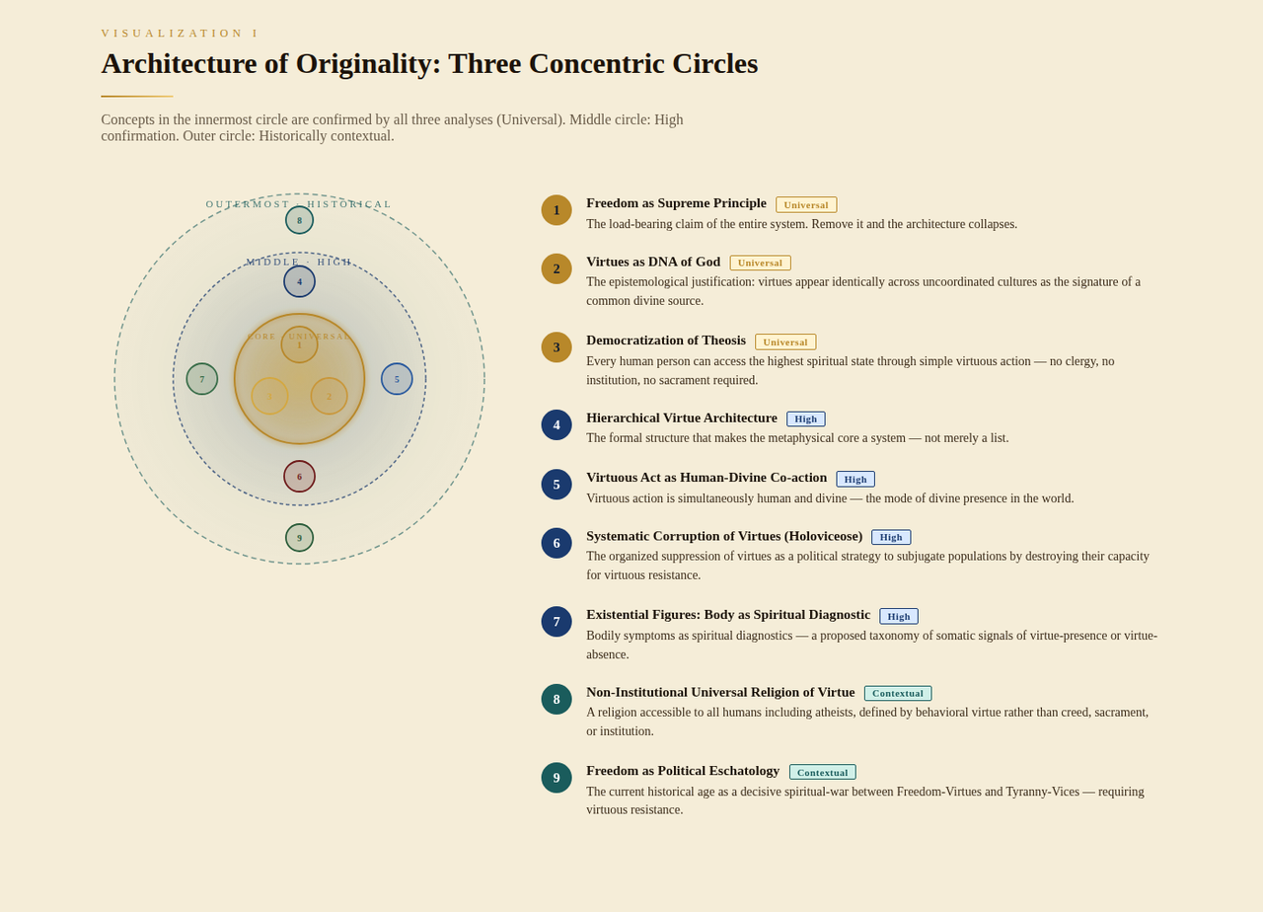
Figure 1 Architecture of Originality — Three concentric circles mapping the nine concepts by depth of cross-disciplinary confirmation. Gold inner ring = Universal; blue middle ring = High; teal outer ring = Contextual.

Figure 2 — Radar Web: Confirmation Strength
The radar web plots all nine concepts as axes radiating from a central point. Three overlapping polygon shapes — one per analysis (blue for Philosophy, purple for Theology, green for World Religions) — are drawn by connecting each analysis's score (0–3) on each axis.
The key insight is visual: the area where all three polygons overlap represents the universal core. Concepts 1, 2, and 3 show the largest overlap area — they are the concepts where Philosophy, Theology, and World Religions all agree at the highest level of confirmation. Concept 4 shows Philosophy as the dominant confirming discipline (the large blue polygon on axis 4), while Concept 9 shows World Religions as the dominant confirmer.

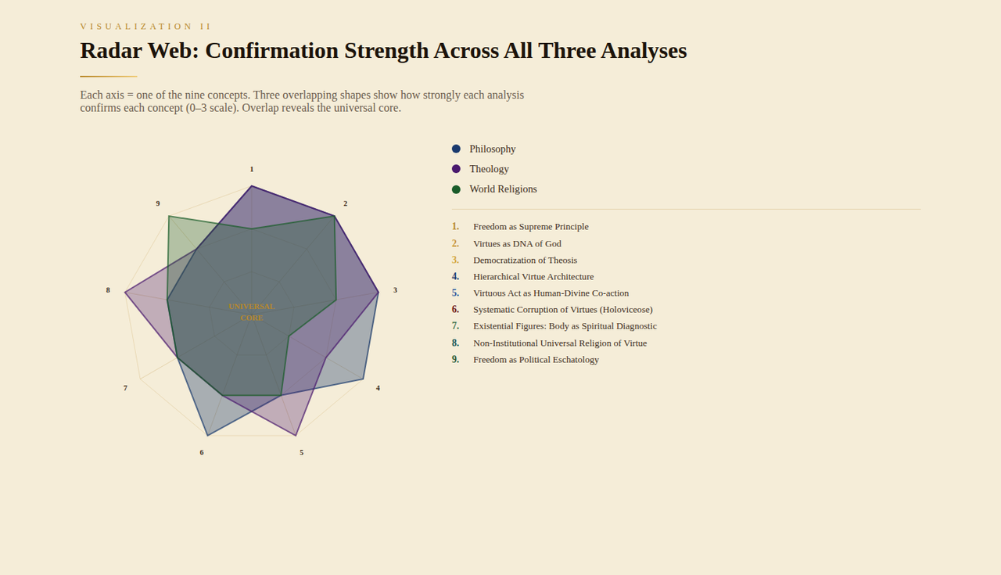
Figure 2 Radar Web — Three overlapping polygons — Philosophy (blue), Theology (purple), World Religions (green) — plotted across nine concept axes. The area of overlap is the universal core.

Figure 3 — Confirmation Bars: Evidence Weight
The stacked horizontal bars rank all nine concepts from highest to lowest total cross-disciplinary confirmation score (maximum 9 points = 3 per analysis × 3 analyses). The three colour segments within each bar reveal which disciplines confirm each concept most strongly.
Concepts 1, 2, and 3 top the chart with the highest combined scores, their bars nearly identical in length and colour balance — reflecting the uniform confirmation across all three disciplines. Concept 7 (Existential Figures) shows balanced confirmation across all three analyses with no single discipline dominating. Concept 9 (Political Eschatology) shows a notably larger green segment, reflecting that the World Religions comparison provides the richest confirmation through the universal concept of a corrupt age requiring virtuous resistance.

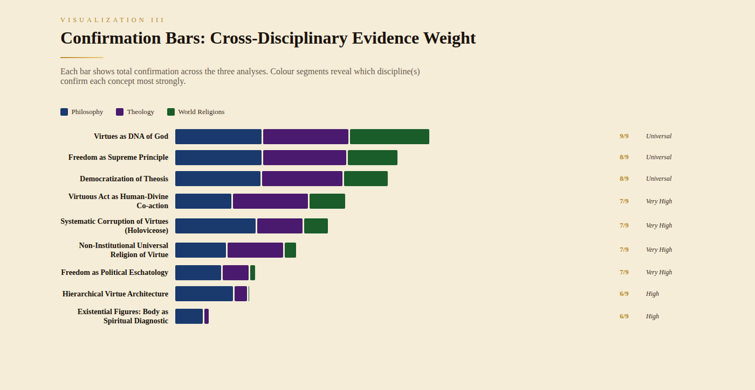
Figure 3 Confirmation Bars — Horizontal stacked bars sorted by total cross-disciplinary score (max 9). Colour segments show which discipline confirms each concept most strongly.

Figure 4 — Concept Flow Diagram
The flow diagram arranges all nine concepts in three vertical columns representing the logical sequence of the system: Metaphysical Core (left), Structural Framework (centre), and Historical Application (right). Dashed curved arrows connect concepts that have a generative or dependency relationship.
Reading the diagram from left to right reveals the architecture of Mattos's thought: the three foundational concepts (1, 2, 3) radiate outward to generate the structural framework. Concept 1 (Freedom) feeds into all other concepts, being the most generative node. Concept 4 (Hierarchical Architecture) gives shape to Concept 6 (Holoviceose) and Concept 7 (Existential Figures). Concepts 8 and 9 (Universal Religion and Political Eschatology) are the terminal applications of the entire system.

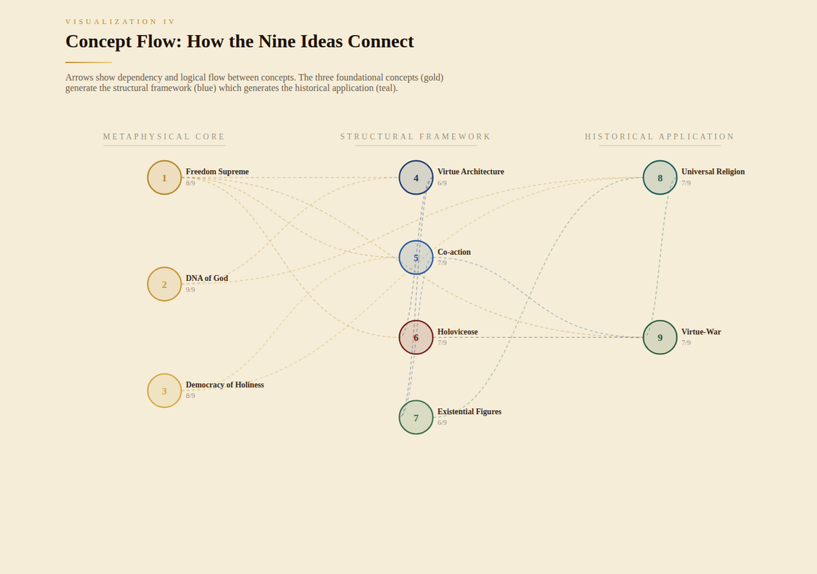
Figure 4 Concept Flow Diagram — Logical dependencies between concepts arranged in three columns: Metaphysical Core → Structural Framework → Historical Application. Arrows show generative relationships.

Figure 5 — Heat Matrix: Confirmation Score Grid
The heat matrix provides a compact, data-dense view of all confirmation scores. Rows are the nine concepts (sorted by total score), columns are the three analyses. Cell colour encodes the originality rating: dark green for Landmark (3), blue for High (2), amber for Moderate (1).
The top three rows — Concepts 1, 2, and 3 — show an almost entirely dark-green matrix: every cell is at the Landmark level. This visual uniformity is striking, confirming that these three concepts are independently judged as landmark contributions by every analytical framework. The bottom rows show more colour variation, reflecting the contextually specific nature of Concepts 8 and 9.

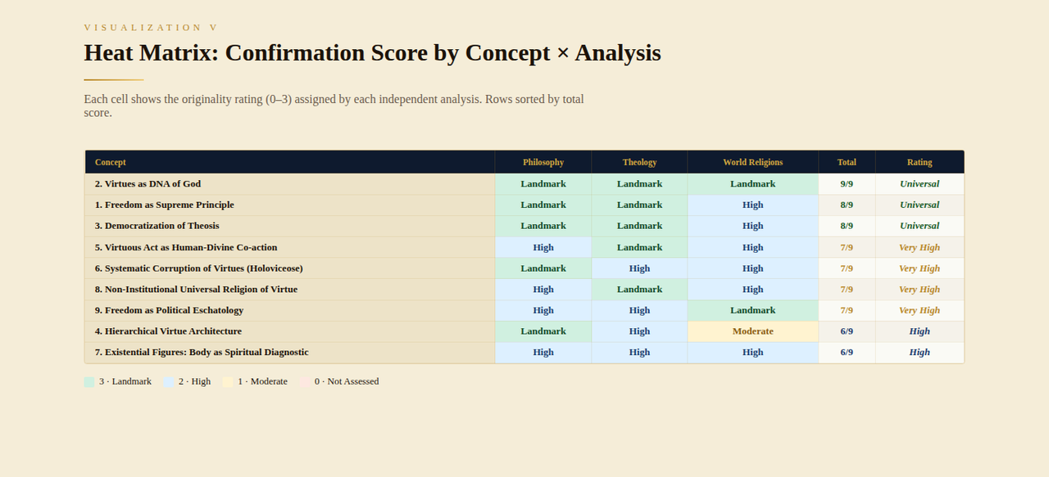
Figure 5 Heat Matrix — Colour-coded grid: dark green = Landmark (3), blue = High (2), amber = Moderate (1). Rows sorted by total score; columns are the three analyses.

Figure 6 — Narrative Arc Timeline
The narrative arc presents the nine concepts as a sequential story rather than a data grid. A vertical gold-to-teal gradient line serves as the spine of the narrative, with each concept attached at a node. The phases — Foundation, Justification, Implication, Architecture, Phenomenology, Diagnosis, Psychosomatics, Ecumenism, Prophecy — show how the system tells a complete intellectual narrative.
Reading from top to bottom: the system begins with the most abstract (Freedom as the name of God), moves through its justification (virtues as divine DNA), its democratic implication (everyone can access the Divine), its practical structure (the hierarchy), its experiential dimension (co-action), its defensive analysis (Holoviceose), its clinical contribution (Existential Figures), its universal offer (religion of virtue), and culminates in its urgent prophetic call (political eschatology).

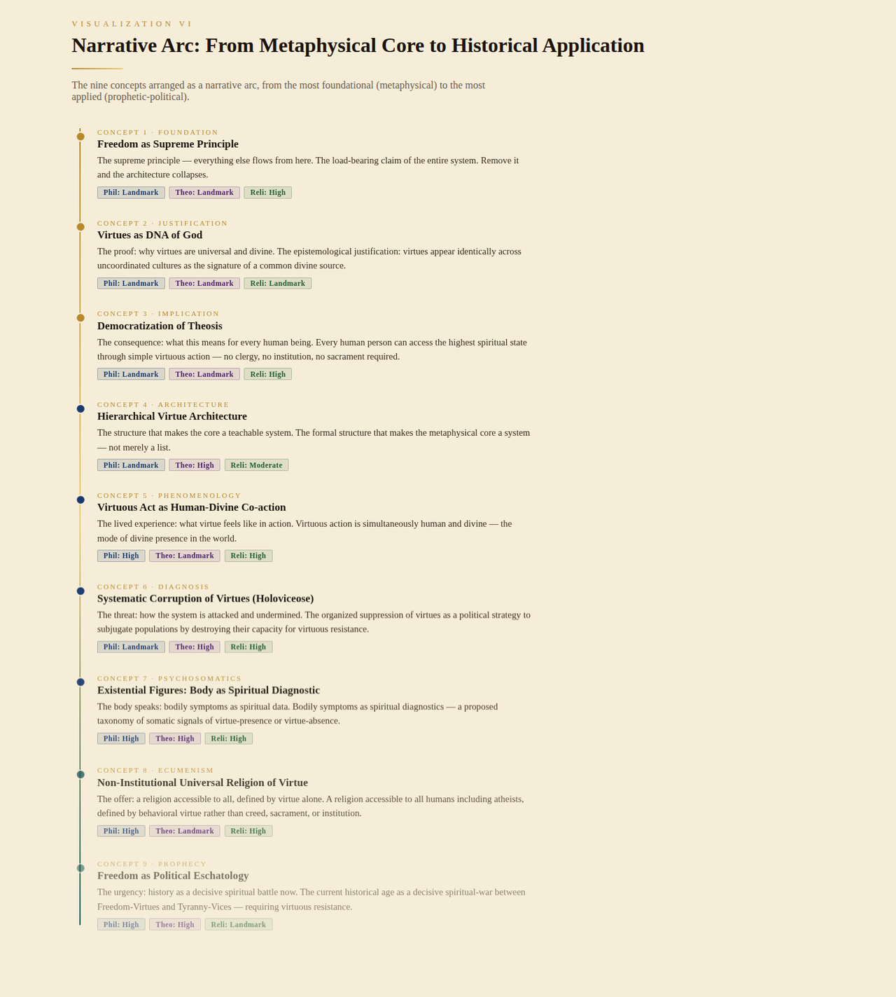
Figure 6 Narrative Arc — The nine concepts as a sequential narrative from Foundation through Prophecy, showing how each phase of the system builds on the previous.

Figure 7 — Relation Chord Diagram
The chord diagram is a circular visualization where each of the nine concepts occupies a position on the ring. Lines drawn between nodes connect concepts that share a common confirming rationale across the three analyses — that is, concepts that were confirmed in the same way, by the same intellectual tradition, in multiple analyses.
Thicker lines indicate stronger shared logic. The diagram reveals which concepts are intellectually closest to each other. Concepts 1, 2, and 3 are the most heavily connected nodes — the hubs of the system — because virtually every other concept relates back to Freedom, the DNA of God, or the democratization of divine participation. Concept 6 (Holoviceose) has a notably thick line connecting it to Concept 9 (Political Eschatology), reflecting their shared confirmation in the universal religious concept of the 'age of corruption.'

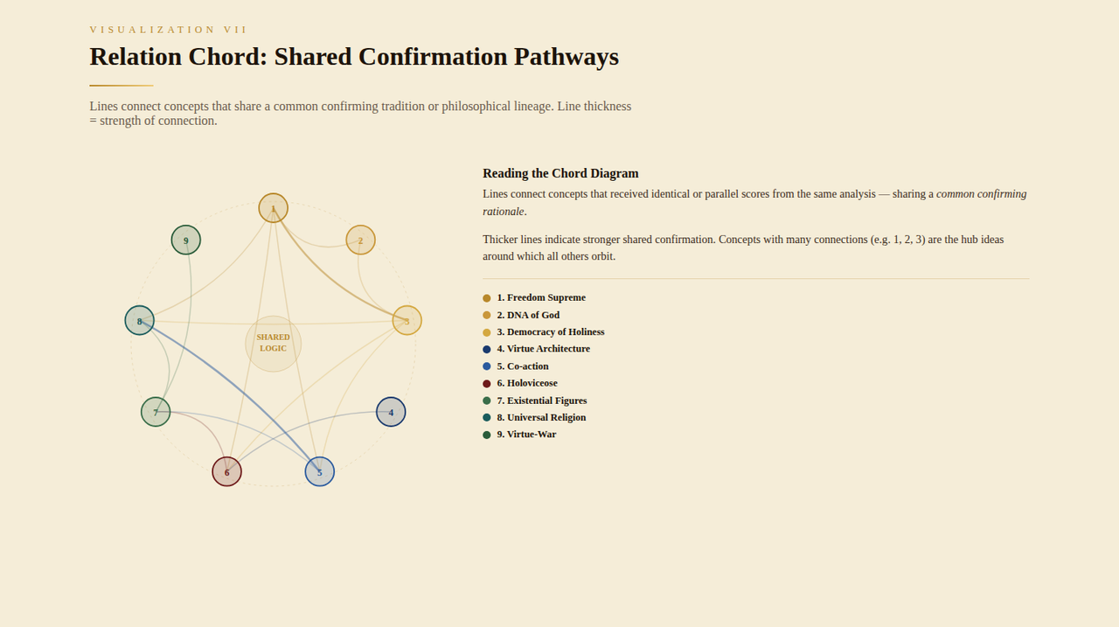
Figure 7 Relation Chord Diagram — Circular chord chart connecting concepts that share a common confirming rationale. Line thickness reflects strength of shared logical connection.

Figure 8 — Concept Cards: Full Profiles
The concept cards provide the most granular view: one card per concept, showing its name, a one-sentence summary, individual bar scores for each analysis (Philosophy / Theology / World Religions), its overall originality rating, and the specific religious or philosophical traditions that resonate most strongly with it.
The top border colour of each card encodes its tier: gold for Universal (Concepts 1–3), deep blue for High (Concepts 4–7), and teal for Contextual (Concepts 8–9). The small ghost number in the bottom-right corner of each card facilitates quick reference. Reading across the nine cards reveals the full intellectual profile of the synthesis at a glance.

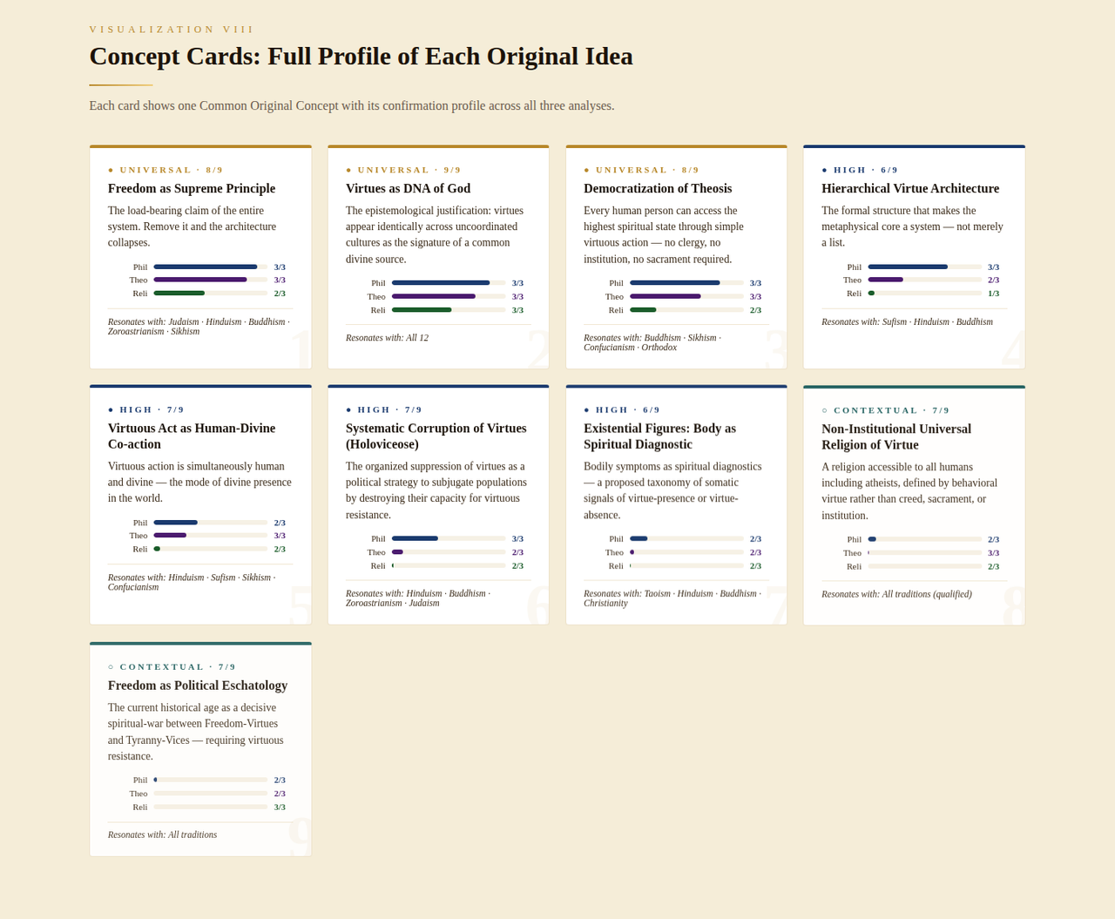
Figure 8 Concept Cards — Individual profile cards for each of the nine Common Original Concepts, with confirmation bar scores and resonating traditions.

Conclusion: What the Graphics Reveal Together
Eight graphic formats, each designed to illuminate a different dimension of the same nine concepts. Viewed together, they converge on a single conclusion: Filosofia das Virtudes contains a coherent, unified intellectual architecture — not merely a collection of insights — whose three foundational concepts (Freedom as Supreme Principle, Virtues as DNA of God, and the Democratization of Theosis) are independently confirmed as landmark contributions by three entirely separate analytical frameworks.
The Radar Web shows where all three analyses overlap. The Concentric Circles show the structural depth of each concept. The Bars show the weight of evidence. The Flow shows the logical dependencies. The Heat Matrix shows the uniformity of the universal core. The Narrative Arc shows the book's intellectual journey. The Chord shows the relational logic. The Cards show the complete profile of each idea.
Together, they make visible what the synthesis report argues in prose: that this book has produced original ideas which are not only philosophically novel and theologically significant but also resonate with the deepest virtue traditions of the entire human family across every major world religion.

Filosofia das Virtudes · José Caetano de Mattos · Rio de Janeiro, 2023 · March 2026

