

The HOLT Accident Reporting Procedure

The UK Health and Safety at work statistics for 2021 highlight the importance of continuing to improve health and safety measures in workplaces: 0.4 million workers sustained a non-fatal injury and 142 workers were killed while at work.

The “The Reporting of Injuries, Diseases and Dangerous Occurrences Regulations 2013” made it a legal requirement for employers or responsible persons to report certain injuries and illnesses to the HSE. By reporting accidents to the relevant authorities, this allows them to understand more about how risks come about and how they can support workplaces to avoid future risks. It also enables them/enables authorities to determine if further investigation of a specific incident is required.
Under “The Social Security (Claims and Payments) Regulations 1979”, it is also the law for any employer of 10 or more people to keep an accident recording system readily accessible by which employees, or someone acting on their behalf, can record accidents. Internal recording of accidents supports workplaces in understanding the causes of accidents and how to prevent them in the future, providing an essential aid to risk assessments.

What is the procedure for accident recording?
Not only do workplaces need to keep records of any accidents that are reportable under RIDDOR, they must also keep records of occupational injuries that result in a worker being unable to perform their normal duties for more than three consecutive days.
It is the law that employers of 10 or more workers should provide a system of recording accidents that is easily accessible for use. These records must then be kept for at least 3 years and stored in a secure place for confidentiality.
There are five key details of accidents legally required: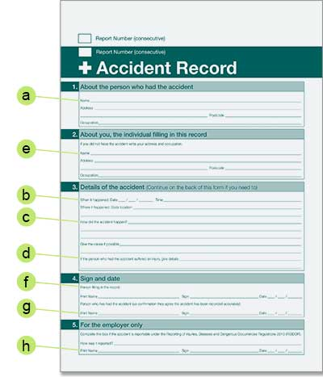
- Full name, address and occupation of the injured person (a)
- Date and time of the accident (b)
- Location of the accident (c)
- Cause and nature of the injury (d)
- Name, address and occupation of the person giving the notice, if other than the injured person (e).
In addition, it is also useful to have a signature from the person recording the incident (f), as well as a signature from the injured person to confirm the details of the incident (g).
Finally, a note of whether the accident has been reported to the HSE under RIDDOR ensures that this has been completed where necessary (h).

The Accident Book for The HOLT is kept in the front office.
The HOLT also keeps a near miss book which should be completed in the case of any near miss incidents.

What should be included in a “Near Miss” record?

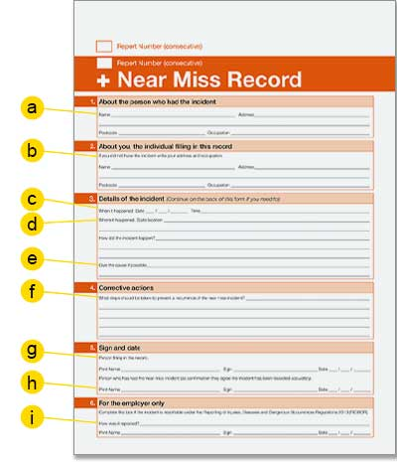
- Full name, address and occupation of the person who experienced the incident (a)
- Name, address and occupation of the person filling in the record, if other than the above (b).
- Date and time of the incident (c)
- Location of the incident (d)
- Description and cause of the incident (e)
- Description of corrective actions (f) to ensure future health and safety measures
- Signature of the person recording the incident (g) and the person who experienced the incident (h)
- A record of whether the accident has been reported to the HSE ensures that this has been completed where necessary (i).
Some “Near Miss” incidents classified as Dangerous Occurrences need to be reported under RIDDOR.

What is the procedure for accident reporting?
Employers, self-employed people and people in control of work premises are required to report certain workplace accidents, occupational diseases and dangerous occurrences to the HSE under RIDDOR.

When to report to the HSE under RIDDOR
Most incidents should be reported within 10 days of the incident. Exceptions to this rule are as follows:
- Incidents that are reported due to over-seven-day incapacitation of a worker – these must be reported within 15 days of the incident
- Cases of occupational disease – these must be reported as soon as the responsible person receives a diagnosis

How to report to the HSE under RIDDOR
Responsible persons can report appropriate accidents, diseases or occurrences online through the HSE. There are different online forms, depending on types of incidents and, for fatal/specified incidents only, there is also a telephone number.
In addition to reporting to the HSE, workplaces must keep their own records of the incident. This can be in an accident or near miss book (also recording the date and method of reporting), or a copy of a RIDDOR form can be downloaded after submitting.

What types of accidents require reporting under RIDDOR?
- Any death of workers or non-workers (excluding suicides) must be reported under RIDDOR if they result from a work-related accident, including acts of physical violence.
- The following injuries to workers must be reported under RIDDOR:
  - Fractures, other than to fingers, thumbs and toes
  - Amputations
  - Injuries likely to lead to permanent loss of, or reduction in, sight
  - Crush injuries to the head or torso, resulting in damage to the brain or internal organs
  - Serious burns, including scalding, that:
    - Cover more than 10% of the body
    - Cause significant damag3e to the eyes, respiratory system or other vital organs
  - Any scalping that requires hospital treatment
  - Loss of consciousness caused by head injury or asphyxia
  - Injuries resulting from working in an enclosed space that:
    - Lead to hypothermia or heat-induced illness
    - Require resuscitation or admittance to hospital for more than 24 hours.
- Accidents that result in employees or self-employed people being unable to perform normal work duties for more than seven consecutive days because of their injury. This timeframe does not include the day of the injury but does include weekends and rest days.
- Non-fatal accidents to non-workers, if they result in the person being taken directly from the accident to hospital for treatment. In this case, examinations and diagnostic tests are not considered “treatment”.
- Occupational diseases that have been made worse or caused by work.
- Diagnosis of a disease after exposure to carcinogens, mutagens or biological agents.
- Dangerous occurrences – a specific list of near misses that have not resulted in death or injury
- Gas-related incidents

Created on 01/02/2026
Review 01/02/2027

