
Infection Control Policy

Written By: Juliet Bell
Date: 02/01/2026
Review: 01/2027

Infection Control
Infection control is the name given to a wide range of policies, procedures and techniques intended to prevent the spread of infectious diseases amongst staff and students.
All of the staff working at The HOLT are at risk of infection or of spreading infection, and risk coming into contact with substances that may well contain pathogens that can be spread if staff do not take adequate precautions.
Policy Statement
The HOLT believes that adherence to strict guidelines on infection control is of paramount importance in ensuring the safety of both students and staff. It also believes that good, basic hygiene is the most powerful weapon against infection, particularly with respect to hand washing.
Aim: basic principles of infection control.
The aim of The HOLT is to prevent the spread of infection amongst staff, students and the local community.
Goals
The goals of the The HOLT are to ensure that:
- Students, their families, staff and visitors are as safe as possible from acquiring infections through work-based activities
- (b) All staff at The HOLT are aware of and put into operation Basic principles of infection control.
The HOLT will adhere to infection control legislation:
(a) The Health and Safety at Work Act, etc 1974 and the Public Health Infectious Diseases Regulations 1988, which place a duty on The HOLT to prevent the spread of infection
(b) The Reporting of Incidents, Diseases and Dangerous Occurrences Regulations 1995, which place a duty on The HOLT to report outbreaks of certain diseases as well as accidents such as needle stick accidents
(c) The Control of Substances Hazardous to Health Regulations 2002 (COSHH), which place a duty on The HOLT to ensure that potentially infectious materials within the organisation are identified as hazards and dealt with accordingly
(d) The Environmental Protection Act 1990, which makes it the responsibility of The HOLT Isle of Wight CIC to dispose of clinical waste safely.
(e) The Food Safety Act 1990. ensure that all food prepared in service users’ homes for service users is prepared, cooked, stored and presented in accordance with the high standards required by the Food Safety \Act 1990 and the Food Hygiene (England) Regulations 2005.
Infection Control Procedures At The HOLT Isle of Wight CIC:
• All staff are required to make infection control a key priority and to act at all times in a way that is compliant with safe, modern and effective infection control practice
• The management of The HOLT will make every effort to ensure that staff working with students have access to sufficient facilities and supplies of appropriate equipment to ensure that they can implement effective infection control procedures and techniques
• Any staff who does not feel that they have access to sufficient facilities and supplies of appropriate equipment to ensure that they can implement effective infection control procedures and techniques have a duty to inform their line manager or supervisor.
Effective Hand Washing
The HOLT believes that the majority of cross-infection in a support environment is caused by unwashed or poorly washed hands which provide an effective transfer route for micro-organisms. The HOLT believes that regular, effective hand washing and drying, when done correctly, is the single most effective way to prevent the spread of communicable diseases. Staff who fail to adequately wash and dry their hands before and after contact with students may transfer micro-organisms from one student to another and may expose themselves, students and the public to infection.
At The HOLT Isle of Wight CIC:
• All staff should, at all times, observe high standards of hygiene to protect themselves and students from the unnecessary spread of infection
• All staff should ensure that their hands are thoroughly washed and dried:
- Between seeing each and every student where direct contact is involved, no matter how minor the contact
- After handling any body fluids or waste or soiled items
- After handling specimens
- After using the toilet
- Before handling foodstuffs
- After smoking
- Before and after any care or clinical activity
- Before and after handling medications
- Hands should be washed thoroughly — liquid soaps and disposable paper towels should be used rather than bar soaps and fabric towels (whenever possible)
• All cuts or abrasions, particularly on the hands, should be covered with waterproof dressings at all times
• Ordinary soap is considered to be effective for routine use in removing dirt and reducing levels of transient micro-organisms on the skin to acceptably safe levels
• The use of antiseptic or antimicrobial preparations is recommended if service users are known to have an infectious disease or are colonised with antibiotic-resistant bacteria, such as Methicillin Resistant Staphylococcus Aureus (MRSA) • Antiseptic hand washing solutions may also be used in situations where effective hand washing is not possible
• The use of alcoholic products for hand decontamination is not intended to replace washing hands with soap and water but rather to supplement hand washing where extra decontamination is required or to provide an alternative means of hand decontamination in situations where standard facilities are unavailable or unacceptable (for example between students or in unsanitary conditions)
• Non-clinical waste should be disposed of in normal black plastic bags.

The Use of Protective Clothing
• Adequate and suitable personal protective equipment and clothing should be provided by The HOLT.
• All staff should who are at risk of coming into direct contact with body fluids should use disposable gloves and disposable aprons.
• Sterile gloves are provided for clinical procedures such as applying dressings. These should be worn at all times during student contact and should be changed between students. On no account should staff attempt to wash and reuse the gloves.
• Non-sterile gloves are provided for non-clinical procedures.
• The responsibility for ordering and ensuring that supplies of gloves and aprons are readily available and accessible lies with the management team.

Cleaning and Procedures for the Cleaning of Spillages
• Staff should treat every spillage of body fluids or body waste as quickly as possible and as potentially infectious.
• When cleaning up a spillage staff should wear protective gloves and aprons provided.

The Disposal of Sharps (e.g. Used Needles)
• Sharps — typically needles or blades — should be disposed of in proper, purpose-built sharps disposal containers complying with BS7320.
• Sharps should never be disposed of in ordinary or clinical waste bags.
• Staff should never re-sheath needles.
• Boxes should never be overfilled.
• When full, boxes should be sealed, marked as hazardous waste and clearly labelled with the service user’s details.
• Staff should never attempt to force sharps wastes into an over-filled box.
• Used, filled boxes should be sealed and stored securely until collected for incineration according to individual arrangements. In the event of an injury with a potentially contaminated needle staff should:
• Wash the area immediately and encourage bleeding if the skin is broken
• Report the injury to their line manager immediately and ensure that an incident form is filled in
• Make an urgent appointment to see a GP or, if none are available Accident and Emergency.

Food Hygiene
• All staff should adhere to The HOLT’s food hygiene policy and ensure that all food is prepared, cooked, stored and presented in accordance with the high standards required by the Food Safety \Act 1990 and the Food Hygiene (England) Regulations 2005.
• Any member of staff who becomes ill while handling food should report at once to his or her line manager or management team.
• Staff involved in food handling who are ill should see their GP and should only return to work when their GP states that they are safe to do so.

Reporting:

The Reporting of Injuries, Diseases and Dangerous Occurrences Regulations 1995 (RIDDOR) oblige The HOLT to report the outbreak of notifiable diseases to the HSE.

Notifiable diseases include: cholera, food poisoning, smallpox, typhus, dysentery, measles, meningitis, mumps, rabies, rubella, tetanus, typhoid fever, viral haemorrhagic fever, hepatitis, whooping cough, leptospirosis, tuberculosis and yellow fever. Records of any such outbreak must be kept specifying dates and times and a completed disease report form must be sent to the HSE.
In the event of an incident, the management team are responsible for informing the HSE.

Training
All new staff must read the policy on infection control as part of their induction process. Existing staff should be offered training covering basic information about infection control. All staff will complete mandatory training in Food Hygiene and infection control, and renew this training on a regular basis.

Correct Hand Washing Technique

Removing all dirt and contaminants from the skin is extremely important. Hands and other soiled parts of the body should be cleaned at least at the end of each work period, prior to breaks, or when visiting the toilet.

The correct method of cleaning is also important. Developing a good hand washing technique is imperative to ensure hands are thoroughly clean. Particular attention should be paid to the backs of the hands and fingertips as these are frequently missed.
It is usual to wet hands before dispensing a dose of soap into a cupped hand, however for heavily soiled hands it is advisable to apply the appropriate specialist hand cleanser directly to the skin before wetting. In all cases, it is important to follow the manufacturer’s recommended instructions.

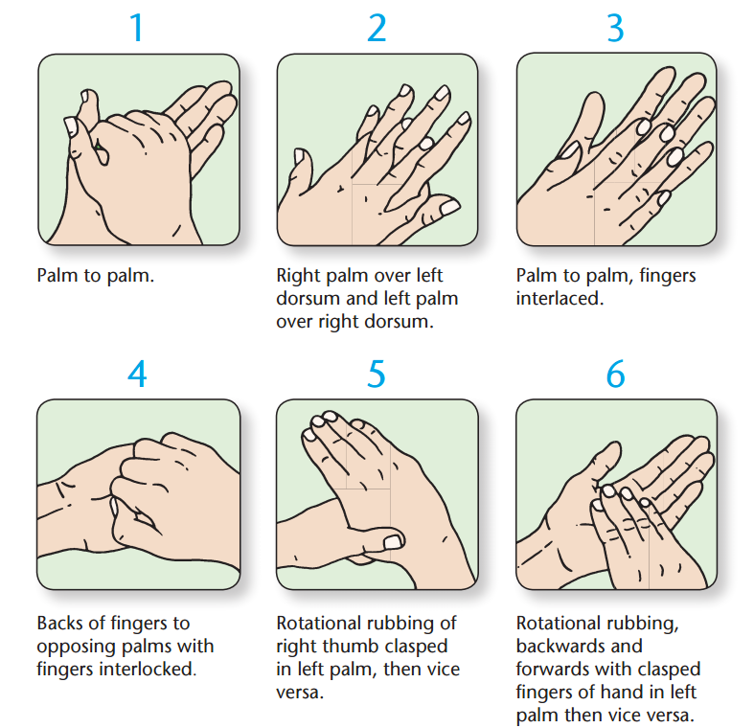

The skin should always be properly dried to avoid risk of chapping particularly during cold weather. Clean towels should be available at all times – dirty towels mean exposing the skin to more dirt and the risk of infection. Ideally, ‘single issue’ disposable towels should be used, as the use of ‘communal’ towels can lead to contamination.

