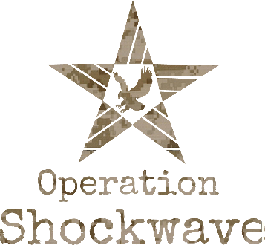
CALL ROSTER

FOUNDER/CEO
Andrew Jones ajones@operationshockwave.org 702-306-4610

TRAINERS
Sande Roberts sanderoberts@mac.com 480-748-5527
CaS Facciponti casfacciponti@gmail.com 845-545-4521

BOARD
Tim Araiza araizatimoteo@gmail.com 480-371-9508
Christine Payseno cpayseno1314@gmail.com 623-853-5955
Judy Mellody jmellody@live.com 623-824-4640

VETERAN LEADERS
James Anderson* james4147kanderson@gmail.com 602-397-9517
Bryan Barrow bryan.s.barrow@gmail.com 520-366-1699
Talitha Porter talitha.m.porter@gmail.com 602-515-9306
Leroy Sanders Leroy.sanders1@gmail.com 480-255-6546
Brian Gallagher bgallagher714@yahoo.com 602-386-8190
Mike Montiel gmmontiel83@gmail.com 480-272-3786
Jenifer Allen flicka1972@msn.com 602-705-7202
Tim Rogers hmfic4ever@gmail.com 602-692-1980

*Denotes Veteran Leadership Unit Director

