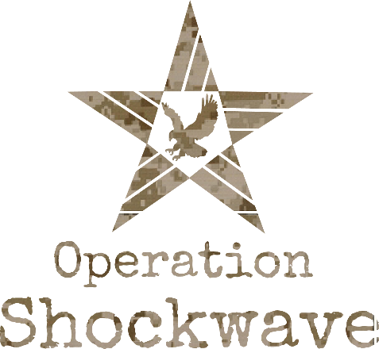

VETERAN LEADERSHIP UNIT
OATH OF MENTORSHIP

I, [state your name], commit to lead and empower fellow warriors to choose life.

I will not let any diagnosis determine my identity.

I will pursue my mission with purpose and enthusiasm.

I will become proficient with my weapons to defeat the enemy of my mind.

I will answer the call to support fellow warriors.

I will call for support when I am overwhelmed.

I will serve as an example to others by applying the Operation Shockwave vision & message in my life.

I will commit to the process, be patient and ultimately persevere.

I will take my life to a place of joy and success.

I CAN be successful in this mission.

I WILL be successful in this mission.

I MUST be successful in this mission.

