JUNIOR RIFLE CLUB
November 2025 Newsletter

Rifle matches
Matches went well no problems. Poor turn out only 4 including 2 first time junior shooters. They did well for their first time out.

Pumpkin shoot
Pumpkin shoot went well despite the weather. Started off overcast then rain. the kids did not notice. We had a good turnout upwards of 20 kids most first-time shooters. Everyone seemed to have a good time. We ran out of handgun ammo and I am unsure of how much 22rf we used. 3000 plus rounds that I can confirm used. A brick would get low and another box would appear on the table donated by J.B. and E.B. mostly. Bill and I will be drying firearms, cases etc. and cleaning guns for a week.
We would like to thank Cheryl and Marceia at the Newark Home Depot store 1601 for the donation of pumpkins and JB for doing the negotiating. K. T. for her donation of clay pigeons and B.T. for the ammo and use of his handguns. I would also like those that donated ammo, time and cash. That is what allows us to get the kids involved in the sport.
I would like to thank everyone that turned out to help run the line. setup, and cleanup.

Saturday shooting has gone well. we added a few new shooters this month. We have had a few BHRGC members join us on the second Saturday to shoot steel targets.
We will continue to shoot at Brandywine Hundred Rod & Gun Club on Saturdays till the weather turns bad. We will be there starting at 9am.
Range cover on the rifle range now for rainy days. We can shoot at 50 yards when its damp
We are shooting paper targets at 50 feet for those working on the program and steel targets 2nd Saturday of the month for a change of pace. And if you have anything you would like to try, let us know and we will see if it can be done.

Again, we would like to thank Brandywine Hundred Rod & Gun Club for their support

Tentative EVENT dates for next year. subject to change
Saturday, may 16th 2026
GARAND, & Modern military rifle 10 AM
&
ANY RIFLE MATCH &
3 POSITION 22RF MATCH 50,100 or 200YD 1 PM
22rf can be used in the ANY RIFLE MATCH
------------------------------------------------------------------------------------------------ SUN OCTOBER 11TH 2026
GARAND, & Modern military rifle 10 AM
&
ANY RIFLE MATCH &
3 POSITION 22RF MATCH 50,100 or 200YD 1 PM
22rf can be used in the ANY RIFLE MATCH
-------------------------------------------------------------------------------------------
SUNDAY NOV 8th 2026
PUMPKIN SHOOT FOR KIDS 9AM
OPEN TO ALL* KIDS up to 16,

We still have rifles and other shooting items for sale. These are extra rifles that we will not use. Contact me if you are interested in the list. All sales through a firearms dealer.

If anyone would like to add to the newsletter, please email me your note, article, accomplishment, picture etc.

Things to work on:

Having fun on the range.

Remember shooting is about being consistent.
sight picture, breathing, follow through, attitude, etc. are all important things to remember

Ask yourself, "What does it take to make a good shot?"
Sight picture, position, breathing, etc..
Remember the basics: position, natural point, focus on the front sight, trigger pull, follow through.

Practice Practice Practice

remember focus on the front sight
check your natural point
concentrate on every shot
don't rush your shots

Find time to shoot.
Funny thing about life…if you practice you will get better at it.

Remember to think about this shot, not the last one, not the next one.

Remember we are here to help you become better shooters. Let us help.

Reminder if you have any pictures or videos you would like to post, just email them to me as an attachment .jpg file etc. No faces or names please.

For new shooters, the first Saturday is free

I would like to thank everyone for the time they put in on and off the range. There is a lot to do, and they help to make Saturdays run like a smooth operation.

We still have a few t shirts for sale for $18.00.

Donation Home Depot
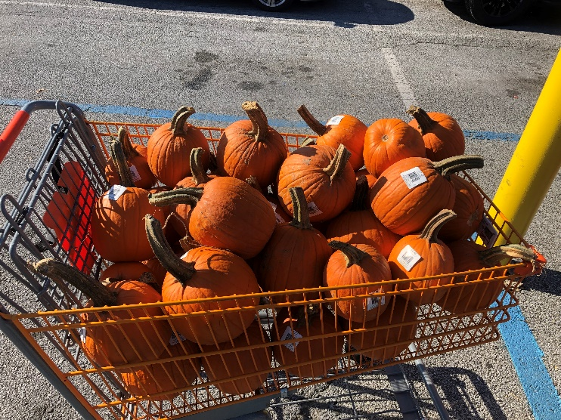

Webpage
https://JuniorRifleClub.org, and Facebook for notices and updates. Schedules, fliers, & etc. can be downloaded from the webpage. A few new pictures have been posted. If you have any pictures to post, email them to me.

Member Accomplishments

Congratulations to I.Z. on his first deer

