**Sleep Workshop Outline**

How important is good sleep to you? What if you had all the tools you needed to set yourself up to have that restorative experience night after night? How different would your life be?

Our Sleep Workshop is a Holistic approach to sleep because we understand that people are a perfect combination of body, mind, and soul. We empower you, as a participant, with the knowledge and tools (physical, emotional, and spiritual) to create the sleep you want night after night.

In the space of 5 hours, you will learn a little more about sleep as a state of consciousness and how you can use specific tools to adjust your body and mind states to experience the sleep you desire. Expect to take away resources and knowledge to continue to improve your sleep over time.

Your facilitators:

Sherri Kozubal, RRT, CRE, RPSGT, CCSH

Registered Respiratory Therapist

Certified Respiratory Educator

Registerd Polysomnography Technologist

Certification in Clinical Sleep Health

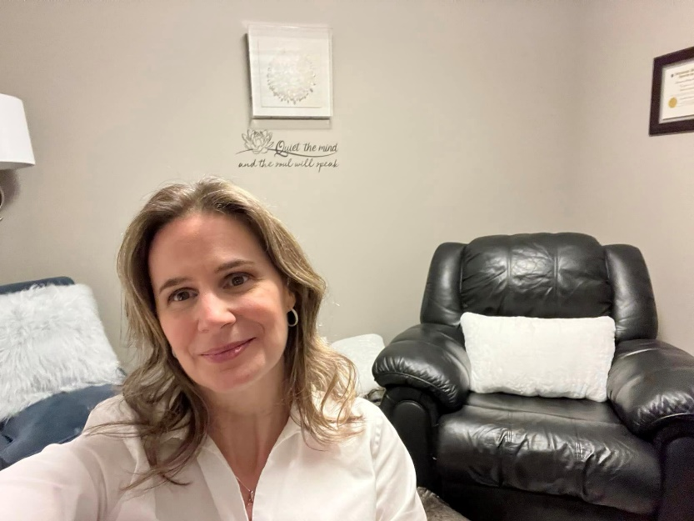

Gordana Boscovic, RHN

Registered Holistic Nutritionist

Reiki Master

Yoga Teacher

Through our combined certifications and experiences of Sleep medicine, Clinical Sleep Health, Nutrition, Somatics, Breathwork (Respiratory Therapy and Yoga), NLP, and Hypnotherapy, you will have access to an extensive toolkit to put you back into the driver’s seat of your sleep.

What to expect in your time with us:

* **Introduction to the anatomy and mindset of sleep with Sherri.** **(40mins)**
* Theories behind the function of sleep in how it improves our body functions such as memory, concentration, and neurological balance.
* Common thieves of sleep (diet, light exposure, activity, electronics, online content exposure prior to sleep).
* How our daily routines influence sleep quality. (level of activity, timing of activities, themes we expose ourselves to, mindset practices.
* The biology of mindset. How to use your mindset to influence your hormone response to create the preferred experience.
* What is your suggestibility and why is this important for the right tools for you?
* Question and answer time.
* **Somatic yoga and Breathwork for sleep (with Gordana). (BODY) (45 mins?)**
* Training the body and mind to reconnect inward for calm and balance.
* Increasing body awareness to increase mindfulness and ability to self-regulate.
* **Hypnosis, Meditation and Sleep (with Sherri). (MIND) (40 mins)**
* Self-Hypnosis and Meditation as intentional tools of the mind to shift easier into sleep or meditative states.
* Sleep Hygiene and routine in creating new triggers to shift you from fear of sleep to anticipation of calm.
* **Nutrition do’s and don’t (with Gordana and Sherri). (30 mins?)**
* Common thieves of sleep related to what we consume and the importance of timing.
* What we might be missing nutritionally and how that can also affect our sleep. (iron for restless legs or Cal Mag for muscle tension)
* **Energy and Sleep. (SOUL) 30 mins (Gordana and Sherri)**
* NLP and Visualization as tools of concentrated energy.
* Shift your body chemistry with intention. (thoughts creating physical responses as energy moves where you want it to go.)
* **Wrap up. (30mins) Sherri**

Putting it all together in a hypnotherapy session of your best sleep using all your new tools. Body, mind, and soul.

What you leave with:

New tools for your best sleep involving the body, mind and soul integrated into a recipe created intimately for you.

A journal to record notes and insights during session.

A take-home resource of key points of the workshop to refer to as needed.

A complete toolkit for sleep designed to address all aspects of you.

Commitment: 5 hours

Cost: $129.00

Max 14 people

Reserve your spot at <https://highergroundwellnessretreat.com/>