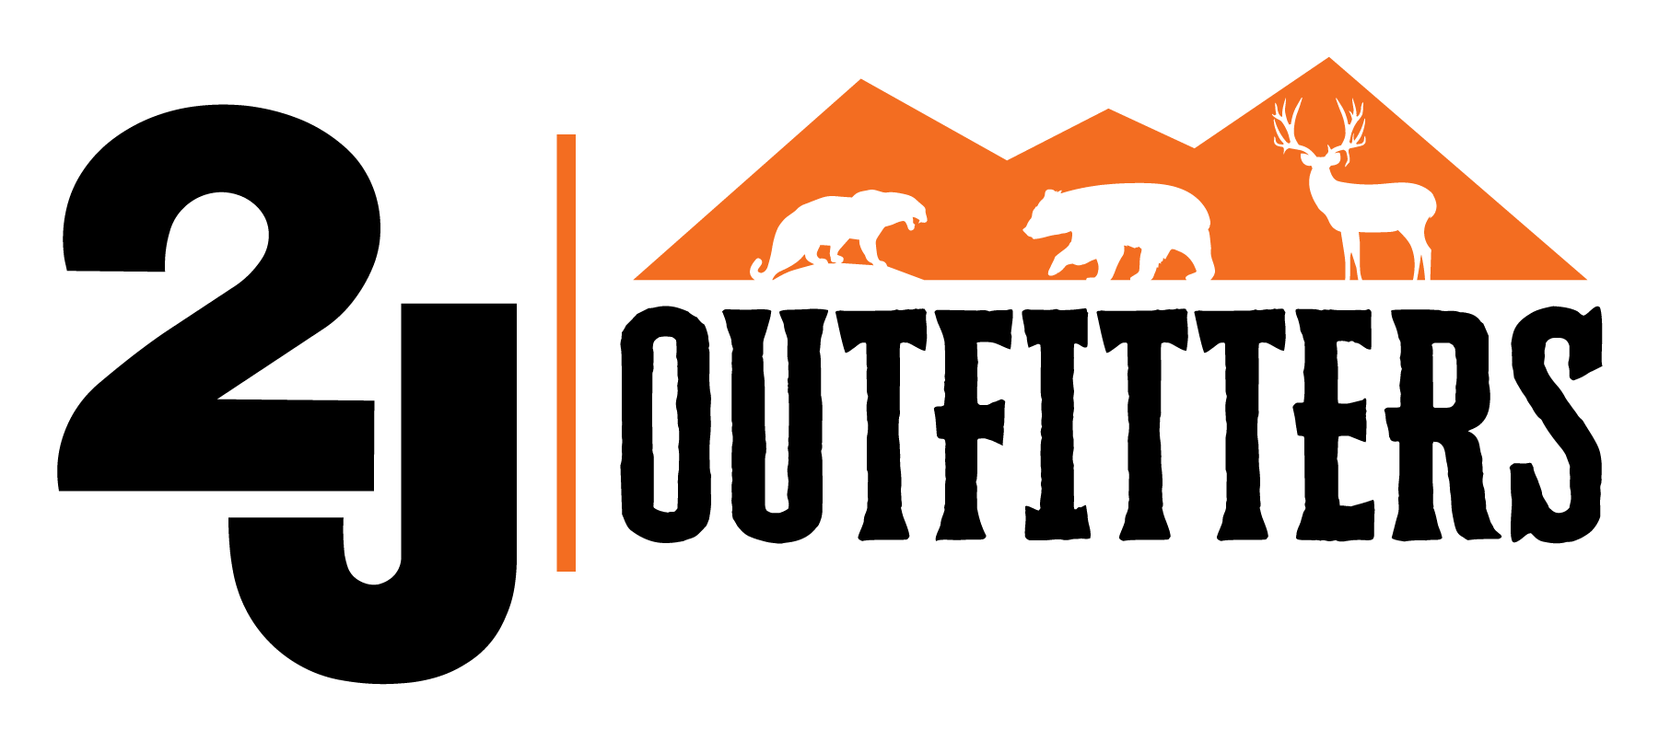

**2J Outfitters - Client Acknowledgment and Risk Form**

**Client Information:**

* **Name of Client:** _________________________________
* **Contact Information:** _____________________________
* **Date of Hunt:** _________________________________

**Acknowledgment of Risks:**

I, the undersigned, acknowledge that I have chosen to participate in hunting activities organized and conducted by 2J Outfitters. I understand and accept that hunting involves inherent risks, including but not limited to the following:

1. **Firearm Handling and Shooting:** Hunting activities may involve the handling and use of firearms, which can be dangerous if not used properly. I understand that I am responsible for my own firearm safety and that I must adhere to all safety instructions provided by the guides and outfitters.
2. **Terrain and Environmental Hazards:** Hunting often takes place in remote and rugged terrain, and may involve exposure to adverse weather conditions, wildlife encounters, and rough terrain. I acknowledge the risks associated with these factors and agree to take appropriate precautions.
3. **Wildlife Encounters:** The possibility of encountering wildlife, including potentially dangerous animals, exists while hunting. I understand that I should not approach or provoke wildlife and should follow the guidance of my guides to mitigate potential risks.
4. **Physical Demands:** Hunting can be physically demanding, requiring walking, hiking, and carrying equipment over uneven terrain. I confirm that I am physically capable of participating in the chosen hunt and will inform the outfitters of any health or mobility concerns.
5. **Medical Emergencies:** I acknowledge that medical assistance may not be readily available in remote hunting locations. I understand the importance of informing the guides of any medical conditions or allergies I may have.
6. **Firearm Accidents:** I understand the importance of following safe firearm handling practices and acknowledge that accidents involving firearms may result in injury or death.

**Assumption of Responsibility:**

I agree to assume full responsibility for my own safety during the hunting trip. I acknowledge that the guides and outfitters will provide safety instructions and guidance, which I will follow diligently. I will exercise good judgment and adhere to all laws and regulations governing hunting and firearms.

**Release of Liability:**

In consideration of the services provided by 2J Outfitters I hereby release, waive, and discharge 2J Outfitters, its guides, employees, and affiliates from any and all claims, liabilities, and responsibilities related to personal injury, property damage, or any other harm that may occur during the hunting trip.

**Emergency Medical Treatment Authorization:**

In the event of a medical emergency, I hereby authorize 2J Outfitters and its guides to seek and administer necessary medical treatment on my behalf.

**RELEASE AND ACKNOWLEDGMENT OF RISK**

This RELEASE AND ACKNOWLEDGMENT OF RISK is voluntarily and knowingly  
entered into by the persons as signed hereunder, (hereinafter “Participant”) and 2J Outfitting  
LLC (“Outfitter”) its owners, employees, agents, volunteers, officers, and directors hereinafter  
collectively referred to as Outfitter. This document is a full release and indemnity agreement  
whereby Participant is releasing and indemnifying Outfitter from various risks, known and  
unknown involving the various activities, including, but not limited to the Outfitting Services  
described in the Outfitter Agreement.  
Participant acknowledges and agrees that Participant’s participation in and receipt of the  
Outfitting Services is completely voluntary and Participant acknowledges all risks, known and  
unknown, accepts all risks, known and unknown, and assumes full responsibility for all risks,  
known and unknown, including, but not necessarily limited to, those risks identified in this  
release and acknowledges and accepts full responsibility for all property damage, bodily and  
personal injury, illness, paralysis, and death to Participant and/or members of Participant’s  
family.  
Participant will be engaged in activities involving fire arms, wild and domestic animals,  
wild terrain, unpredictable weather, all-terrain vehicles, horses and other pack animals, and other  
potentially dangerous recreational activities related to the Outfitting Services (“Activities”).  
Participant acknowledges and fully understands:  
1. That there are inherent risks and dangers involved with the Activities.  
2. That the risks related to these Activities, and others, are inherent and may not be  
anticipated, controlled, or eliminated by Outfitter and, further, Outfitter has no duty to do so;  
3. That these risks and activities in general can cause property damage, bodily and personal  
injuries, illnesses, paralysis, and death to you, your guests or members of your family;  
4. That Outfitter and/or other people and Participants may, on occasion, be negligent  
(negligent meaning, generally, a failure to exercise ordinary or reasonable care) in their duties  
and responsibilities to Participant and this negligence can cause property damage, bodily and  
personal injuries, illness, paralysis, and death to you or members of your family;  
5. That the Activities and other related activities may be over rough or unpredictable terrain and be in remote areas and that bodily and personal injury, illnesses, paralysis, and other injuries  
may occur to you where you are a considerable distance from doctors, hospitals, and any type of medical help or assistance.  
Participant does hereby completely release, acquit, and forever release and discharge, Outfitter, its successors, personal representatives, and assigns of and from any and all actions, claims, demands, obligations, causes of action, damages, costs, loss of services, expenses, attorneys’ fees, and compensation of any kind or nature whatsoever on account of or in any way growing out of, or which in the future may result from, property damage, bodily and personal injuries, illnesses, paralysis, and death to Participant, Participant’s guests or members of Participant’s family as a result of participation in the Activities or from Outfitter’s negligence.

This release includes, but is not limited to, all claims or causes of action whether based on a tort, contract, or any other theory of recovery, which the Participant now has or which may hereafter accrue or may otherwise be acquired on account of or may in anyway grow out of any  
recreational activities including, but not limited to, any and all claims for emotional distress, loss of consortium, loss of companionship, loss of income, bodily or personal injury to Participant, or members of Participant’s family, or any wrongful death claim or punitive damage or any other claim of Participant’s representatives or heirs which have resulted or may result from the Activities, acts, omissions, or negligence of Outfitter. Participant further stipulates and agrees, to fully indemnify and hold forever harmless Outfitter against loss from any and all claims,  
demands, or actions which may hereinafter or at any time be made or brought against Outfitter by any person or entity who has made, or agreed to make payments on Outfitter’s behalf for any  
medical expenses or any other obligations incurred by Participant as a result of property damage, bodily and personal injury, illness, paralysis, and/or death to Participant or any members of Participant’s family arising out of Outfitter’s activities. Participant further agrees and stipulates to indemnify and hold forever harmless Outfitter against loss from any and all further claims, demands, or actions which may hereinafter or at any  
time be made or brought against Outfitter by any person or entity who claims to have been damaged, or who asserts a claim as a result of property loss or damage, bodily and personal injury, illness, paralysis, and/or death to Participant arising out of the Activities. Participant  
further stipulates and agrees to fully indemnify and hold forever harmless Outfitter from any action, claim, demand, obligation, cause of action, damages, costs, loss of services, expenses, and compensation of any kind or nature whatsoever on account of or in any way growing out of,  
or which in the future may result from property damage, bodily and personal injury, illness, paralysis, and/or death to any person, including minors and incompetents, over whom and for whom Participant has custody, control, and/or other legal responsibilities.  
Participant represents that:  
1. Participant has completely and fully read this document and agrees to its terms, has been given ample opportunity to seek legal counsel to review and advise Participant as to the legal effect of this release and has been provided additional opportunities to ask questions and make  
inquiries of Outfitter regarding this release;   
2. Participant warrants and represents he/she has no medical problems which might interfere with Participant’s ability to safely engage in any equestrian oriented activity;  
3. Participant is voluntarily participating in the Activities with full knowledge of the activities and the risks involved;  
4. Participant accepts and assumes the risks and legal responsibilities for any and all injuries and damages which may result from those risks associated with participation in the Activities;  
5. Participant warrants and represents that he/she can fulfill any physical requirements involved with the Activities;  
6. Participant understands that the presence of Outfitter’s personnel is no assurance of Participant’s safety or lessens any risks assumed by Participant;  
7. Participant warrants and represents that he/she has obtained adequate  
medical/disability/life insurance or other monies to cover losses to himself or others. It is agreed that this release and its provisions shall be governed by the laws of the State of Utah. NOTICE. Notice is hereby provided pursuant to Utah Code § 78B-4-201 through 203. The  
Outfitter is not liable for inherent risk related to equine or livestock activities. “Inherent risk" with regard to equine or livestock activities means those dangers or conditions which are an integral part of equine or livestock activities, which may include:  
(a) the propensity of the animal to behave in ways that may result in injury, harm, or death to persons on or around them;  
(b) the unpredictability of the animal's reaction to outside stimulation such as sounds, sudden movement, and unfamiliar objects, persons, or other animals;  
(c) collisions with other animals or objects; or  
(d) the potential of a participant to act in a negligent manner that may contribute to injury to the participant or others, such as failing to maintain control over the animal or not acting within his or her ability.

This release shall not be canceled, modified, or changed in any manner except by the written agreement of both Outfitter and Participant. The invalidity of any portion of this release shall not affect the validity of the remaining release.

1. **Client's Signature:** _______________________________
2. **Date:** _____________________