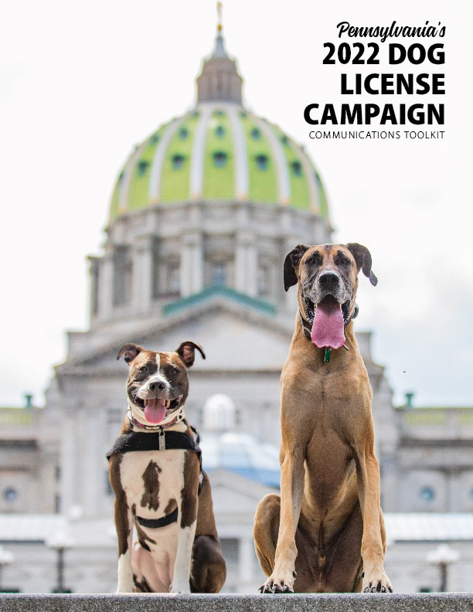

Table of Contents:
Introduction to Pennsylvania Dog Licensing
Suggested Twitter and Facebook posts
Sample Content for e-Newsletters and Websites
Sample Press Release template

Introduction
Bureau of Dog Law Enforcement

The Bureau of Dog Law Enforcement is responsible for ensuring the welfare of dogs and puppies in licensed kennels. The Bureau also regulates activities pertaining to dogs that are classified as dangerous, and oversees annual licensure and rabies vaccinations for dogs.

Our state dog wardens:
  - Enforce licensing and rabies laws
  - Seize and detain any dog viewed running at large without its owner
  - Investigate dog bites and establish and enforce quarantine of dogs
  - Enforce kennel licensing and regulations through at least two inspections each year of every licensed kennel
  - Maintain a registry of dogs declared dangerous by a magisterial district judge and perform dangerous dog inspections
  - Prosecute dog law violations in court
  - Provide educational services about dog ownership

Pennsylvania’s Rabies Law:
Ignoring Pennsylvania’s rabies vaccination law can be costly – in more ways than one. Dogs and cats are exposed to the rabies virus through wild and stray animals, posing a threat to their health and yours.
  - Dogs and cats three months or older must have a current rabies vaccination
  - Owners of non-vaccinated pets may be fined up to $300 plus court costs
  - Licensed veterinarians can vaccinate dogs and provide a vaccination certificate
  - Dog wardens perform random checks to ensure rabies vaccinations are current

License Your Dog. It’s the Law:
- All dogs three months or older must be licensed by Jan. 1 of each year
- Owners of non-licensed dogs can be cited with a maximum fine of $300 per dog plus court costs
- Dog wardens randomly canvass neighborhoods to ensure all dogs are licensed, violators may be fined
- If your dog gets lost, a current license is the fastest way to get your dog back home
- Licensing fees help the millions of dogs in Pennsylvania by funding the Bureau of Dog Law Enforcement
- Purchase a license from your local county treasurer or issuing agent
- An annual license is $8.50 and a lifetime license is $51.50, if your dog is spayed or neutered, the annual fee is $6.50 and lifetime is $31.50, discounts are available to older adults and people with disabilities

Pennsylvania’s Dog Laws:
- If your dog is not licensed, you may be fined up to $300 per dog. Get a license at your county treasurer’s office.
- Your dog must be under control and supervised at all times. You are responsible for any damages caused by your dog on someone else’s property.
- It is illegal to mistreat or abuse animals. Report suspected abuse to your local humane organization or police.
- Purposely poisoning a dog, whether it is yours or someone else’s, is illegal.
- You may not abandon or attempt to abandon any dog. You could be fined $1,000 plus court costs.
- Puppies under eight weeks old cannot be bartered, traded, sold, or transferred.
- You must have a kennel license if you keep, sell, transfer, adopt or foster at least 26 dogs in a calendar year.
- If your dog attacks or kills a human or domestic animal without provocation, it may be considered dangerous. You may face extensive fines and restrictions.

Social Media
Tweets and Facebook posts are great ways to raise public awareness about dog licensing and the campaign for 2022. All posts related to dog licensing should use the hashtag #LoveYourDogLicenseYourDog

We’ve created some suggested posts for you to share on your pages as you see fit. You may also follow us on Twitter (@PAAgriculture) or like us on Facebook (fb.com/PADeptofAg) and share our posts promoting the campaign.

What? You didn’t get your 2022 dog license yet?!

All dogs three months and older are required to be licensed. Annual licenses expire December 31 each year. 🐶 Don’t delay, get your 2022 license today!

[insert method for acquiring dog license here – online, mail, walk-in, etc.]

#LoveYourDogLicenseYourDog

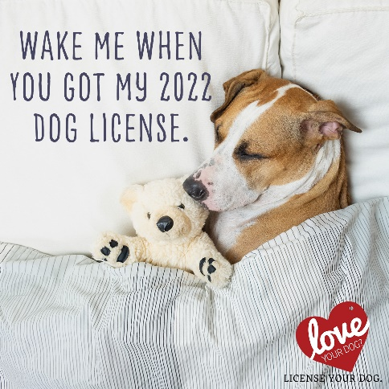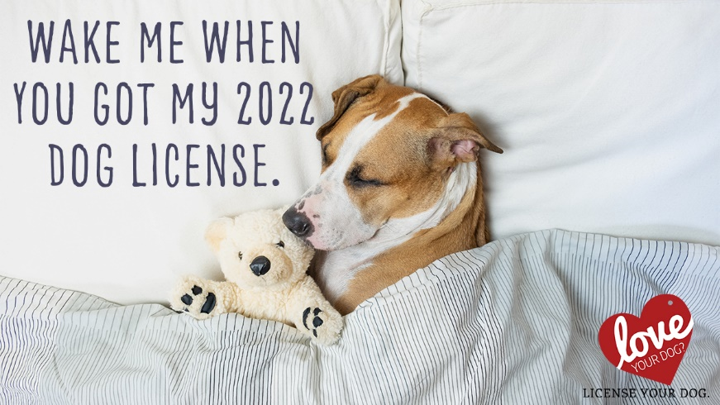

A dog license is a ticket home for a lost dog. 🏠 Set your dog’s mind, and your own, at ease. Get your 2022 license now!

[insert method for acquiring dog license here – online, mail, walk-in, etc.]

#LoveYourDogLicenseYourDog

There for you through it all. ❤️🐶 Now do something for them: keep their dog license up-to-date.

An up-to-date dog license is the best way to bring home your dog should they get lost.

Get your 2022 dog license today.

[insert method for acquiring dog license here – online, mail, walk-in, etc.]

#LoveYourDogLicenseYourDog

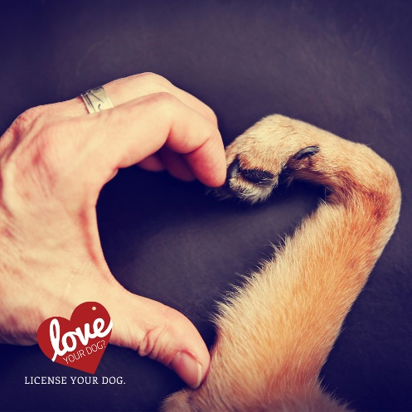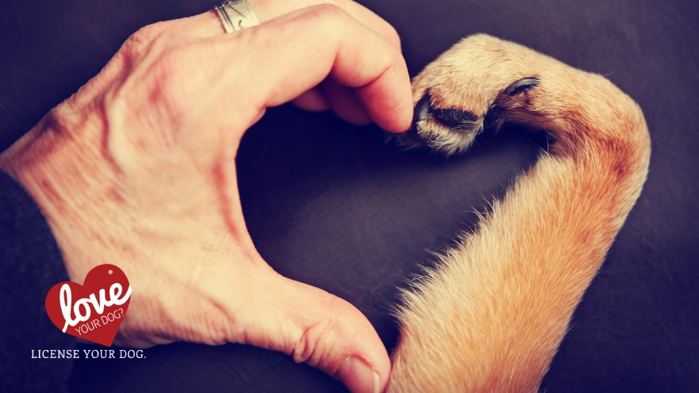

Get your pup what they really want this year: the safety and security of an up-to-date dog license.

🎁 2022 dog licenses are available now.

[insert method for acquiring dog license here – online, mail, walk-in, etc.]

#LoveYourDogLicenseYourDog

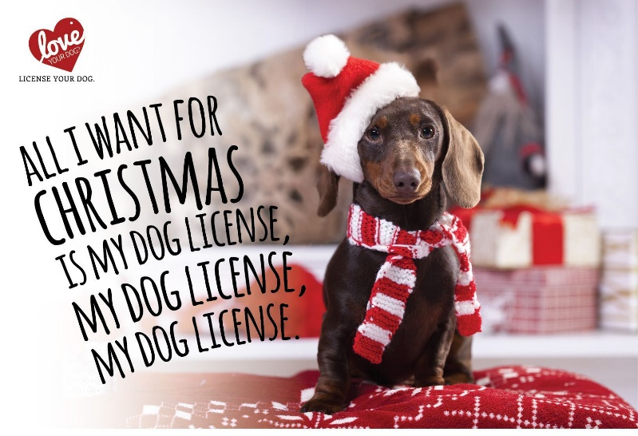

Protect your family from the hurt of a lost dog. A dog license dramatically increases your chances of getting them back if they go missing.

[insert method for acquiring dog license here – online, mail, walk-in, etc.]

#LoveYourDogLicenseYourDog

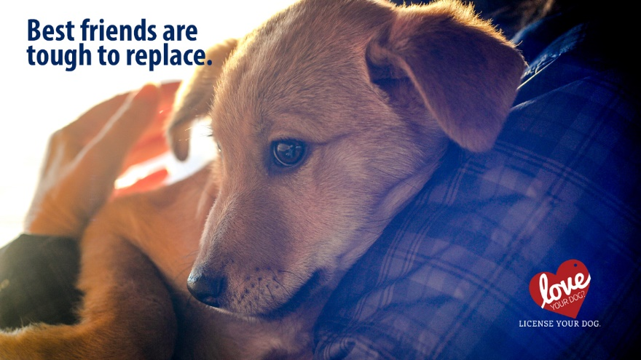

Licensing your dog: it’s part of being a responsible pet owner. Do it for them, do it for every dog in PA.

Having a dog license is the best way to bring them home if they get lost. And the cost of your dog license allows the Bureau of Dog Law Enforcement to crack down on illegal kennels, investigate dog bites, and ensure dangerous dogs are not roaming the streets.

[insert method for acquiring dog license here – online, mail, walk-in, etc.]

#LoveYourDogLicenseYourDog

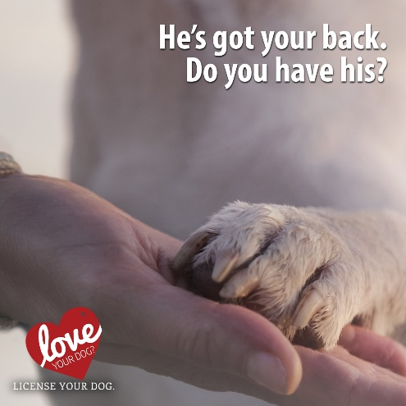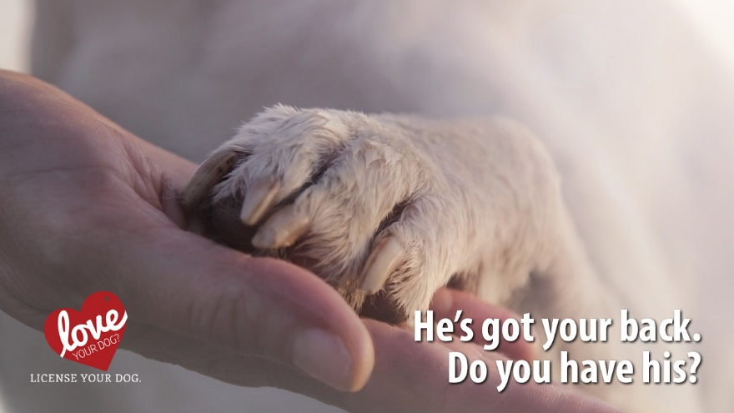

Pet owners are responsible for caring for their four-legged family members and assuring their pets do not affect others negatively. In addition to finding a way home for lost dogs, dollars spent on a license allow the Bureau of Dog Law Enforcement to protect dogs in kennels, keep track of dangerous dogs and investigate reports from Pennsylvanians.

🐶 License your dog. It’s a simple thing to do. It’s the right thing to do.

[insert method for acquiring dog license here – online, mail, walk-in, etc.]

#LoveYourDogLicenseYourDog

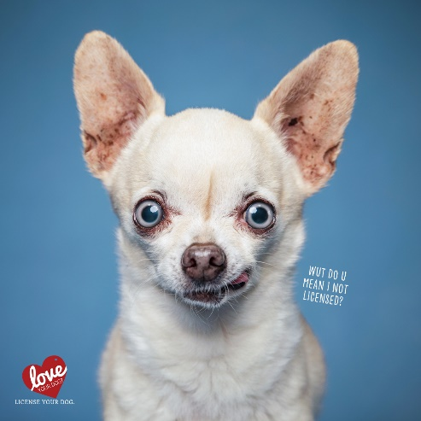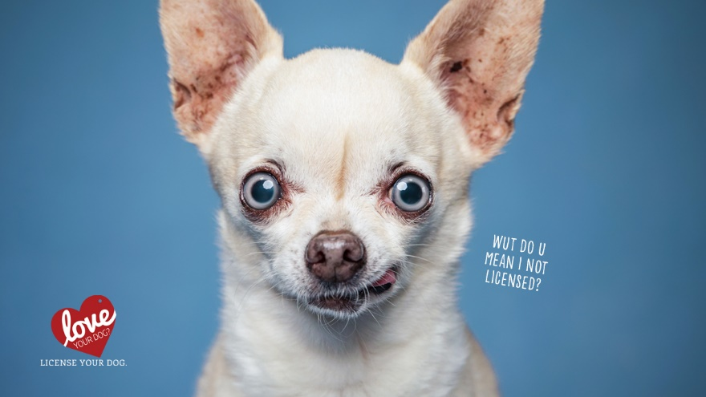

📦 If you’ve moved, your dog’s license needs transferred to your new county. Be sure to contact both your old and new county treasurer so that your dog can be properly tracked and returned home if lost!

#LoveYourDogLicenseYourDog
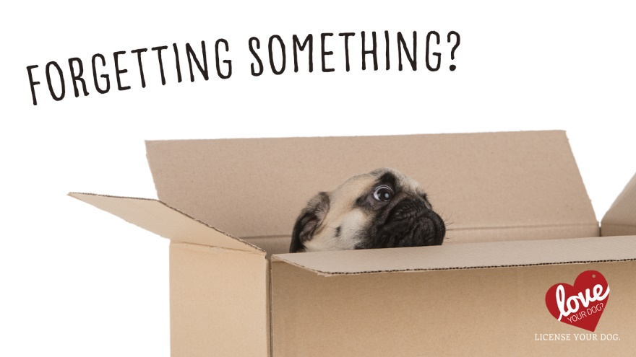

The look you get when your dog finds out you still didn’t get their 2022 license… 👀

[insert method for acquiring dog license here – online, mail, walk-in, etc.]

#LoveYourDogLicenseYourDog

Start the New Year off on the right paw 🐾… we mean foot.

All dogs three months or older must be licensed by January 1 of each year! 🎉2022 dog licenses are available now!

[insert method for acquiring dog license here – online, mail, walk-in, etc.]

#LoveYourDogLicenseYourDog

Attention: 2022 dog licenses are on sale now! 🎁

Get your pup the best gift of all: the safety and security of an up-to-date dog license.
[insert method for acquiring dog license here – online, mail, walk-in, etc.]

#LoveYourDogLicenseYourDog

Sample Content for Newsletters and Websites
License Your Dog in PA
All dogs three months or older must be licensed by Jan. 1 of each year. Violators can be cited with a maximum fine of $300 per violation plus court costs.
An annual license is $8.50 and a lifetime license is $51.50. If the animal is spayed or neutered, the annual fee is $6.50 and lifetime is $31.50. Discounts are available to older adults and people with disabilities.
The small license fee helps the millions of dogs in the state by funding the Pennsylvania Department of Agriculture Bureau of Dog Law Enforcement.
Dog licenses are available from your local county treasurer and other licensing agents.
Reasons for dog licensing:
- It’s the law. All dogs three months and older must have a current license.
- If your dog gets lost, a license is the best way to get him back. A license helps animal control and shelters identify your dog and get him back home safely.
- The cost of a license is less than the penalty for being caught without one. Owners who fail to license their dogs could face a fine of up to $300 for each unlicensed dog.
- License fees support animal control. The annual fee you pay to license your dog helps keep shelters running and supports the work of the Bureau of Dog Law Enforcement, which is responsible for ensuring the welfare of dogs, regulating dangerous dogs and overseeing annual licensing and rabies vaccinations.

Sample News Release
FOR IMMEDIATE RELEASE
December 00, 2021
2022 Dog Licenses Available at County Treasurers’ Offices; All Dogs Must be Licensed by Jan. 1
<<CITY>>, PA – Pennsylvanians can now purchase 2022 dog licenses from their county treasurers. State law requires all dogs three months and older to be licensed by Jan. 1 of each year.
Insert a quote from the county treasurer.
An annual dog license is $8.50, or $6.50 if the animal is spayed or neutered. Lifetime licenses are available for dogs that have permanent identification like a microchip or tattoo. Older adults and people with disabilities may be eligible for discounts.
The dog license application is simple and only requests owner contact information and details about the dog being licensed, including name, age, breed and color.
[Insert name of county treasurer] offered these reasons for dog licensing:
- If a dog gets lost, a license is the best way to get him/her back. A license helps animal control and shelters identify a dog and its rightful owners.
- It’s the law. All dogs three months and older must have a current license.
- The cost of a license is less than the penalty for being caught without one. Owners who fail to license their dogs could face a fine of up to $300 for each unlicensed dog.
- License fees support animal control. The annual fee to license a dog helps keep shelters running and supports the work of the Pennsylvania Department of Agriculture’s Bureau of Dog Law Enforcement, which provides a number of vital services to protect dogs and the public. Last year, the Bureau of Dog Law Enforcement:
  - Enforced health and safety regulations in kennels by licensing 2,428 such operations and conducting more than 5,200 inspections.
  - Helped to secure more than 4,500 stray dogs, placing them in shelters until those that were licensed could be reunited with their owners.
  - Issued more than 3,000 citations and filed 115 misdemeanor complaints for violations of the Dog Law, including failing to license dogs, abandoning dogs, and allowing them to run at large.
  - Investigated nearly 1,500 dog bites, and they investigated and monitored 587 dogs that were deemed dangerous by magisterial judges.

For more information, contact <<INSERT COUNTY NAME>> County Treasurer <<INSERT TREASURER’S NAME>> at <<INSERT PHONE NUMBER AND/OR EMAIL ADDRESS>>. For a list of county treasurers, visit www.licenseyourdogPA.com or call the Department of Agriculture’s Bureau of Dog Law Enforcement Office at 717-787-3062.
MEDIA CONTACT: [Contact person for the county treasurer’s office]

