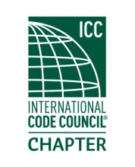

**MEETING Notice**

**(PLEASE RSVP)**

An invitation and reminder of the upcoming chapter meeting for

**Thursday**

**February 15th,2018**

Located at

Branks BBQ

13701 24 St E

Sumner, WA

The February meeting is scheduled for Brank’s BBQ in Sumner. Ralph Baumann, Technical Manager, PNW, WA Viega, LLC will discuss Plumbing Pathogen Risk Reduction and Legionella. Bring your questions.

Registration and socializing starts at 6:00 PM. Meeting will start immediately if a quorum is present. Dinner will commence shortly thereafter.

The meeting cost are $20.00, which includes a dinner, raffle, and your training CEU's upon membership eligibility. (Cash or Check Only) Hope to see you there!

Please rsvp prior to end of business on Monday February 12th.

Order of Meeting

1. Introductions and call to order
2. Approval of January minutes
3. Officer reports
4. Old business- Kelly Talley. WABO winter meeting, Enrollment for WABO spring AEI in March
5. New business- Annual training benefit. ICC Committee Action Hearings.
6. Dinner
7. Raffle drawing
8. Adjournment.