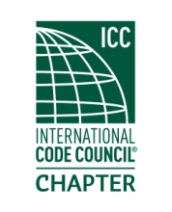
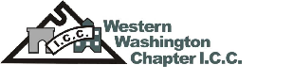

Minutes of Meeting
Thursday
February 15, 2018
Located at
Branks BBQ
13701 24 St E
Sumner, WA

Meeting topic:

Guest Speaker is Ralph Baumann, Technical Manager, PNW, WA Viega, LLC. He will discuss Plumbing Pathogen Risk Reduction and Legionella. Bring your questions.

Social gathering and meeting start at 6:00 PM.

14 RSVP 3 non-RSVP members in attendance, 17 total members.

Meeting called to order at 6:00 by President Marc Schoenberg. A quorum was established.

Old business: Bylaws have been amended and signed by officers.

January minutes were approved by motion, seconded and approved.

New business: Job openings for the following.
Edgewood, Inspector; Seatac, Inspector and Plan Reviewer; Kent, Inspector and 3 Plan Reviewers.

Officer reports:

President- Building Safety Month is in May and we are getting some posters to hand out. We need a list of volunteers to fill committee openings, see Marc.

Executive Vice- Jim Sayers is running for ICC board and needs Chapter support. Jack Applegate is being nominated for Code Official of the Year, we will support him as well. WABO is going for the Chapter of the year from ICC, we are also supporting them.

Vice President- The next meeting will be at Trackside Pizza in Puyallup on March 15th.

Treasurer- Justin has his report attached.

Secretary- I am working on setting up a training with ICC and City of Seattle using our Chapter benefit after September. Don’t forget the WABO AEI in March.
Dave Spencer from Safe Built and ICC board of directors was also present at our meeting.

Dinner started being served at 6:30 and the speaker held the floor from 6:45- 7:40. It was a great informational meeting on a growing issue of waterborne related illnesses and the causes from plumbing and hvac systems.

Raffle was held, Sue Coffman won a satchel, Jamie Fackler won a tool bag, Justin Fox won the money and redirected it to the Chapter, and finally, Ralph Bauman won an 8 GB flash drive.

Meeting was adjourned at 8:00.

