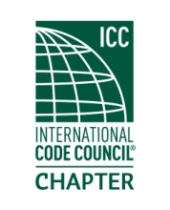

Minutes of Meeting
Thursday
20 Sep 2018

Located at
Brank’s BBQ
13701 24th St E Unit A1, Sumner, WA 98390

Meeting called to order at 6:34 PM after dinner had been served. Introductions were held as well as rollcall of officers. A quorum was achieved. 10 people RSVP’d and 14 were in attendance.

Minutes from previous meeting were put forth in motion, seconded and approved.

A presentation on emergency management occurred.

Officer reports:
President Marc Schoenberg: ADA training on 16 Oct 18 at the Kent Simpson facility for 8 hours and other training opportunities tbd.

Vice president Dana Herron mentioned participation levels and encouraging people to attend future meetings. Spoke of possible northern locations to have meetings and outreach to other interested parties.

Treasurer report given by Dean Mundy. Contest for new chapter logo.

Drawing of raffle tickets was held with the following winners:

- Steve Fratella won the 1st prize which was the choice of $25 gift card or $24 cash, he went for the cash.
- Randall Bergum won a gift card.

The meeting was adjourned at 8:09 PM.

