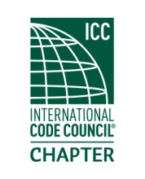

**MEETING Notice**

**(PLEASE RSVP)**

An invitation and reminder of the upcoming chapter meeting for

**Thursday**

**18 October 2018**

Located at

Tuscany at Des Moines Creek

21830 Marine View Drive S, Des Moines, WA 98198

Justin Evatt, CSI of Specified Technologies, Inc. will speak on the subject of fire stopping.

Registration and socializing starts at 6:00 PM. Meeting will start immediately if a quorum is present. Dinner will commence shortly thereafter.

The meeting cost are $20.00, which includes a dinner, raffle, and your training CEU's upon membership eligibility. (Cash or Check Only) Hope to see you there!

Please rsvp prior to end of business on Monday the 16th.

Order of Meeting

1. Introductions and call to order
2. Approval of September minutes
3. Officer reports
4. Old business -
5. New business-
6. Dinner
7. Raffle drawing
8. Adjournment.