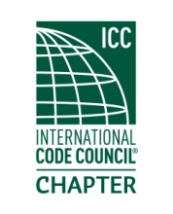
MEETING Minutes

Thursday
December 19th, 2019
Located at
Sustainable Living Innovations LLC.

- Meeting was held in two parts, beginning at the SLI showroom at 5:30 PM. We had a quorum with several members in attendance along with staff from SLI. SLI is a new innovative construction group with new means and methods of Type 1 apartment structures that are pushing the envelope in design and speed of construction.
- Jatinder Khokar, Inspection Services Director from SDCI was introduced to the group in attendance.
- Justin Fox gave the treasurers report, separate email.
- Robert Horton was excused.
- At 6:15, the group moved to Jack’s BBQ on Airport Way for the social portion and dinner.
- Drawings for raffles were won by Randy Bergum, gift certificate for AMC movies, Sam Steele for $20, Jamie Fackler won gift certificate for Rainier Growlers.
- Meeting was adjourned at 8:15.

