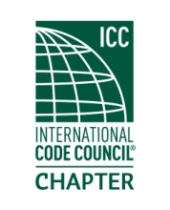
MEETING Notice
(PLEASE RSVP)
An invitation and reminder of the upcoming chapter meeting for

Thursday
21 Feb 19
Located at
Brank’s BBQ
13701 24th Street E A1 Sumner, WA 98390

Meeting topic: Preparing a Code Enforcement Case for the Hearing Examiner presented by Emily Terrell, AICP Principal of Sound Municipal Consulting.

Registration and socializing starts at 6:00 PM. Meeting will start immediately if a quorum is present. Dinner will commence shortly thereafter.

The meeting cost are $20.00, which includes a dinner and your training CEU's upon membership eligibility. (Cash or Check Only) Due to increased meal costs, raffle tickets will no longer be included in the price of admission. However, raffle tickets will be available for $1.00 each. We will still be having the 50/50 and other assorted prizes for the winners.

Please RSVP
Order of Meeting
- Introductions and call to order
- Approval of January minutes
- Officer reports
- Old business
- New business
- Dinner
- Raffle drawing
- Adjournment.

