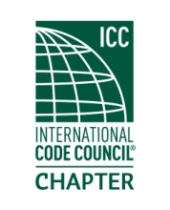
MEETING Notice
(PLEASE RSVP)
An invitation and reminder of the upcoming chapter meeting for

Thursday
January 16th 2020
Located at
PPI Group (Topcon Solutions)
18040 72nd ave South Kent WA

Meeting topic: Bluebeam Revu -We will learn about how this software is used to improve workflow and manage projects.

Registration and socializing commences at 6:00 PM. Meeting will start immediately if a quorum is present. Dinner will commence shortly thereafter.

The meeting cost are $20.00, which includes a dinner and your training CEU's upon membership eligibility. (Cash or Check Only) Due to increased meal costs, raffle tickets will no longer be included in the price of admission. However, raffle tickets will be available for $1.00 each. We will still be having the 50/50 and other assorted prizes for the winners.
If you plan to attend, please let us know so we can order the right amount of food.
NEW!! Our training will now be one and a half hours in duration, and we will issue .15 CEU’s. Best of all, the meeting will still only be two hours long.

Please RSVP by the close of business 1/14/2020.
Order of Meeting
- Introductions and call to order
- Approval of December minutes
- Officer reports
- Old business
- New business
- Dinner
- Raffle drawing
- Adjournment.

