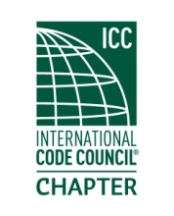

**MEETING Notice**

**(PLEASE RSVP)**

An invitation and reminder of the upcoming chapter meeting for

**Thursday**

**21 Mar 19**

Located at

Claim Jumpers

5901 S 180th St, Tukwila, WA 98188

Meeting topic: ICC code development process and government relations issues by Kraig Stevenson.

Registration and socializing starts at 6:00 PM. Meeting will start immediately if a quorum is present. Dinner will commence shortly thereafter.

The meeting cost are $20.00, which includes a dinner and your training CEU's upon membership eligibility. (Cash or Check Only) Due to increased meal costs, raffle tickets will no longer be included in the price of admission. However, raffle tickets will be available for $1.00 each. We will still be having the 50/50 and other assorted prizes for the winners.

Please RSVP

Order of Meeting

1. Introductions and call to order
2. Approval of February minutes
3. Officer reports
4. Old business
5. New business
6. Dinner
7. Raffle drawing
8. Adjournment.