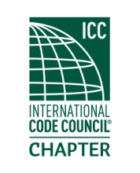
MEETING MINUTES

Thursday
17 Dec 2020
Location: virtual meeting
Order of Meeting
- Introductions and call to order: Meeting was called to order at 5:08 PM with 15 members in attendance. A roll call of officers was made, a quorum was present.

- Approval of the May minutes: The minutes of the May 2020 meeting was approved.
A motion to appoint Steven Blake treasurer was approved.

- Officer reports : President…Still working 0n ICC Preferred Provider status for the chapter.
VP…Spoke of future training possibilities
Treasurer…gave the Treasurer’s report.
Secretary…none.

- Old business : None

- New business: A discussion on how to conduct future meetings during the pandemic.

- Dinner: none

- Raffle drawing :none
- Adjournment.: Meeting was adjourned at 6:50 PM.

