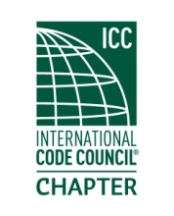

Minutes of Meeting
Thursday
February 18, 2021
Hybrid Meeting (virtual and physically at Sumner, WA)

Meeting called to order at 5:15 PM.

12 members present, quorum per by-laws.
Officer roll call: President- Marc Schoenberg, present
Vice president- Dana Herron, present
Treasurer- Steven Blake, present
Secretary- Rob Horton, present

January minutes were approved by motion, seconded, and approved.

Old business: The chapter was planning to give a gift to the owner of Brank’s due to a death in the family but never did. The President suggested that the chapter gift a $250 gift card and there was no need to vote on this as the chapter had already voted to do this.

New business: Elections are coming up and we need an elections chairperson.

Officer reports:

President- The chapter is going to have training on a vacuum plumbing system next meeting.

Vice President- Advised membership about free online opportunities to earn ceu’s.

Treasurer- Reviewed balances from treasurer’s report.

Secretary- No report.

Meeting was adjourned at 6:22 PM

