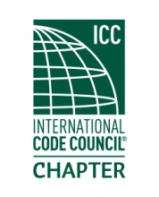

**MEETING MINUTES**

**Thursday**

**21 May 2020**

**Location: virtual meeting**

Order of Meeting

1. Introductions and call to order: Meeting was called to order at 6:05 PM with 14 members in attendance. A roll call of officers was made, a quorum was present.
2. Approval of the February minutes: The minutes of the February 2020 meeting was approved.
3. Officer reports : President…Still working 0n ICC Preferred Provider status for the chapter.

VP…none

Treasurer…gave the Treasurer’s report.

Secretary…none.

1. Old business : None
2. New business: A discussion on how to conduct future meetings during the pandemic.

Elections of officers: all incumbents were nominated and were re-elected via a voice vote.n

Dave Spencer installed the officers.

1. Dinner: none
2. Raffle drawing :none
3. Adjournment.: Meeting was adjourned at 7:13 PM.