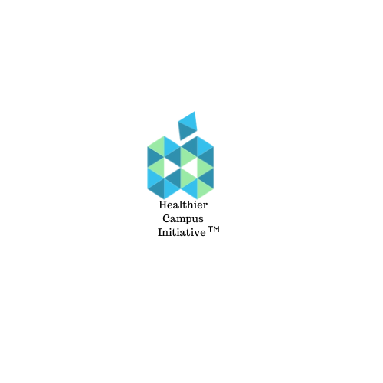
July 8, 2024 |  | Healthier Campus Initiative Partnerships  501c3 EIN: 88-3269801  4441 13th Street NE  Washington, DC 20017
Dear Donor:

We’re happy to celebrate our 10th anniversary of helping nearly 2 million college students at 80 campuses across the country through the Healthier Campus Initiative. Our dining vendors, campus rec directors, mental health counselors and food pantry workers and students are all so vital to creating healthier environments. However, we need your help.

Our goal is to raise $250K during Healthy Campus Week (Sept. 16-20, 2024) to continue to promote healthy eating, physical fitness, food insecurity and mental health measures. We’d love your participation as a sponsor. The options are listed below:

SPONSORSHIPS
- Gold: $25K Logo, social media handles, reposts, on-campus activation, newsletter
- Silver: $10K Logo, social media handles and reposts
- Bronze: $5K Logo and social media handles

Also, here are links to prior activities during Healthy Campus Week: Howard Univ Sodexo Largest Farmers Market; VIDEO Miss Cheyney Relaxation Tips; VIDEO Mr. Cheyney Making Seamoss VIDEO

For additional posts: Follow/Like/Subscribe @healthiercampusinitiative

Please reach out to Kimberly O’Shields kimberly@continuumnow.com no later than July 15th to discuss how we can make a difference together. Thank you!
