Measuring Procedure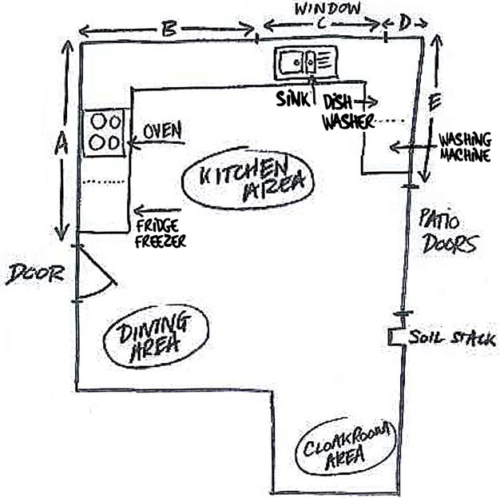

1. Please note ceiling height.
2. Please provide a rough sketch with as much information that you want to convey.
3. When measuring doors and windows please include the trim.
4. See example above.