

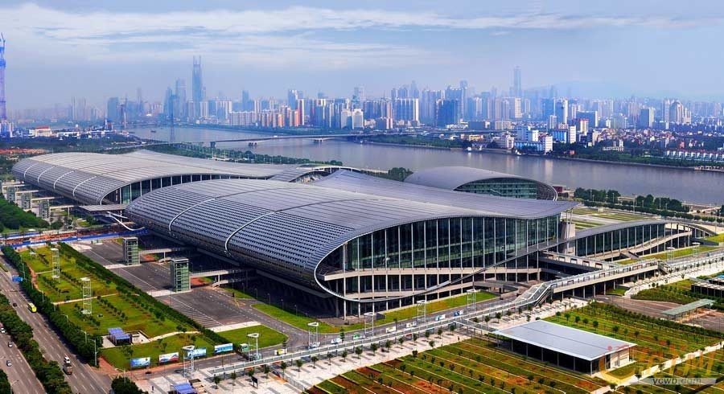

**CANTONFAIR2024(Phase-I)**

### Canton Fair Spring Phase One focuses on electrical and electronic products and industrialproducts.MostofChina's latesthigh-techproductsareinthefirst

**PhaseoftheCantonFair.Ithasthelargestnumberofdealsandbuyersof3phases.**

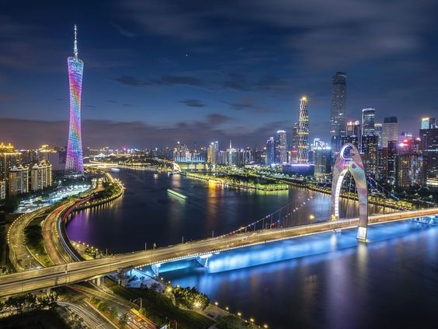

**2024ExhibitionLayoutPhaseWise**

|  |  |  |
| --- | --- | --- |
| **PHASEI 14-19APR** | **PHASEII23-27 APR** | **PHASEIII14 MAY** |
| * Household ElectricalAppliances * Consumer ElectronicsandInformationProducts * Electronic and ElectricalProducts * LightingEquipment * NewEnergyResources * New Materials andChemicalProducts * Hardware * Tools * Machining Machinery andEquipment * Power and ElectricalEquipment * General Machinery andMechanicalParts * Industrial Automation andIntelligentManufacturing * ConstructionMachinery * AgriculturalMachinery * New Energy VehiclesandSmart Mobility * Motorcycles * Bicycles * VechicleSparePart | * Building and DecorationMaterials * Sanitary and BathroomEquipment * Furniture * KitchenandTableware * Daily-useCeramics * HouseholdItems * Clocks, Watches andOpticalInstrument * GiftsandPremiums * FestivalProducts * HomeDecorations * Art Ceramics * GlassArtware * GardeningProducts * Woven, Rattan and IronProducts * Iron and StoneDecorations and OutdoorSpa Facilities | * Personal CareAppliances * BathroomProducts * Medicines, HealthProducts and MedicalDevices * Pet Products * Maternity and BabyProducts * Toys * Children'sClothing * Men's and Women'sClothing * Sportswear and CasualWear * Underwear * Fur, Leather, Down andRelatedProducts * Clothing Accessories andFittings * HomeTextiles * Textile Raw Materialsand Fabrics * CarpetsandTapestries * Shoes * OfficeSupplies * BagsandSuitcases * Sports and TourismLeisureProducts * Food * Featured Products forRuralRevitalization |



|  |  |  |  |
| --- | --- | --- | --- |
| **PLAN1**  **EXCLUSIVEPACKAGEFORCANTONFAIRCHINA2024SINGAPOREAIRLINES** | | | |
| **Date** | **Itineraryfor04Nights/05Days** | | |
| **13th-14thApr2024** | **DepartDelhi,**ArriveGuangzhou.TransfertotheGuangzhouHotel.**Dinnerat the**  **comfortofhotel**.OvernightstayattheHotel. | | |
| **15thApr2024** | AfterBreakfast,Visit**CantonFair2024.Dinneratthecomfortofhotel.**Overnightstay  atthehotel. | | |
| **16thApr2024** | AfterBreakfast,Visit**CantonFair2024.EveningPearlRiverCruise.Dinnerat the**  **comfortofhotel.**OvernightstayattheHotel. | | |
| **17thApr2024** | AfterBreakfast,Visit**Canton Fair2024.IntheAfternoonPanoramiccityTourof**  **Guangzhou.Dinnerat thecomfort ofhotel.**OvernightstayattheHotel. | | |
| **18thApr2024** | AfterBreakfast,CheckoutfromtheHotel.TransfertotheGuangzhouAirport.Depart  Guangzhou,ArriveDelhi. | | |
| **Hotel** | | **DaysInnbyWyndhamGuangzhou4****HotelorSimilar** | |
| **PackagePriceEx.DelhionTwin Sharing** | | **INR1,06,900PerPerson** | |
| **SingleSupplement(Optional)** | | **INR24,800** | |
| **PACKAGEINCLUSIONS** | | | **PACKAGEEXCLUSIONS** |
| Return economy class airfare on mentioned airline.Airporttaxes of IndiaandChina.  Return transfers from Guangzhou Airport to Hotel byLuxuryACcoach as pergroup.   1. fairground transfers by Luxury AC coach as perGroup. 2. Night’s accommodation on mentioned hotel.Daily buffet breakfast at the hotel (2 Indian DishesandMasala Tea).   Daily Indian Dinner at the comfort of the hotel withsoft and hard drinks (soda, soft drinks, juice, whiskeyandbeer).  PearlRiverCruiseas perGroup.  Panoramic city tour of Guangzhou with shoppingdropasperGroup.  OverseasTravelInsurance.  Services of Tourministry’s Tour Manager.RedCarpetComplimentaryTravelKit. | | | Anyitem notmentionedininclusions.  Anything related to personal nature orexpenses. |
| **EXTRAS:** |
| GST@ 5% will be payable on total packagecost.  TCS@ 5% will be payable on total packagecost  Tips to driver and guide USD 20SingleEntryChinaVisaCharges INR  directlypayableatVFS. |
|  |

|  |  |  |  |
| --- | --- | --- | --- |
| **SingaporeAirlineExDEL** | | | |
| **Airline** | **Date** | **Departure** | **Arrival** |
| SQ 403 | 13APR | DEL2155 | SIN0610+1 |
| SQ 850 | 14APR | SIN0820 | CAN1220 |
| SQ 851 | 18APR | CAN 1325 | SIN1730 |
| SQ 402 | 19APR | SIN0235 | DEL0540 |



|  |  |  |  |
| --- | --- | --- | --- |
| **PLAN2**  **EXCLUSIVEPACKAGEFORCANTONFAIRCHINA2024CATHAYPACIFIC** | | | |
| **Date** | **Itineraryfor04Nights/05Days** | | |
| **14thApr2024** | **DepartDelhi/Mumbai,**ArriveHongKong.TransfertotheGuangzhouviaFerry.**Dinnerat**  **thecomfort ofhotel**.OvernightstayattheHotel. | | |
| **15thApr2024** | AfterBreakfast,Visit**Canton Fair2024.Dinneratthecomfortofhotel.**Overnightstayat  theHotel. | | |
| **16thApr2024** | AfterBreakfast,Visit**CantonFair2024.PearlRiverCruise.Dinneratthecomfort ofhotel.**  OvernightstayattheHotel. | | |
| **17thApr2024** | AfterBreakfast,Visit**CantonFair2024.PanoramiccityTourofGuangzhou.Dinnerat the**  **comfortofhotel.**OvernightstayattheHotel. | | |
| **18thApr2024** | AfterBreakfast,CheckoutfromtheHotel.TransfertotheHongKongAirportviaFerry.Depart  HongKong,ArriveDelhi/Mumbai. | | |
| **Hotel** | | **DaysInn byWyndhamGuangzhou4 ****Hotel** | |
| **Ex.Delhi/MumbaiPackagePriceonTwinSharing** | | **INR1,19,900PerPerson** | |
| **SingleSupplement** | | **INR25,800PerPerson Extra** | |
| **PACKAGEINCLUSIONS** | | | **PACKAGEEXCLUSIONS** |
| Return economy class airfare on mentioned airline.Airporttaxes ofIndia andHong Kong.  Return Ferry from Hong Kong to Kong as per group.Return transfers from Guangzhou Port to Hotel byLuxuryACcoach as pergroup.   1. fairground transfers by Luxury AC coach as perGroup. 2. Night’s accommodation on mentioned hotel.Daily buffet breakfast at the hotel (2 Indian DishesandMasala Tea).   Daily Indian Dinner at the comfort of the hotel withsoft and hard drinks (soda, soft drinks, juice, whiskeyandbeer).  PearlRiverCruiseas pergroup.  City tour of Guangzhou with shopping drop as pergroup.  OverseasTravelInsurance.  Services of Tourministry’s Tour Manager.RedCarpetComplimentaryTravelKit. | | | Anyitem notmentionedininclusions.  Anything related to personal nature orexpenses. |
| **EXTRAS:** |
| GST@ 5% will be payable on total packagecost.  TCS@ 5% will be payable on total packagecost  TipstodriverandguideUSD20  Single Entry China Visa Charges directlypayableatVFS. |
|  |

|  |  |  |  |  |  |  |  |
| --- | --- | --- | --- | --- | --- | --- | --- |
| **FlightDetails** | | | | | | | |
| **CathayPacificAirlineExDelhi** | | | | **CathayPacificAirlineExMumbai** | | | |
| **Airline** | **Date** | **Departure** | **Arrival** | **Airline** | **Date** | **Departure** | **Arrival** |
| CX 694 | 14 OCT | DEL 0105 | HKG 0910 | CX 660 | 14APR | BOM0125 | HKG0950 |
| CX 695 | 18 OCT | HKG 1745 | DEL2115 | CX663 | 18APR | HKG2020 | BOM0020 |

**Days Inn byWyndhamGuangzhou4\*\*\*\***

**Add:**88YunxiaoRoadBaiyunDistrict,Guangzhou,Guangdong510403

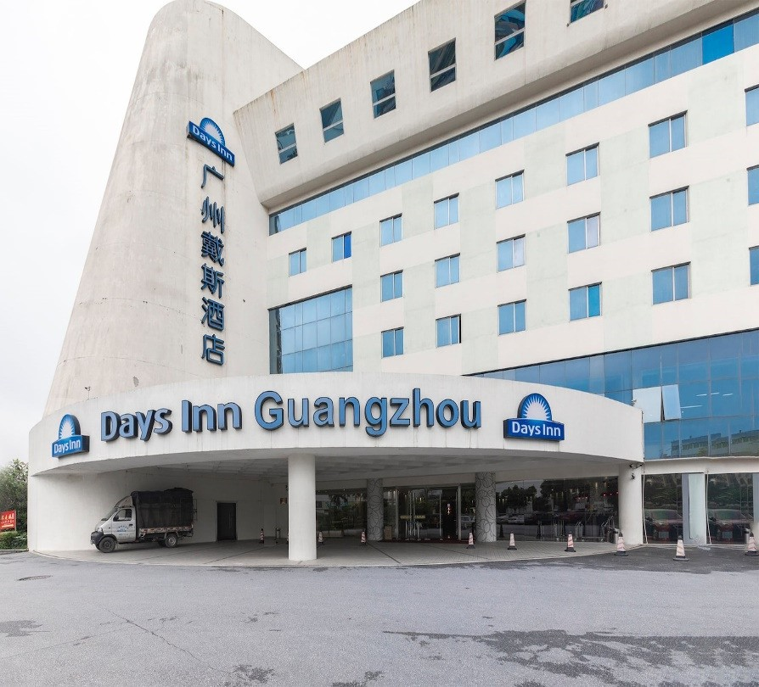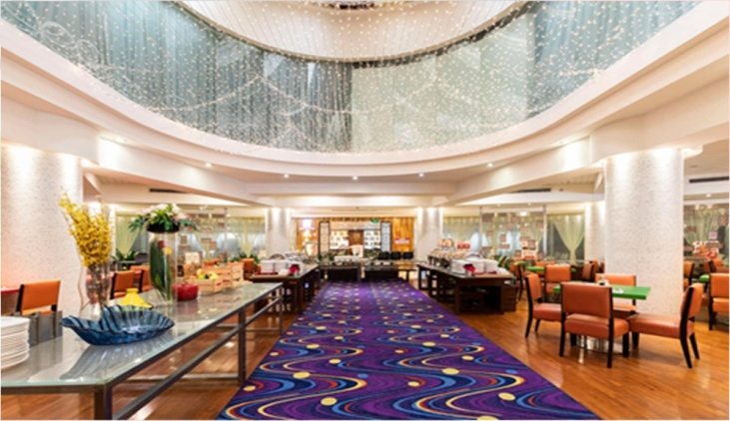**Tel:**+86-20-86638838

# DiscoverGuangzhouwithUs

## LocatedinBaiyunCity closetoBaiyunInternationalAirport

Make yourself at home when you make a reservation at our Days Inn Guangzhou hotel. Located just a shortdistance from the Zhu River, our location near Temple of the Six Banyan Trees provides comfortable lodging inadditiontoeasyaccess togreatrestaurants and topattractions.

#### FreshAmenities

**EnjoyabreakfastbuffetandfreeWi-Fi**

Start your morning with our breakfast buffet, and read the daily newspaper as you enjoy a fresh mug of coffee.ConnecttoyourfriendsandfamilybackhomeusingourfreeWi-Fi.Non-smokingaccommodationsareavailable.

# Whileyou’rehere

## Marvelattemplesandwalkthroughbeautifulbotanicalgardens

Hop onto the Baiyun Mountain cable car and soar above the clouds of Guangzhou or walk through the South ChinaBotanicalGardenwithitsvastarrayofgreenhouses.VisitthemausoleumoftheNanyueKing orascendthefive-

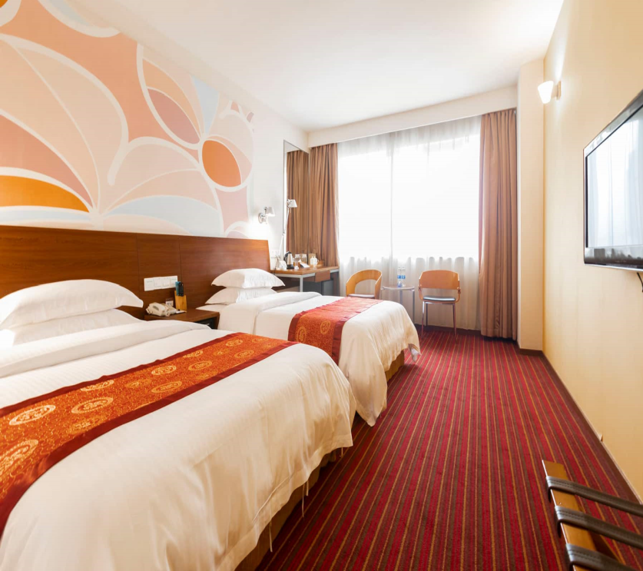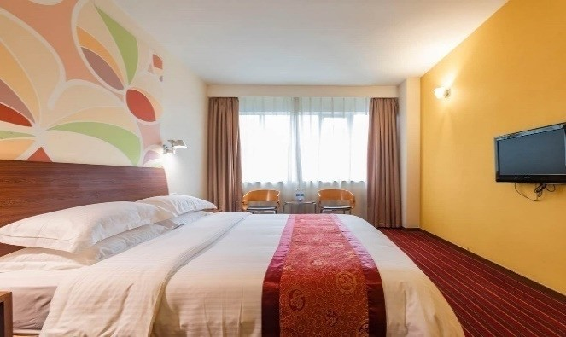storied pagoda, Zhenhai Tower. For a more modern perspective, the Guangdon Museum of Art exhibitscontemporaryChineseartists.Seepandas withthekids attheGuangzhouZoo.

### DistancefromHoteltoFairGround:

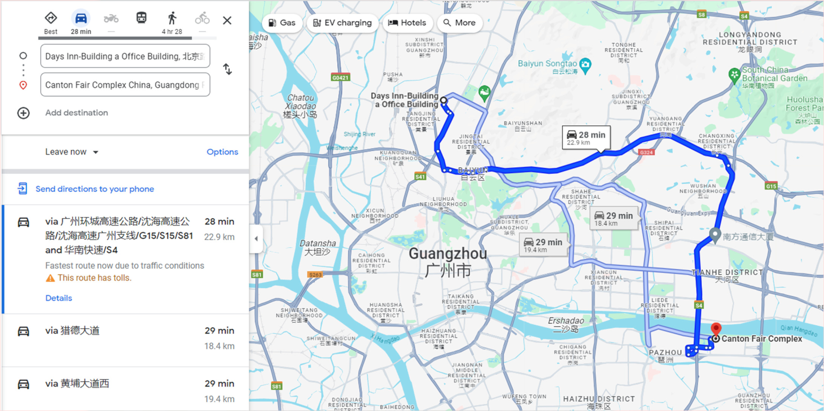

#### TermsandConditions

**INR.85,000/-**advancedeposit(non-refundable)tobepaidwhilebooking&fullpaymenttobecleared06Weeks priorto departureorelse thedeparturedatewill besubjecttochange.

Iftheabove-mentionedhotelsarenotavailable,similargradehotelswillbeprovidedwithoutcompromising onanyservice orfacility.

GroupTicketsarenon-refundableanddatechangeoptionispossibleonlybeforeticketing.



**Anyseatupgradeorclassupgradecanbedoneattheairportonly.(Subjecttoavailabilityattheairport)**

Thecostisbasedonrateofexchange1USD= INR83

Airfare&Taxesareasof06/11/2024andaresubjecttochange.

No change in itinerary once confirmed will be honored unless given in writing.Noverbalcommitmentswill behonoredunless giveninwriting.

Thetravelpackageispurelybasedonminimum**35adult**passengerstravellingtogether.Anyreductioninthegroupsizewill leadto anincreaseinprice orchange inthe services.

TheInternationalCheck-intime:-1500hrs.&check-outtimeis1200hrs.

Any increase in the rate of exchange can lead to an increase in the cost of surface transportation & otherland arrangements, which can come into effect prior to departure, the difference will have to be paid bythepassengerdirectlytoTOURMINISTRY TOURS.

All prices of the hotel are subject to change without notice due to delay or change in management ofsuppliers. In case of non-availability of hotel, alternate options will be suggested which may involve anyincreaseinpriceand hotels.

Any overstay expenses due to delay or change or cancellation in flight will be on the passenger's own &Tourministry will not be held liable for such expenses. However, we will provide assistance to the best ofourabilities.No refundwill beprovidedfor anyunutilized services.

Tourministry is not responsible for any change in dates of Trade Fairs, Venue, Cancellation and / or theexhibitionProfile.

In case of any last-minute confirmations received for a single person or non-availability of finding a twinpartnerforasingleperson,singleroomsupplementwillhavetobebornebythepassenger’smandatory.

**Documentation**

The passenger/s will not hold Tourministry / Tour MSTY, under any circumstances, liable or responsiblefor any refused / delayed documents and / or for any expenses incurred due to non-availability of visaand / or error in dates of visa granted, etc. In case of visa refusal, cancellation charges will be applicableas given.



#### CancellationCharges:

If due to some unforeseen circumstances you can not avail the package,you shouldintimateyour cancellation in writing for which the following charges will be applicable over and abovethenonrefundable registration amount of**Rs.85,000/-.**

#### PeriodofCancellation: Charges(PerPerson)

##### Morethan45dayspriortodeparture INR.85,000/-Between45to31dayspriortodeparture 75 % of package priceBetween30to0dayspriortodeparture 100%ofpackagepri