

DISCOVER HAVERFORD (HPED)

Press release: Discover Haverford Announces Winners of Holiday Display Contest
(V-2: 993 words)

December 20, 2025

Discover Haverford announces the winners of its 2025 Holiday Display Contest. First and second place awards are made in each of seven categories, one award for “Rookie of the Year” plus a Best in Show award. This year a new category of “Most Attractive Business District” was introduced for a total of 17 awards.

The contest, now in its 14th year, is one of many programs run by Discover Haverford to strengthen the business districts and enhance community life in Haverford Township through special events, shop local campaigns and beautification projects.

The category of BEST IN SHOW recognizes a display that stands out as the singularly best display of all. This year that award goes to Sweet Messina’s Bakery at 1217 Darby Road in the Brookline business area. Contest judge, Angelo Capuzzi, explains why he voted for Sweet Messina’s Bakery for this special recognition: “My initial reaction when I saw Messina’s display was ‘This display is by far the best I’ve seen, hands down!’ It brought back so many childhood memories.”
In the MOST BEAUTIFUL WINDOW category the first-place winner is Novita Boutique at 24 Brookline Boulevard. Contest judge and local artist, Rudy Miller, describes Novita’s display: “Novita Boutique’s holiday window display is simply enchanting due in no small part to the expertly rendered window painting by artist Pearl Bell. The lights around the border help make the snowy artwork glow, thereby beautifully framing the two dress forms wearing lovely seasonal apparel complete with cozy scarves.” Second place is Plant Roots Local at 19 Brookline Boulevard with its stunning natural woods scene.
In the MOST CREATIVE WINDOW category the winner is In-the-Fringe at 1306 Edgewood Road in the Edgewood business district. Judge Kristina Early notes: “What I love about the In-the-Fringe window display is how it showcases her line of business (drapery), incorporates a full scale "tree" outline with the drapery and incorporates additional decorations serving as ornaments. The whole display is elegant, festive, elevated, and a wonderful display of her unique and creative eye for design!” Second-place winner in this category is Lighthouse Commercial Insurance at 2118 Darby Road in the Oakmont South business district with its clever integration of winter images and their business symbol.

Burke’s Inn at 26 E. Eagle Road is awarded first place in the MOST BEAUTIFUL FAÇADE category. Judge Don Kelly shares his impression of their display: “In all seasons Burke’s Inn evokes the welcoming feel of a traditional Irish pub. However, during this Christmas season its tasteful integration of green lighting and holiday décor make it especially inviting.”

This year there is a three-way tie for second place: Westgate Pub at 1019 West Chester Pike, Faust Orthodontics at 1635 Darby Road and Wilson’s Secret Sauce at 265 Township Line Road.

In the MOST ENTERTAINING THEME category the first-place winner is Steve Clott, CPA at 2024 Darby Road. Judge Amy Killeen says: “Steve Clott and his office manager, Carol Razzano, consistently deliver witty and engaging window displays, and this year was no exception. ‘Sleigh into Christmas’ is not only clever but also pretty to look at.” Tied for second place are: House Cup Coffee at 2116 Darby Road and Tuscany Café at 803 West Chester Pike.

In the MOST EFFECTIVE MARKETING category first place is won by Havertown Bicycle at 2030 Darby Road with its clever use of bicycle parts to create a giant menorah and Christmas tree. In second place is Mainline Chimney at 2343 Darby Road in the Oakmont Village district.

The first- place award for the MOST WHIMSICAL WINDOW goes to Moore’s Books at 28 E. Eagle Road. Judge Chris Kelly says: “Moore Books enlists beloved book characters to help install holiday lights. Get up close to see what the colorful rascals are up to!” In second place is The Bookery at 19 Brookline Boulevard.

Discoverie Goods, Inc. at 2339 Darby Road is the winner of the ROOKIE-OF-THE-YEAR award for a new business. “The attractive and enticing window displays holiday gifts including home goods with Delco and Pennsylvania motifs plus fun Philadelphia sports teams and pet lover choices” is the way Judge Chris Kelly describes its display.

THE MOST CLASSIC DISPLAY recognizes displays that create an overall impression of beauty and joy in a traditional sense. The first-place winner in this category with a charming display is Juice Pod at 30 Brookline Boulevard. In second place with another gorgeous display is The Bakery House at 604 Lancaster Avenue.

This year for the first time, recognition is given to the business district within Haverford Township that demonstrates the best combination of the percentage of decorated businesses and quality. We are pleased to announce that the Brookline Business District excelled this year in this category. We especially acknowledge the contributions of Kettle, Dynamic Image Salon, Plant Roots Local, The Bookery, St. Jude Shop, McGillicuddy’s Pub, Juice Bar, Headlines by Renee, Ruthies’ Eyes, Novita Boutique, Sweet Messina’s Bakery and Centrella’s Deli.

Discover Haverford appreciates the efforts made by all 32 registered contestants and how nicely their displays contributed to the beauty and vibrancy of our community during this holiday season. The following contestants have earned Honorable Mentions for their displays:

Baby Bloom Clothing
Brew Your Own Beer
Brick and Brew
Carl’s Cards
Centrella’s Deli
Danielle Foster Creations
Dream Team
Dynamic Image Salon
East Eagle Yoga
Headlines by Renee
Hendren House
Wagner Compass Real Estate
Yard Pub
Yearsley’s Services
Children’s Ark at St. George’s Church

Beautiful photographs of first and second-place winners were taken by Scott Reynolds of STR Productions as a complimentary public service. The photos have been placed on the Discover Haverford (HPED) website at https://discoverhaverford.org/holiday-decorating and made available to each winner to use for their own purposes.

Discover Haverford (HPED) is a non-profit, charitable organization through which business owners, commercial property owners, residents and the Township of Haverford collaborate to strengthen local business districts by helping existing businesses be successful, welcoming new businesses and beautifying business areas. For more information contact Don Kelly at donaldkelly@aol.com

One photo below:
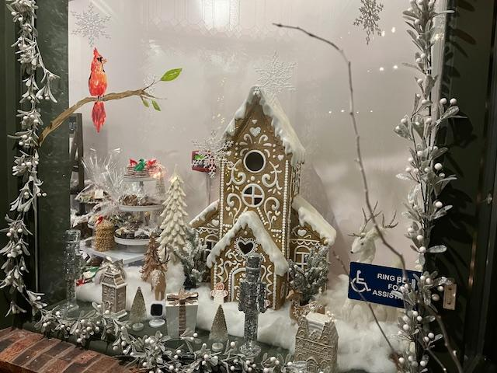

Sweet Messina’s Bakery, 1217 Darby Road in Havertown – Best-in-Show

End

