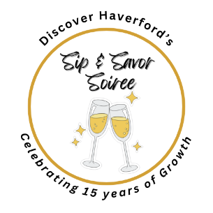
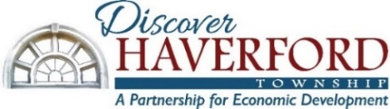
2026 Event Sponsorship Opportunities
Pay for two of our event sponsorships
and get 10% off the cost of both!
Sip & Savor Soiree - Friday, April 17th at Brick & Brew
- Presenting Sponsors (3) - $5,000 Turnerstone., A. Marinelli & Sons
- Photo Booth Sponsor (1) - $2,500 M&D CleanStart
- DJ Sponsor (1) - $2,000
- Named Signature Drink Sponsor (1) - $2,000 - Gans Plumbing, Heating & AC
- Dessert Sponsor (1) - $2,000 (1) – Payroll Vault Mainline
- Floral Decor Sponsor (1) - $2,000 Haverford Dance Company
- Soiree Supporter - $1,000 Kilkenny Law
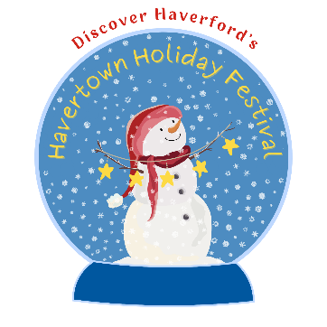
Havertown Holiday Festival - Saturday, December 5th (Raindate 12/6)
Attendance Expected: 4000+

- Presenting Sponsor - $6,000
- Stage Sponsor - $3,000
- Holiday Tree Sponsor - $3,000
- Ice Sculpture Sponsor - $2,500
    - Kid’s Craft Booth Sponsor - $2,500 ($2,000 w/o booth)
    - Face Painting Booth Sponsor - $2,500 ($2,000 w/o booth)
    - Snow Globe Photo Booth Sponsor - $2,500 ($2,000 w/o booth)
    - Holiday Marketplace Sponsor - $1,500
    - Festival Supporter - $500 (no booth)
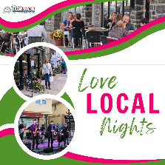
Love Local Nights in Brookline & Oakmont Business Districts (4 Dates TBD)
Attendance Expected: 250 per event
- Presenting Sponsors (up to 4) - $1200

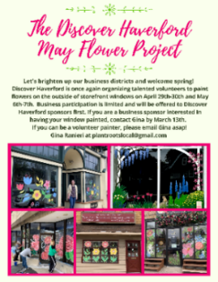
May Flower Project – focus for 2026 will be America 250
- Presenting Sponsors (up to 4) - $1000



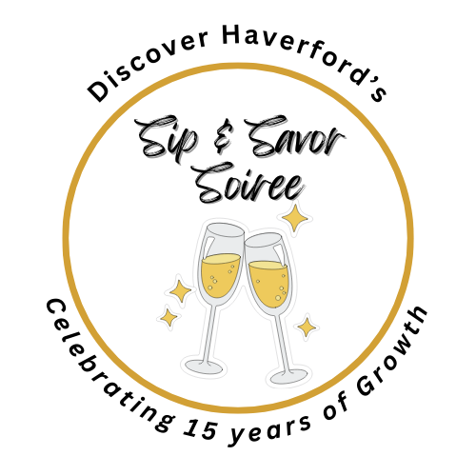
Sip & Savor Soiree - 15th Anniversary Fundraiser
Friday, April 17th 7:00-10:00pm
Brick & Brew on Eagle Road
Attendance Expected: 200-250
Our Sip & Savor Soiree will celebrate the accomplishments of Discover Haverford/HPED over the past 15 years, and will be an opportunity for us to present our five 2025 Awards of Excellence. The party will include a photo booth, DJ & dancing, silent auction, food, an open bar and drink specials.

Presenting Sponsors (3) - $5,000 Turnerstone., A. Marinelli & Sons
- Named as Presenting Sponsor on all marketing materials, including web page, social media posts, e-newsletters, press releases, slide show and posters at event and announced throughout the evening
- 4 complimentary VIP tickets to the event ($640 value)
- ^{Table space at event}
- Includes Platinum 2026 Discover Haverford sponsorship ($500 value)
  - Logo in monthly newsletter and on our website
  - Featured as sponsors at our Annual Meeting
  - Invitation to our VIP Holiday Party

Photo Booth Sponsor (1) - $2,500 M&D CleanStart
- Named as Photo Booth Sponsor on all marketing materials, including web page, social media posts, e-newsletters, press releases, slide show and posters at event and announced throughout the evening
- 3 complimentary VIP tickets to the event ($320 value)
- Logo shown on photos from photo booth
- Includes Gold 2026 Discover Haverford sponsorship ($250 value)
  - Business name listed in monthly newsletter and on our website

DJ Sponsor (1) - $2,000
- Named as DJ Sponsor on marketing materials, including web page, social media posts, e-newsletters, press releases, slide show and posters at event and announced throughout the evening
- ^{Sponsorship poster at DJ booth}
- 2 complimentary VIP tickets to the event ($320 value)
- Includes Gold 2026 Discover Haverford sponsorship ($250 value)
  - Business name listed in monthly newsletter and on our website

Named Signature Drink Sponsor (1) - $2,000 – Gans Plumbing, Heating & AC
- Named as Signature Drink Sponsor on all marketing materials, including web page, social media posts, e-newsletters, press releases, slide show and posters at event and announced throughout the evening
- Sponsorship listed on displays at the bar
- 2 complimentary VIP tickets to the event ($320 value)
- Includes Gold 2026 Discover Haverford sponsorship ($250 value)
  - Business name listed in monthly newsletter and on our website

Dessert Sponsor (1) - $2,000 – Payroll Vault Mainline
- Named as Dessert Sponsor on all marketing materials, including web page, social media posts, e-newsletters, press releases, slide show and posters at event and announced throughout the evening
- Sponsorship listed on display at dessert table
- 2 complimentary VIP tickets to the event ($320 value)
- Includes Gold 2025 Discover Haverford sponsorship ($250 value)
  - Business name listed in monthly newsletter and on our website

Floral Decor Sponsor (1) - $2,000 Haverford Dance Company
- Named as Floral Decor Sponsor on all marketing materials, including web page, social media posts, e-newsletters, press releases, slide show and posters at event and announced throughout the evening
- Sponsorship listed with floral displays on tables
- 2 complimentary VIP tickets to the event ($320 value)
- Includes Gold 2026 Discover Haverford sponsorship ($250 value)
  - Business name listed in monthly newsletter and on our website

Soiree Supporter - $1,000 Kilkenny Law,
- Named as Sip & Savor Soiree Supporter on all marketing materials, including web page, social media posts, e-newsletters, press releases, slide show and posters at event and announced throughout the evening
- 1 complimentary VIP ticket to the event ($160 value)
- Includes Silver 2026 Discover Haverford sponsorship ($100 value)

SPONSORSHIP FORM
Sip & Savor Soiree
Friday, April 17th

Yes, I’d like to sponsor the Sip & Savor Soiree!

____ Presenting Sponsor (3) - $5,000 Turnerstone., A. Marinelli & Sons
____ Photo Booth Sponsor (1) - $2,500 M&D CleanStart
____ DJ Sponsor (1) - $2,000
____ Named Signature Drink Sponsor (1) - $2,000 Gans Plumbing, Heating & AC
____ Dessert Sponsor (1) - $2,000 – Payroll Vault Mainline
____ Floral Decor Sponsor (1) - $2,000 Haverford Dance Company
____ Soiree Supporter - $1,000 Kilkenny Law,

The Sip and Savor Soiree is hosted by Discover Haverford (HPED) to support our work. Discover Haverford is a 501c3 non-profit organization, and sponsorship costs are tax-deductible. For more info about Discover Haverford, visit www.DiscoverHaverford.org.
Name of Business __________________________________________________________________
Contact Name(s) __________________________________________________________________
Address __________________________________________________________________________
Work Phone ____________________________ Cell ______________________________________
Email _______________________________________ Website _____________________________
For questions, contact Discover Haverford Executive Director Jeanne Angell at 610-945-5822 or email jangell@hped.org. Please mail this form and your check payable to Discover Haverford to: 412 Darby Road, Havertown, PA 19083 or pay via PayPal to jangell@hped.org or Venmo@Discover-Haverford.
Please note that your sponsorship will be reserved upon receipt of your payment.
THANK YOU FOR YOUR PARTNERSHIP!

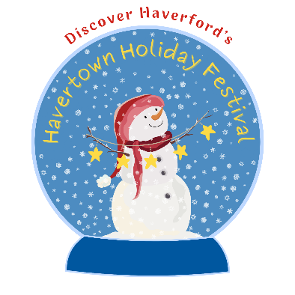
Havertown Holiday Festival
Saturday, December 5th (Rain date 12/6), Brookline Boulevard
^{Attendance Expected: 3-4,000}
The Havertown Holiday Festival is a family friendly event focused on Christmas, Hanukah, and Winter Fun! We will have costumed characters, live holiday music, story time and crafts for kids, face painting, food vendors, a beer & hot adult beverages for sale, a holiday marketplace, an ice sculpture demonstration, face painting, a snow globe photo booth, and a lit holiday tree and menorah.
^{Presenting Sponsor $6,000 (1)}
- Named as Presenting Sponsor with large logo on all marketing materials, including posters, web page, social media posts, e-newsletters, welcome banners at event entrances, signs at event
- Named as presenting sponsor in press release; Announced throughout the day on stage
- ^{Booth space at event}
- Includes Premium 2026 or 2027 Discover Haverford sponsorship ($1,000 value)
  - Banner in monthly newsletter and on our website
  - One targeted social media campaign about your business per year
  - Featured as sponsors of our Annual Meeting

^{Stage Sponsor - $3,000 (1)}
- Named as Stage Sponsor with large logo on all marketing materials, including posters, web page, social media posts, e-newsletters, press releases, and 24”x36” sign next to stage
- Announced throughout the day on stage
- ^{Booth space at event}
- Includes Platinum 2026 or 2027 Discover Haverford sponsorship ($500 value)
  - Logo in monthly newsletter and on our website
  - Featured as sponsors of our Annual Meeting
  - Participation in our Keep it Local Gift Card Program

Holiday Tree Sponsor - $3,000 (1)
- Named as Holiday Tree Sponsor with large logo on all marketing materials, including posters, web page, social media posts, e-newsletters, press releases, and 24”x36” sign next to tree
- Announced throughout the day on stage
- ^{Booth space at event}
- Includes Platinum 2026 or 2027 Discover Haverford sponsorship ($500 value)
  - Logo in monthly newsletter and on our website
  - Featured as sponsors of our Annual Meeting
Ice Sculpture Sponsor - $2,500 Porche of the Main Line
- Named as Ice Sculpture Sponsor w/ logo on all marketing materials, including posters, web page, social media posts, e-newsletters, press releases, and banner at Ice Sculpture Tent
- Announced throughout the day on stage
- ^{Booth space at event}
- Includes Gold 2026 or 2027 Discover Haverford sponsorship ($250 value)
  - Listing in monthly newsletter and on our website

Kid’s Craft Booth Sponsor - $2,500 ($2,000 without booth space)
- We will offer various crafts throughout the day
- Named as Craft Booth Sponsor with logo on all marketing materials, including posters, web page, social media posts, e-newsletters, press releases, and banner at Craft Tent
- Announced throughout the day on stage
- Includes Gold 2026 or 2027 Discover Haverford sponsorship ($250 value)
  - Listing in monthly newsletter and on our website

Face Painting Sponsor - $2,500 ($2,000 without booth space)
- Named as Face Painting Sponsor with logo on all marketing materials, including posters, web page, social media posts, e-newsletters, press releases, and banner at Face Painting Booth
- Announced throughout the day on stage
- Includes Gold 2026 or 2027 Discover Haverford sponsorship ($100 value)
  - ^{Listing on our website}

Snow Globe Sponsor - $2,500 ($2,000 without booth space)
- Named as Snow Globe Sponsor with logo on all marketing materials, including posters, web page, social media posts, e-newsletters, press releases, and banner at Face Painting Booth
- Announced throughout the day on stage
- Includes Gold 2026 or 2027 Discover Haverford sponsorship ($100 value)
  - ^{Listing on our website}

Holiday Marketplace Sponsor - $1,500 with booth space ACRE Windows
- Named as Holiday Marketplace Sponsor with logo on all marketing materials, including posters, web page, social media posts, e-newsletters, press releases, and logo/name on sign at marketplace
- Announced throughout the day on stage
- Includes Silver 2026 or 2027 Discover Haverford sponsorship ($100 value)
  - ^{Listing on our website}
^{Festival Supporter - $500}
- Logo on all marketing materials, including posters, web page, social media posts,
e-newsletters, and welcome banner
- Announced throughout the day on stage



SPONSORSHIP FORM
Havertown Holiday Festival
Saturday, December 5th (Raindate 12/6)

Yes, I’d like to sponsor the Havertown Holiday Festival!

____ Presenting Sponsor - $6,000 (booth space included)
____ Stage Sponsor - $3,000 (booth space included)
____ Holiday Tree Sponsor - $3,000 (booth space included)
____ Ice Sculpture Sponsor - $2,500 (booth space included)
____ Kid’s Craft Booth Sponsor - $2,500 ($2,000 without booth space)
____ Face Painting Booth Sponsor - $2,500 ($2,000 without booth space)
____ Snow Globe Photo Booth Sponsor - $2,500 ($2,000 with out booth space)
____ Holiday Marketplace Sponsor - $1,500 ($1,200 without booth space)
____ Festival Supporter - $500 (no booth)

The Havertown Holiday Festival is hosted by Discover Haverford (HPED) to support our work. Discover Haverford is a 501c3 non-profit organization, and sponsorship costs are tax-deductible. For more info about Discover Haverford, visit www.DiscoverHaverford.org.
Name of Business __________________________________________________________________
Contact Name(s) __________________________________________________________________
Address __________________________________________________________________________
Work Phone ____________________________ Cell ______________________________________
Email _______________________________________ Website _____________________________
For questions, contact Discover Haverford Executive Director Jeanne Angell at 610-945-5822 or email jangell@hped.org. Please mail this form and your check payable to Discover Haverford to: 412 Darby Road, Havertown, PA 19083 or pay via PayPal to jangell@hped.org or Vemno @Discover-Haverford.
Please note that your booth will be reserved upon receipt of payment.
50% payment can be negotiated with the balance paid by November 1st.
THANK YOU FOR YOUR PARTNERSHIP!

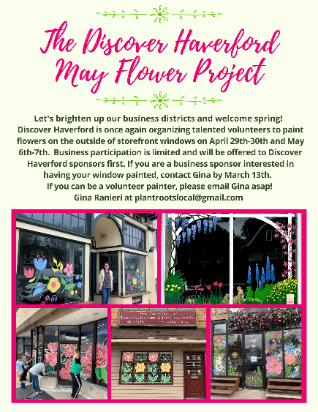
May Flower Project
Spring-Summer 2026 – Focus will be America 250
Number of Participating Businesses 30-35
Number of Volunteers – 30-40
The May Flower Project matches businesses with local volunteers to paint flowers on storefront windows as a way to welcome spring!

^{Sponsors $1,000 (up to 4)}
- Logo on posters, web page, and on artist labels on each window
- Logos and/or mentions on social media posts and our newsletters
SPONSORSHIP FORM
MAY FLOWER PROJECT

____ Yes, I’d like to sponsor the May Flower Project!

The May Flower Project is hosted by Discover Haverford (HPED) to support our work. Discover Haverford is a 501c3 non-profit organization, and sponsorship costs are tax-deductible. For more info about Discover Haverford, visit www.DiscoverHaverford.org.
Name of Business __________________________________________________________________
Contact Name(s) __________________________________________________________________
Address __________________________________________________________________________
Work Phone ____________________________ Cell ______________________________________
Email _______________________________________ Website _____________________________
For questions, contact Discover Haverford Executive Director Jeanne Angell at 610-945-5822 or email jangell@hped.org. Please mail this form and your check payable to Discover Haverford to: 412 Darby Road, Havertown, PA 19083 or pay via paypal to jangell@hped.org or Discover-Haverford.
Please note that your sponsorship will be reserved upon receipt of your payment.
THANK YOU FOR YOUR PARTNERSHIP!

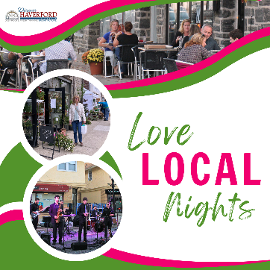
Love Local Nights in Brookline & Oakmont
Spring – Summer – Fall
Number of Attendees – 250 per event
The Love Local Nights will take place in the Brookline & Oakmont Business Districts. The focus will be on expanded shopping and dining with live music and other activities.
^{Sponsors $1,200 (up to 4)}
- Booth or table space at each event (4 nights, dates TBD)
- Logo on posters, web page, and Facebook event page
- Logos and/or mentions on social media posts and our newsletters
- Logo and sponsorship listed on 24”x36” schedule at each event
SPONSORSHIP FORM
LOVE LOCAL NIGHTS
____ Yes, I’d like to sponsor the Love Local Nights!

The Love Local Nights are hosted by Discover Haverford (HPED) to support our work. Discover Haverford is a 501c3 non-profit organization, and sponsorship costs are tax-deductible. For more info about Discover Haverford, visit www.DiscoverHaverford.org.
Name of Business __________________________________________________________________
Contact Name(s) __________________________________________________________________
Address __________________________________________________________________________
Work Phone ____________________________ Cell ______________________________________
Email _______________________________________ Website _____________________________
For questions, contact Discover Haverford Executive Director Jeanne Angell at 610-945-5822 or email jangell@hped.org. Please mail this form and your check payable to Discover Haverford to: 412 Darby Road, Havertown, PA 19083 or pay via PayPal to jangell@hped.org or Venmo to Discover-Haverford.
Please note that your sponsorship will be reserved upon receipt of your check or paypal payment.
THANK YOU FOR YOUR PARTNERSHIP!

