Guide to booking stabling for TOYS

- Go to website www.willoughbypark.co.uk

- Click on Competitor Area -> Event Calendar

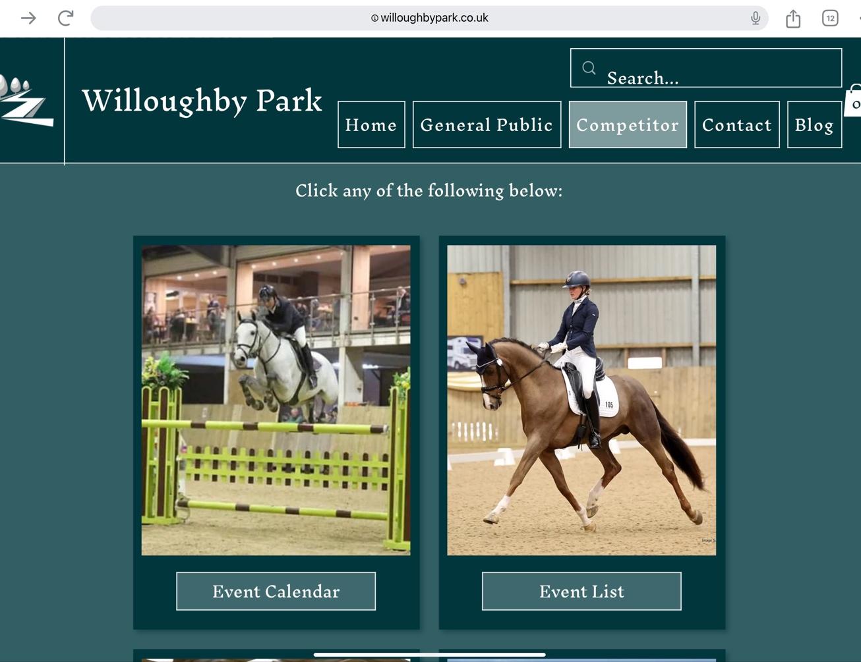

- Go to August 2024 by using the > arrow on the calendar and click on Traditional of the Year Show (TOYS) Stabling
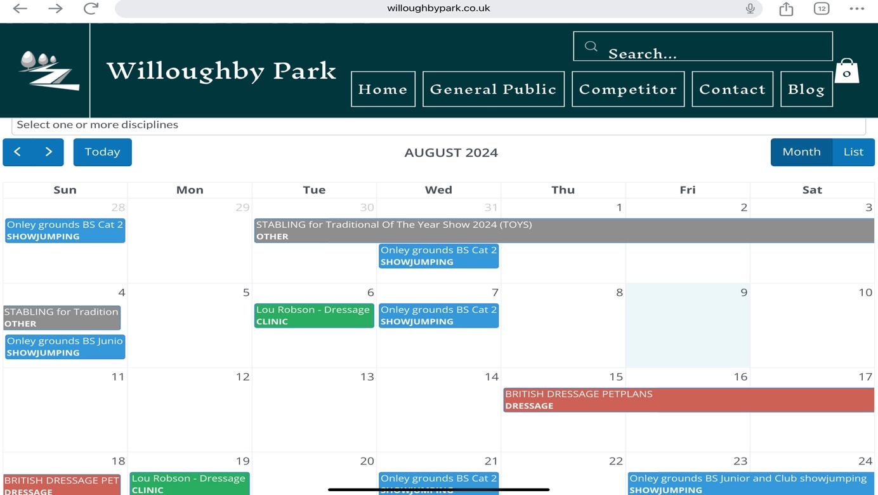
- Click on Enter Event in yellow text box

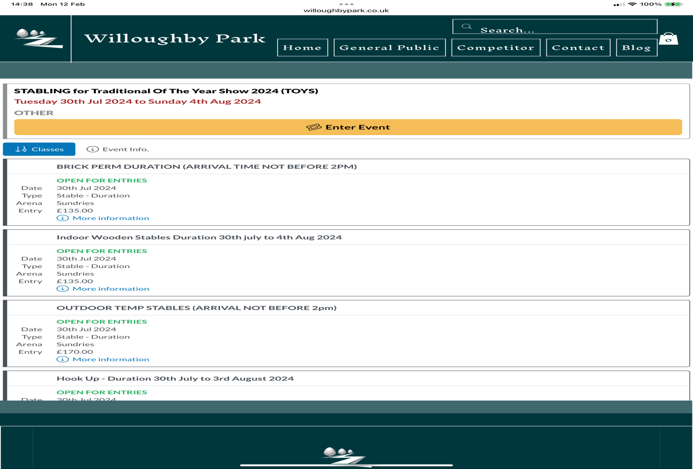

- You will now be prompted to log into Equus or create an account – once you have completed this step you will be redirected to the page below

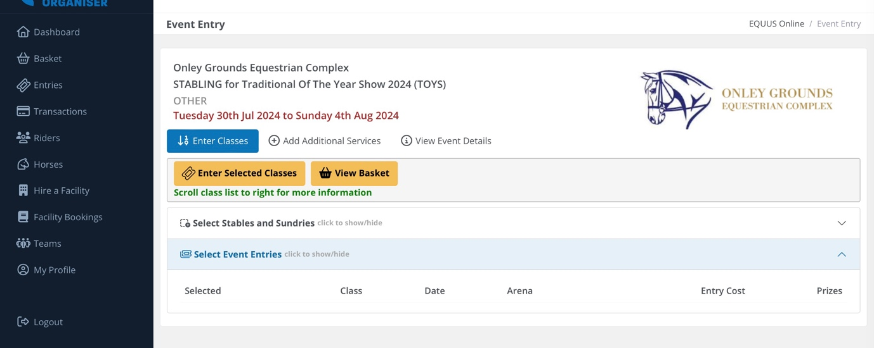

- Click on Stables and Sundries by using the drop down arrow and select your stabling/shavings/hay etc and add to basket

- Upon completion of the above step proceed to checkout – see screenshot below

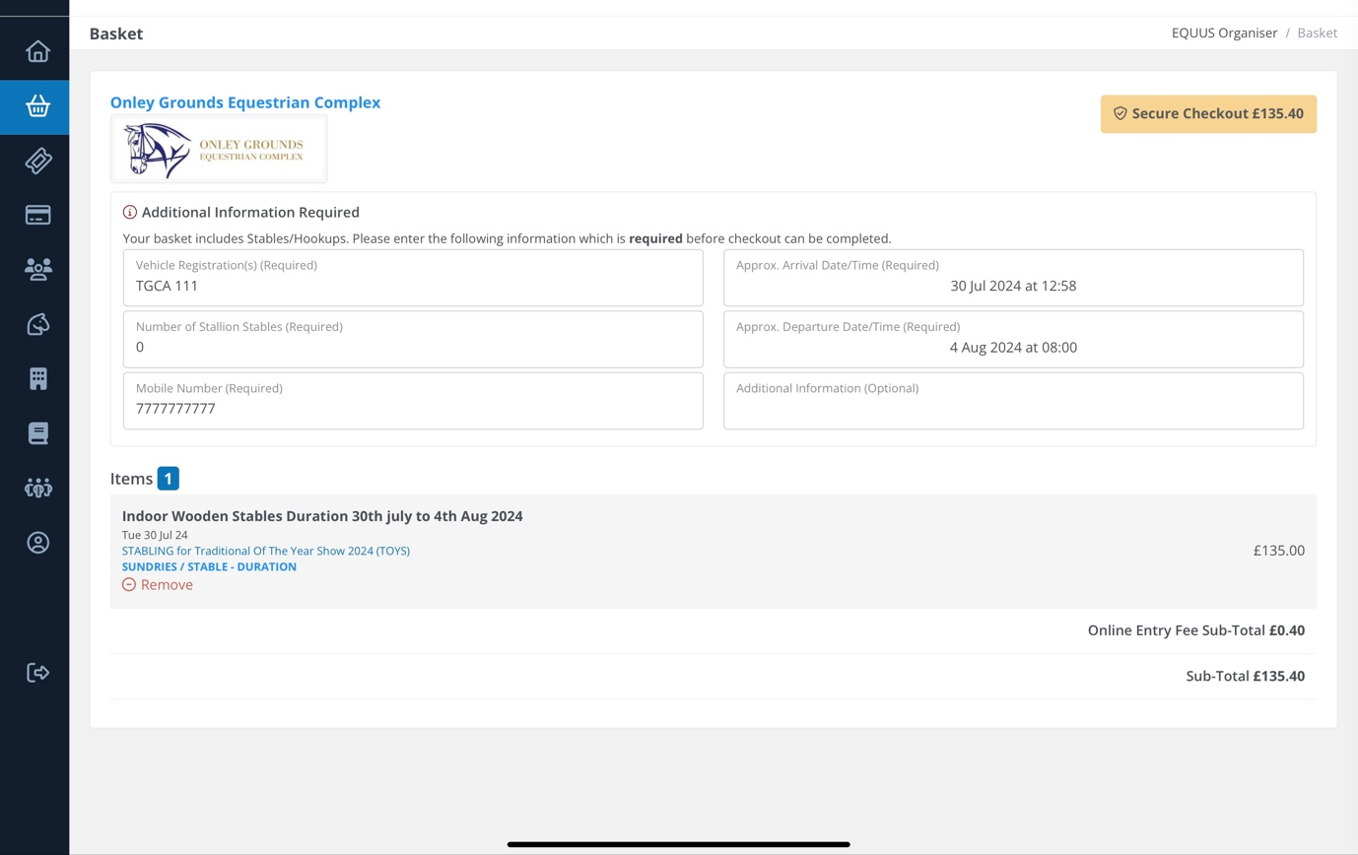

- You will need to complete the vehicle registration field and your mobile number, then click on the Approx Arrival Date/Time (Required) box and update both the date and time as necessary (you will see an error message if this step is not correctly completed)

- Click on the Approx Departure Date/Time (Required) box and update both the date and time as necessary (you will see an error message if this step is not correctly completed)

- You should now be able to proceed to Secure Checkout and complete payment

