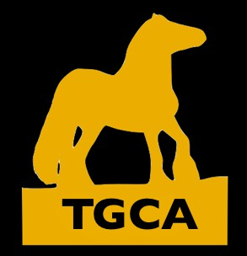

TGCA ENTRY FORM
RIDER MEMBERShIP NuMBER………………………………………………… OWNER MEMBERShIP NuMBER……………………………………………………………………. ADDRESS North
Longmuir, Mintlaw ABcl
……………………………………………………………………………………………………………………………………………………………………………………………………………………………………..
HEMORAILSE…R…EG…I…STR……A…T…IO…N…N…U…M…B…E…R…………………………………………………………………..………………………………………….…H…E…IG…H…T………….……… M…O…B…ILE……N. uCOMLBOEURR……………………………………………………………………A…ge……………………………………………………………… Sex…………………………
TRADITIONAL
MINI COB
PART BRED - PONY
NATIVE
SPORT
DRUM

CLASS  NUMBER | RIDER NAME | HORSE NAME | ENTRY FEE
 |  | 1st AID per person | £5.00
 |  | FINAL TOTAL
Entry fees must be paid by PayPal using tgcaheadoffice@gmail.com at the same time as sending this completed form. Entries will not be accepted without payments
TGCA processes your personal data in accordance with the GDPR. Your personal details will be kept confidential and safe on the secure information server. By signing below, you agree that your data will be processed by the TGCA. The TGCA will never disclose your personal data to third party data controllers without your permission

I agree to the members handbook rules and above conditions of the TGCA Signed /dated

