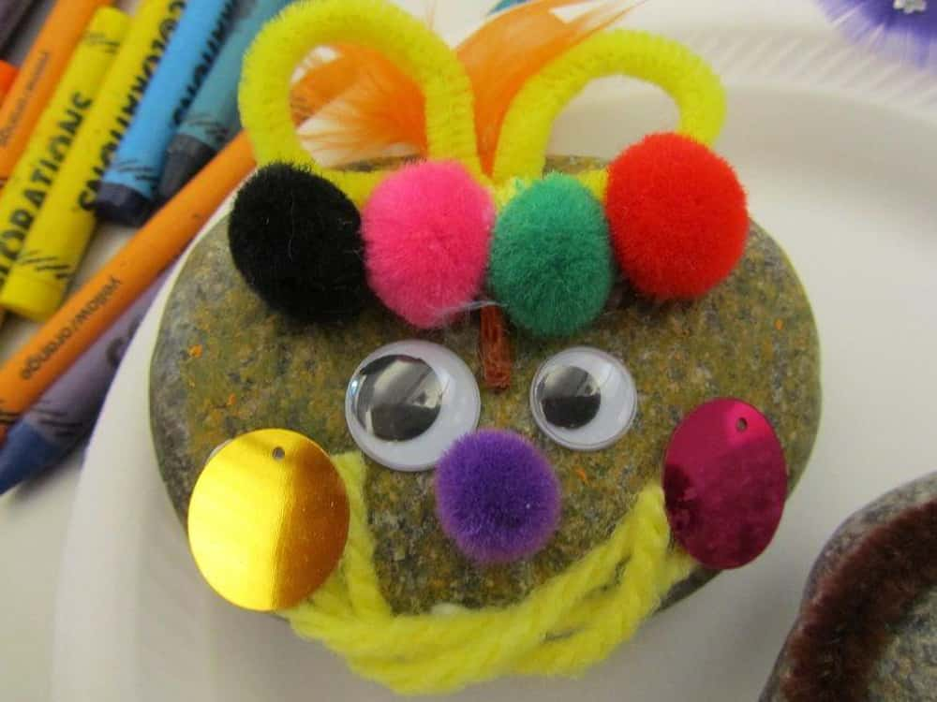

**Stafford County Fair**

**Pet Rock Olympics**

**October 10th @ 7 PM**

$5.00 entry fee per pet rock

Adult and Children Categories.

Bring your completed rock for the rolling and decorated competitions.

See the website for complete information & registration form.

Located at the Homemaking Shed

**WWW. StaffordFair.com**