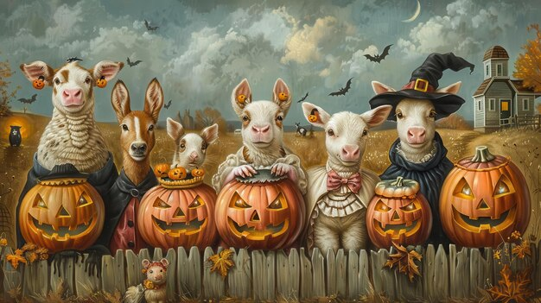

Stafford County Fair
Farm Animal Costume Contest
October 11th @ 5 PM
$5.00 per entry per category
Adult and children categories
See the website StaffordFair.com for complete information, rules & registration forms.

