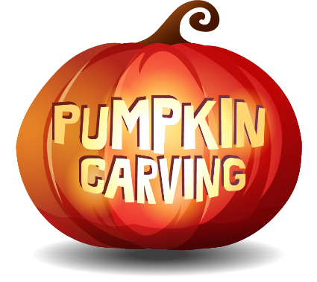
Stafford County Fair
Carved Pumpkin & Decorated Pumpkin Contests
October 17th @ 3:30 PM.
$5.00 Entry Fee per pumpkin entry
Adult, Teen & Children Categories
Pumpkins are carved and/or decorated prior to bringing to the contest.
See the website for complete information & registration form.
WWW.StaffordFair.Com

