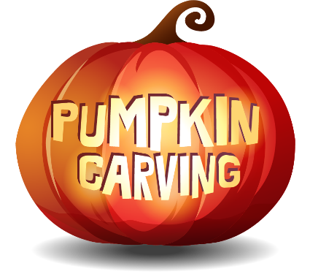

**Stafford County Fair**

**Carved Pumpkin & Decorated Pumpkin Contests**

**October 11th @ 3:30 PM.**

**$5.00 Entry Fee per pumpkin entry**

**Adult, Teen & Children Categories**

**Pumpkins are carved and/or decorated prior to bringing to the contest.**

**See the website for complete information & registration form.**

**WWW.StaffordFair.Com**