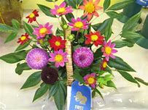

**Stafford County Fair**

**Flower Arranging Contest**

**October 12th @ 2 PM**

$5.00 per entry per category

Adult and Children Categories

See the website for complete information and registration form.

Located at the Homemaking Shed

WWW.StaffordFair.com